**Establishing a Quality Management System to Improve the Business Process**

**By**

**Farnaz Shahvazipour**

*Master of Commerce Management, International Marketing, Payam Noor University, Iran*



**Farnaz Shahvazipour**

*Master of Commerce Management, International Marketing, Payam Noor University, Iran*

**Dedicated to the merciful angels who:**

*The lord of the worlds, who began to guide his servants with the teaching of the pen.*

*My parents, whose presence is a crown of honor for me and their name is a reason for my existence because these two existences after the lord, have been the source of my existence, took my hand and taught me to walk in this valley full of ups and downs.*

**Content**

|  |  |
| --- | --- |
| **Chapter I**  *Introduction* | **5** |
| **Chapter II**  *Target market selection strategies in high level technology marketing* | **47** |
| **Chapter III**  *Different perspectives on customer relationship management* | **60** |
| **Chapter IV**  *Analysis of the mixed effect of social marketing* | **106** |
| **References** | **144** |

**Chapter I**

*Introduction*

**Introduction**

Today, no country lives in complete isolation from other countries. The economic resources, technology and standard of living of the people of a country are relatively dependent on the economy of other countries, which are related by a complex flow of goods, services, capital and technology.

Through international exchanges, countries increase their production level and earn more profit. Through imports, they get the goods that they are unable to produce, and through exports, they send the manufactured goods that are surplus to their consumption to other countries. Although a country may have different factors of production and be able to produce all kinds of goods, it will not be able to produce them at the same price. The primary cause of international exchanges is the difference in the prices of goods and services of countries.

The difference in prices is either due to the difference in the conditions of supply or facilities, production or the difference in the conditions of demand or consumption pattern or a combination of them. Differences in supply conditions may be due to differences in natural resources, efficiency, labor skills, levels of production technology, abundance of production factors, etc.

However, the difference in cost or supply conditions alone is not the cause of the price difference, but the difference in demand conditions, which is mainly formed by the income levels and different consumption patterns of countries, has an effect in creating price differences as much as the supply difference. By starting international exchange, any country can use its factors of production in the production of products that are more productive and exchange them with the products of other countries.

International exchanges become the basis for the creation of international expertise. Economic institutions grow more with access to foreign markets through exports, and in this way, they supply their products with better quality to the domestic and foreign markets and earn more profit. The desire to continue industrial investments, the necessity of economic growth, the motivation to gain excellence and fame in the commercial scene, emphasis on improving efficiency and profitability, saturation of domestic markets, mass production policy and the need for foreign exchange earnings are among the factors that the necessity and importance of marketing between they make the international more obvious.

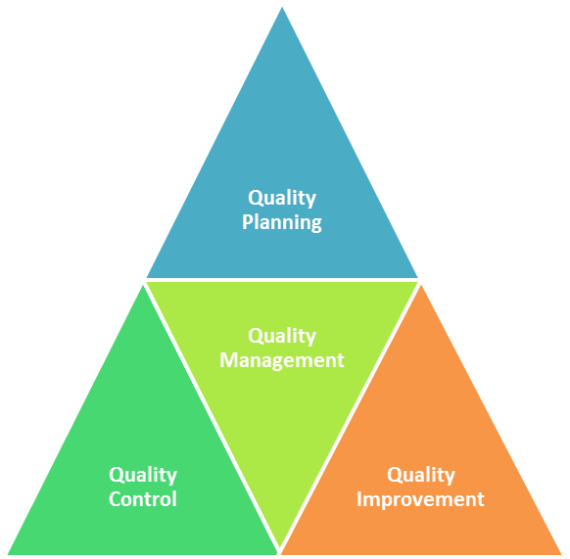

**Figure 1.** [The Ultimate Guide to Implementing a Quality Management System In Your Company.](https://www.sweetprocess.com/quality-management-system/" \o "The Ultimate Guide to Implementing a Quality Management System In Your  Company. - SweetProcess" \t "_blank)

Due to the rapid changes that have occurred in the international economy, planning to operate in foreign markets is far more difficult and complicated than in the past. Several factors are involved in this field, among which the following can be mentioned: the intensity of competition, rapid political and economic developments, increasing trade barriers and restrictions in different countries, more tendency towards support policies, rapid advances and innovations in technology and the extent of commercial advertising.

Without considering customers' perspectives, companies are unable to closely relate to the behavior of their critical customers and also remain oblivious to the many effects that are created on the organization's customers. Today, due to the large choice and also high connections, growth is only done by organizations whose target market strategy is well oriented towards small markets specifically derived from larger markets. Companies that initially enter the market without covering the needs of a specific segment and without considering the risk from different perspectives face the cost of marketing failure (Robert et al,2008).

Commercialization of technology has a defined process which is: transferring knowledge and technology from one person or group to another person or group in order to apply it in a system, process, product or a way of doing work (Martyniuk et al,2002). Meanwhile, technology marketing is a part of technology commercialization process. In this field, marketing managers have not been very active, but active companies in the field of producing high-tech products that have accepted marketing principles and based their plans and programs on the basis of mixed marketing elements have achieved positive results (Kathleen,2003).

High-tech products are advanced products whose production is based on scientific and engineering knowledge. Few conceptual and empirical studies have been done in the field of distinguishing high-tech products from ordinary products. Also, there have not been many studies in the field of identifying effective strategic alternatives for the marketing of technology-oriented products. Of course, the commercialization and sale of high-tech products requires marketing and branding. The financial success of such products is not achieved only through product innovation or the latest and greatest product features. Marketing skills play an increasingly important role in the acceptance and success of high-tech products. On the other hand, the speed and short life cycles of these products have led to unique challenges in the field of marketing and branding. Marketing in high-tech products faces its unique challenges due to the accelerated life cycle of these products and as a result of continuous improvements and R&D innovations.

Many high-tech products fail because the companies producing these products consider marketing unnecessary and the role of marketing in these companies is not properly understood. Marketing for high-tech products is complicated and difficult. Maybe mainly because the companies and institutions producing such products are not market oriented. What improves the success of high-tech products is not only technological superiority, but the combination of technological superiority and marketing competence that maximizes success. According to Porter (1980) and his discussion about emerging industries, it is logical to conclude that the marketing strategy for high-end technology should be different.

Especially Rosen and others (Rosen et al.,1998) argue that high-tech markets have certain characteristics that distinguish them from other sectors. The first thing to note is that there are few products that consist of only one technology, although there are exceptions. Products are usually a combination of advanced, established and old technologies that together create a powerful product.

Therefore, it is difficult to distinguish between high-tech products and low-tech products based only on the technology used in them. What is important is whether the products are considered high-level by customers and suppliers and the amount of high-level technology elements they contain will be the basis of focus for evaluation and thus customer behavior (Meldrum, 1995). One aspect of this focus for evaluation is the risk experienced by customers. All purchases involve risk to the customer in some way, but for high-tech products, the risk issue is exacerbated by the uncertainties that accompany a new technology.

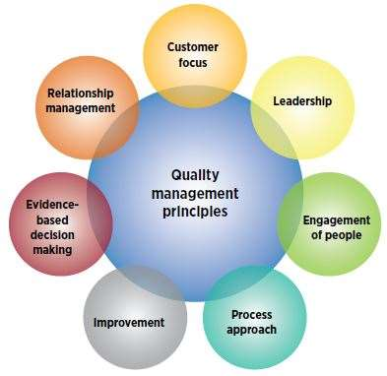

**Figure 2.** [What is a Quality Management System (QMS)?](https://asq.org/quality-resources/quality-management-system" \o "What is a Quality Management System (QMS)? | ASQ" \t "_blank)

Moriarty and Kosnik (1989) believe that this uncertainty can be only on the customer's side or for both the customer and the supplier. Suppliers will experience uncertainty and risk due to lack of expertise in selling, promoting or supporting these products. The nature of the risk depends on the type of technology, the degree of innovation used, and whether the customer is a final consumer or a channel intermediary. Customer risk stems from the lack of experience in applying, maintaining and using technology. Uncertainty is therefore a pervasive aspect of high-tech products.

The term high-tech also implies uncertainty on the leading edge or advanced developments. Although it is debatable whether being progressive and advanced satisfactorily defines high-level technology for marketing purposes, it can be said that being progressive and advanced also means being new to the market. The next implication of being progressive or advanced is that the provider organization has to employ a comparatively high percentage of highly skilled professionals in scientific and technical activities. In fact, in some instances, this issue is a key descriptor for identifying high-tech industries. In these industries, the intensity of research means that the cost of research as a percentage of sales is at least 3 times the average of all industries (Jelinek and Schoonhoven,1990).

Rapid product changes and obsolescence, short product life cycles, low entry barriers, and an ever-changing competitive environment are other operational characteristics of high-tech products in the market. For the purposes of marketing management, high-tech products require a more complex definition that goes beyond cutting-edge and includes products that:

* Developed in a highly technical environment.
* They include a new or advanced technology that serves as the basis of their evaluation.
* They are associated with a high degree of technological uncertainty on the part of the customer and the supplier.
* They are not currently accepted as natural solutions to the problems they were designed to solve.
* They do not yet have a coherent external framework.

This definition is in contrast with the approach adopted by some authors.

These authors limit their definition to descriptions such as complex products, usually with a high-level technical design, or products that are characterized by progressive development and usually have a short and transitory life cycle.

More comprehensive definitions have been provided by authors such as Shanklin and Ryans (Shanklin and Ryans,1987), although they considered only 3 criteria as key:

* A business that requires a strong scientific and technical basis.
* New technology can quickly make existing technology obsolete.
* Along with the emergence of new technologies, their applications create a market and demand.

What is suggested by the above definition is a reduced emphasis on the short-life and leading-edge aspects of high-tech products. Instead, more weight has been given to factors that affect the relationships between suppliers, products and markets, which are closer to the marketing issue. One of our main assumptions in this field is that high-tech products are not just new products. Capon and Glazer believe: the issues and problems that arise in technology management are different from those related to the process of introducing and developing a new product (Capon and Glazer,1987). Similarly, Yoon and Lilien found that completely new products based on technological advances and newly formulated products, which are most likely to be created by product line expansion or product modification, have different market characteristics and strategies (Yoon and Lilien,1985).

The results of their findings showed that the strategic differences between completely new products and products with new formulations are significant. For completely new products, variables related to market structure and potential are vital. While for products with new formulations, the variables related to the level of customer satisfaction with the current products and the suitability of the product type with the strategy are important and vital. For both completely new and newly formulated industrial products, the following three factors are essential for achieving long-term success (Yoon and Lilien,1985):

* The amount of experience in marketing activities.
* Effectiveness of marketing for new product supply.
* Product life cycle stage.

**Nanotechnology**

Nanotechnology or nanotechnology is a field of applied knowledge and technology that covers a wide range of subjects. Its main topic is the containment of matter or devices with dimensions less than one micrometer, usually around 1 to 100 nanometers. In fact, nanotechnology is the understanding and application of new properties of materials and systems in these dimensions that show new physical effects. Nanotechnology is a highly interdisciplinary knowledge and can be a continuation of the current knowledge in nano dimensions or a projection of the current knowledge on a newer and more modern basis.

Considering the initial achievements of technologies based on the knowledge of nanotechnology and its countless benefits in the medium and long term, many countries show a great desire to invest in this matter. The socio-economic perspective of nanotechnology has caused the rapid growth of government investment in research and development of this field. In fact, the amount of government investment in the research and development of nanotechnology is very wide compared to other technologies, and at the same time, the private sector's investment in this field is also increasing rapidly. In general, governments invest about three billion dollars annually on nanotechnology, and it is estimated that the costs of collaborative research and development are equal to these public funds, and therefore, on the whole, 5 to 6 billion dollars are spent on nanotechnology annually.

Based on the forecast of the future market size of nanotechnology, the return of investments in this field is estimated from 150 billion dollars in 2010 to 3100 billion dollars in 2015, which will lead to the creation of 2 million jobs worldwide (Rocco,2007). According to the report recently published by the Nanotechnology Development Headquarters, the United States has been recognized as the leading country in this field by publishing 11,627 nanotechnology articles until 2009. China and Japan with 8,807 and 5,437 articles are in second and third place after America. In the evolutionary course of nanotechnology in the country, the year 2012 can be considered as a turning point for the beginning of a series of infrastructural activities in the research of nanotechnology. This year, in addition to establishing the Nanotechnology Association of the country and holding a number of conferences and research workshops, some ministries expressed special attention to nanotechnology. In the meantime, the Ministry of Industries assigned a series of study projects related to industries to research centers by allocating the budget.

Another move made in the field of research dissemination in nanotechnology, which was led by the Ministry of Science, Research and Technology, is the assignment of some research priorities of the third development plan in 2018 to nanotechnology. In the same year, a special headquarters for the development of nanotechnology was formed for a period of 4 years, whose tasks include the approval of goals, strategies, macro policies and national programs for the development of nanotechnology in the country, the division of the general tasks of the devices and the determination of departmental missions and their coordination in the form of a long-term plan. National, it is an excellent supervision of the realization of goals and plans.

The headquarters' point of view for the development of nanotechnology is to compile the country's long-term activity framework in nanotechnology, and in this regard, a ten-year strategic plan for nanotechnology was prepared and approved at the headquarters. This document was presented to the government committee based on article 43, paragraph B of the fourth development program law, and was approved by this committee in August 2014 under the title of future strategy document. In this document, it is aimed to be among the top 15 countries in the world in the field of nanotechnology and to try to continuously improve this position in order to generate wealth and improve the quality of life of the people. According to the changes and experiences gained during the implementation of the document, it was decided to prepare and approve supplementary documents at specific time intervals. This issue is important because programs should be improved in different periods based on successes and failures and past experiences.

**History of marketing**

There are compiled documents that show the history of marketing up to four thousand years BC and indicate a series of buying and selling activities at that time. Trade between the Egyptians and the Phoenicians was widespread, and the retail and wholesale trades became fully popular during the period of authority of the Romans and Greeks. From 1200 to 1600 AD, European countries gained power and stable governments at that time provided incentives for trade and commerce, as a result of which trade developed and transactions were found. This development continued until our era and is still progressing (Arbabi,1990).

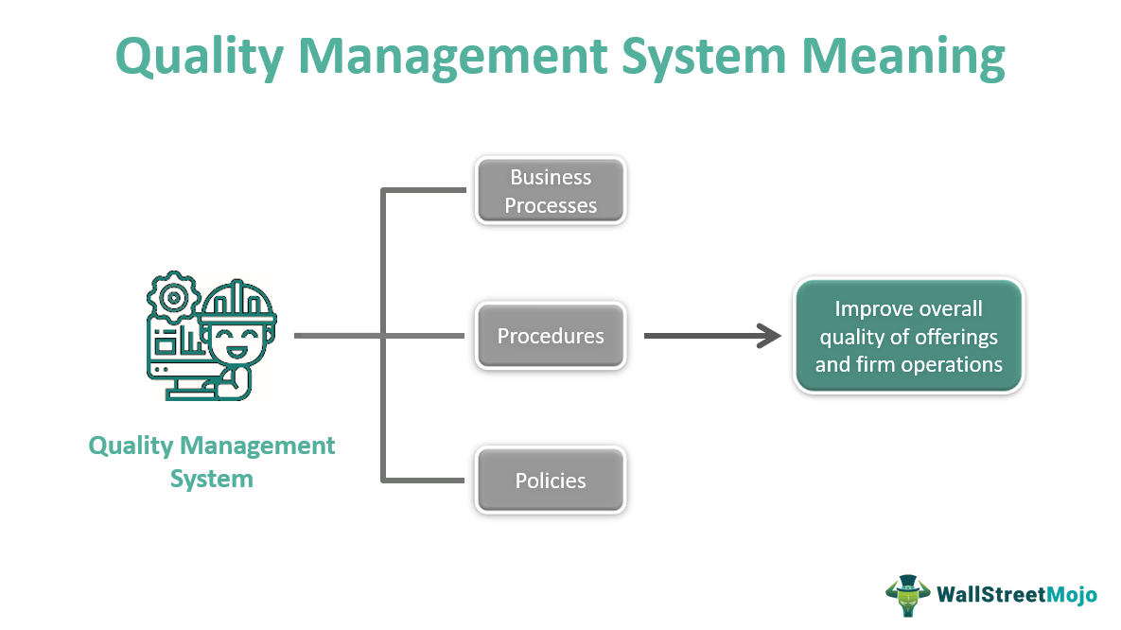

**Figure 3.** [Quality Management System (QMS)](https://www.wallstreetmojo.com/quality-management-system/" \o "Quality Management System (QMS) - What Is It, Types, Example" \t "_blank)

In recent decades, the concept of marketing has changed significantly. Marketing emerged with a focus on the product and building a better product, while the better concept was based on internal standards and values, the goal was profit, and the means to achieve the goal was to sell or persuade a potential customer to exchange their money for the company's product. The new marketing concept that emerged around 1960 shifted its focus from the product to the customer, but the goal was still profitability.

The means of achieving this goal expanded to include the marketing mix or 4Ps, which are known as product, price, promotion and incentive policies, and distribution channels. Then, in the 1990s, the concept of strategic marketing was realized. The strategic concept of marketing shifted its focus from the customer or the product to a wider context including the external environment (Zaribaf and Hosseini Kia,2012).

**Definition of marketing**

So far, many definitions of marketing have been provided. Marketing is defined in the Wikipedia encyclopedia as follows: Marketing is an effort to communicate the value of a product or service to a customer. Marketing is sometimes also known as the art of selling, but selling is one of the small functions of marketing.

The dictionary definition of marketing is: providing goods or services to meet consumer needs. In other words, marketing includes understanding the customer's demands and adapting the company's products or services to meet those needs and including the process of making a profit for the company. Successful marketing requires having the right product at the right time and place, and ensuring that the customer is aware of the product's existence, which in turn leads to future orders. Marketing is the process of balancing company capabilities with customer needs. In a simple definition, marketing is: providing customer satisfaction in a profitable way. Providing satisfaction and creating value for the customer is at the center of modern marketing thought and practice. Based on this, the dual goals of marketing are: attracting new customers by promising superior value and maintaining current customers by ensuring their satisfaction (Parsayian,2015).

According to the definition of the American Marketing Association in 2004, marketing is an organizational task and is a set of processes of creating, communicating and delivering value to customers in order to manage customer relationships in ways that benefit the organization and its stakeholders (Gundlach,2007). In his book "The End of Traditional Marketing", Sergio Ziman defines marketing as follows: Marketing is about having programs and promotions and advertising and a thousand other things that are effective in persuading people to buy a product. Marketing is about benefits and results. Marketing is a strategic activity and way and method focused on the outcome of actions related to attracting more consumers to buy your product more often so that your company earns more money (Sergio Ziman,2007).

In today's perspective, marketing means growing new customers, it means paying attention to their satisfaction and seeing quality from their perspective.

**Marketing mix decisions**

The marketing mix concept was introduced by Borden in 1964. He took his idea from Calliton, who defined the marketing manager as a decision maker and an artist combining factors, and explained the term marketing mix. He has stated that the combiner of factors is someone who continuously uses a mix of marketing practices and policies in his efforts to produce and create a profitable organization. Borden introduced a list of marketing mix elements and classified the marketing mix into the following 12 elements: product programs, pricing, brand, distribution channels, personal selling, advertising, promotion, packaging, product display, service, transportation, Analysis of actual findings (Borden,1964).

After the introduction of Borden, researchers have studied different classifications of the mixture. Albert Frey uses two dimensions for the mix: the offer package including the product, packaging and tools including advertising, personal selling. Keeley and Lezier suggest three classifications: product mix, communication mix and distribution mix, Darling and Lipson divide the mix variables into 4 classes: product mix, sales mix, communication mix and distribution mix (Reynolds & Lipson,1970). Bulte and Waters hoot (1992) define the mix as a combination of useful elements to respond to the market and mention product, price, distribution and communication as the variables of the mix (Waters hoot,1992). McCarthy divided marketing mix elements into four decision variables, which include product, price, product promotion, and distribution channels. His classification was welcomed by marketing managers and researchers, and currently evaluation managers use this classification in their activities (Ahmed & Rafig,1995).

The marketing mix is the variables that come under marketing control and are used to create an attractive position in the target market. In terms of product, it is anything that can be marketed to satisfy a need or desire. In deciding about the product, marketers need to examine aspects such as quality, packaging, features, label, brand name, accompanying services, return and delivery and product presentation (Islam,2015). Price is the amount of money paid for a good or service. In a more comprehensive definition, price is the amount of utility that consumers pay for the benefits of owning or using a good or service. Marketing mix pricing decisions include decisions on pricing methods, price adjustment policies and price changes (Cutler and Armstrong,2016). The product promotion side of the marketing mix is tools to communicate with customers. These tools consist of a combination of advertising, public relations and personal selling (Cutler Armstrong,2016).

Product distribution decisions are divided into two groups: decisions about distribution channels and decisions about physical distribution. The distribution channel is a set of interrelated institutions that deliver the company's product to the consumer and transfer the goods to the customers at the right time and place. The main components of the physical distribution of goods are: ordering goods, warehousing, maintaining inventory and transportation (Cutler and Armstrong,2016). Today's global business environment is characterized by increasing complexity, rapid changes and unexpected market developments. Selection and selection of target markets is the basis for positioning the company in order to provide and meet needs and achieve goals. In order to achieve this purpose, the appropriate marketing mix plays a vital role in realizing the company's marketing strategies. Among them, the most common definition of marketing mix in order to find a suitable position in the target market is: offering the right product at the right price and at the right time. In fact, the marketing mix determines the course of the organization's performance using a series of controllable variables in an environment that has many uncontrollable factors.

To put it better, marketing decision variables in the form of different marketing mix models provide a framework by which the company develops plans for its marketing activities. In this way, two types of applications are envisaged for the use of marketing mix, one is to decide how to supply new products to the market and the other is to measure and evaluate existing marketing strategies. In order to realize the aforementioned, each of the elements of the marketing mix, in addition to being compatible with each other, should also be in harmony with the diverse needs of the target markets selected by the company. Therefore, the marketing mix is defined as the result of management efforts and activities to creatively combine marketing-related activities, so that the main goal of the marketing manager is to have a mix in the market that best meets the needs of customers of a particular product. Satisfy by maximizing profitability. In the following, we will give a better explanation of its position in the market by reviewing the evolution of the concept of mixed marketing.

As mentioned, the concept of marketing mix was proposed for the first time by Neil Burden in 1949, but the most common variables in the formulation of marketing mix were proposed by McCarthy and known as 4p. Since McCarthy's time, the concept of marketing mix has not changed dramatically, and many texts still assume the 4Ps as the main and coordinating concept around which many other aspects of marketing are organized. However, despite its wide application, the conventional mixture has always been doubted in terms of its completeness and comprehensiveness and is faced with shortcomings, to the extent that some critics have gone as far as to deny it. In this regard and in order to compensate for the lack of comprehensiveness of the model, Borden, by adding another 8p to the model proposed by McCarthy, mentions twelve variables as effective variables in marketing decision making.

In the same way, Albert Fry (1961) divided marketing variables into two categories of proposal variables including product, service, packaging, brand and price and process variables including advertising, sales promotion, personal selling, public relations, distribution networks, market research, Development of new products. Bernard Baum and Mary Beaten (1981) also proposed a model including 7p. In their proposed model, in addition to price, product, distribution and promotion, things such as participation, physical evidence and process were also included. However, criticisms of the marketing mix can be divided into two categories.

One is the criticisms on the marketing mix concept and the content of the proposed mixed models, and the other is the criticisms related to their modeling methods. From the conceptual aspect, process reengineering theorists believe that the marketing mix, by guiding the company's activities and various departments to spend costs whose value creation is sometimes not easy to calculate, causes an increase in inefficiency or a decrease in the company's efficiency. Peter Doyle (2006) also claims that the marketing mix drives sometimes unprofitable decisions, because it does not consider financial goals, including increasing value for shareholders and stakeholders. From another point of view and contrary to McCarthy and Borden's point of view, some people believe that the mixed marketing models are largely oriented towards consumer markets and are not very suitable for industrial markets. Some others also state that different mixed marketing models pay a lot of attention to goods markets, they do not consider them suitable for use in service markets and criticize them for this reason. According to them, the 4p model is suitable for consumer products with not so much value. Therefore, the model should be adapted for industrial products, services or high-value consumer products. Other researchers have also proposed other models with a critical view as follows.

Ohma pays attention to the 4p model with a strategic management approach and concludes that no strategic component can be seen in the model. According to him, 3Cs (competitors, customers and the company) are suitable criteria for designing a marketing strategy. According to Bennett, the 4p model is focused on internal variables, so it is considered an insufficient basis for marketing. As a result, the model suggests 5Vs (value, acceptability, variety, volume and durability) as the components of customer interest. Waterborne also points out that the 4p model is very product-oriented and believes that the customer should be at the center of marketing plans. One of the important criticisms of the 4p model is raised by Granros.

In his opinion, by using this model, not only marketing management theories, but also customers are victims of the inherent limitations of the model. Godin also believes that the mixed marketing model is like an abandoned and old product in mass marketing and it cannot be used in line with the promotion of personalization and customization of products in modern marketing. Rafiq and Ahmed also introduced the 7p model as a marketing decision of service companies with the service domain.

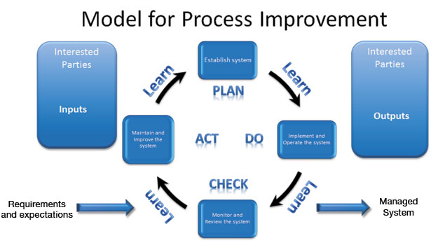

**Figure 4.**  [Improving Your Business with Management System Standards](https://www.qualitymag.com/articles/92035-improving-your-business-with-management-system-standards" \o "Improving Your Business with Management System Standards | 2014-08-04 |  Quality Magazine" \t "_blank)

**International marketing**

In today's advanced world, where the speed of changes doubles every day, intra-border performance in relation to business activities is not enough to remain competitive, but it is better to expand the scope of business performance beyond the borders of the country. Companies or organizations that are interested and prone to enter foreign markets should gain a proper understanding of the global trade system. Each country has its own characteristics that should be considered. The readiness of a country to accept different goods and services and the attractiveness of this country's market for foreign companies depends on several different factors. These factors include: economic, political-legal and cultural environment. Several factors may expand the scope of a company's activity to the international scene (Zikkelgi,2017).

The attack of foreign competitors on the domestic and local market of a company by offering better products or prices is one of these factors. The firm may launch a counterattack with the aim of engaging competitors' resources and facilities in their own markets, or the firm may conclude that operating in the foreign market is more profitable than the domestic market. The company's domestic market may be shrinking, or the company may consider entering new markets to produce more and take advantage of economies of scale. It may be that the purpose of the company to enter foreign markets is to break dependence on a market and get rid of the risks of such dependences. Another factor is that the company's customers are expanding globally, and this requires the company's service to be international. Mass production and excess inventory is another factor that forces companies to enter new markets for their products.

An important aspect of international marketing is the evaluation of market opportunities. If a company decides to develop foreign markets, it must regularly evaluate the possible markets in order to determine the country or group of countries that provide the most opportunities to the company (Cutler and Armstrong,2019). Evaluating international marketing opportunities usually begins with gathering relevant information for each country. Then the countries that are less favorable are eliminated. Table (1) provides a model for selecting countries. This model, which includes four elimination stages for selection, helps the company to focus on the countries with the greatest opportunity using published information.

**Table 1.** A model for examining and selecting foreign markets

|  |  |  |
| --- | --- | --- |
| The first stage | Macro variables | Economic indicators  Political environment  Social structure  Geographical features |
| The second stage | Introductory opportunities | Growth trend of similar products  Cultural acceptance  Market size  stage of economic development  Taxes and duties |
| The third stage | Micro research | Competitors  How to enter  The possibility of accepting the goods  Estimation of sales volume  Potential profit |
| The fourth stage | prioritize | Based on the goals and strategy of the organization and the resources of the organization |

The first stage of the process is the differentiation of favorable and unfavorable countries based on macroeconomic, social, geographical and political variables. In the second stage, the variables that confirm the potential size of the market or the acceptance conditions of the desired product or similar products are examined. In this step, sometimes similar or close variables are used. In the third stage, micro variables such as competitors, ease of entering the market and cost of entry are examined, sales volume and potential profit are calculated.

At this stage, the number of countries that can be examined is somewhat less than in the previous stages. Therefore, the collected information should be up-to-date and with more details. Reviews at this stage focus on ultimate profitability. The fourth stage includes the evaluation and prioritization of potential countries. At this stage, prioritization is done based on the goals, resources and strategy of the organization (Cutler and Armstrong,2019). From the point of view of Hanno Seristo and John Darlig, those who are successful in foreign markets are those who observe 10 key points in order to improve and implement their foreign marketing activities. These key points of success in foreign markets provide a systematic and paradigmatic framework to guide foreign trade and exporting companies (Darling & Seristo,2004).

* Analysis of market opportunities.
* Evaluation of product potential.
* Determining how to enter the market.
* Establishing the commitment of the company.
* Allocation of necessary resources.
* Determining technical issues.
* Development of strategic marketing plan.
* Organization of the operational team.
* Marketing strategy implementation.
* Evaluation and control.

Four basic factors are involved in making global investment decisions: market size and growth, political conditions, competition and market similarity (Cutler and Armstrong, 2000).

**Marketing activities to enter new markets**

Marketing activities for entering a new market include marketing research, product development or modification, distribution and sales promotion operations. Each of these activities is affected by the economic level of the activities and the minimum marketing effort. Before entering a new market, the company must make the necessary investment to know the consumers and obtain information about the market. Modifying and changing the product according to the tastes of the consumers also requires heavy investment. If the volume of sales is impressive, spending these costs will be economically justified for several countries. Therefore, if the market is similar in several countries, making a modification or change is justified in terms of cost. In the field of transportation, the amount of goods that can be exported determines the cost of transporting a unit of goods. Considering the fixed cost of containers, the activities of arranging insurance and bank documents for the export of small shipments are not economical.

Sales promotion activities such as advertising and advertisements, which are considered risky, are strongly influenced by the grouping of countries. For example, Swiss consumers can also receive TV or radio commercials broadcast in Germany. In other words, advertising has fixed overhead costs for entering a country, and if you decide to operate in a group of countries, these costs will increase. Similarly, the costs of sales staff and administrative staff are fixed for a certain volume of sales, and the company can reduce these costs by continuously increasing and doing business in several countries.

**How to enter foreign markets**

After a company has decided to sell in a foreign country, it is time to choose the best way to enter that country. Early decisions about how to enter a market are considered strategic decisions. These decisions are made considering the atmosphere of the country, the capabilities of the organization and the competitive position of the industry. How to enter is done not only by considering the legal borders of the country, but also by understanding the weaknesses and strengths of the company and recognizing its capabilities. Each of the entry methods has its own characteristics, therefore, according to the above two general factors, a method is chosen that can strengthen the company's competitive success. The adopted method can be considered as a sustainable competitive advantage. Each new policy requires more commitment and risk, but also has more control and potential profitability (Dubey,2002).

**International marketing program**

Some companies in the global market use a combination of standard marketing elements and minimize their costs. Because there are no major changes in the elements of marketing elements, but in the method of combining marketing elements adjusted, a producer changes the elements of the composition of marketing elements according to the characteristics of each of their target markets. Of course, in this method, the manufacturer bears more costs, but hopes to achieve more market share and market numbers (Dubey,2002). In short, the main question in marketing is whether different product, price, promotion and distribution elements should be standardized or adapted to local market conditions (Balabanis et al.,2004). Companies manage their international marketing activities in three different ways. Most companies organize an export circle first. In the next stage, they create an international department and finally turn this department into an international organization (Dubey,2002).

**Marketing high-tech products**

**A) Definition of products with high-level technology:** Despite the wide use of the term high-level technology, there is no generalizable definition of high-level technology in the technical and management literature. In particular, there is no good definition that guides the marketing strategy of high-tech products. Rexard defines high-end technology as: the part of technology that is closer to the edge or the latest developments in a field. This is how this technology naturally emerges from the laboratory to practical application (Rexroad,1983). Similarly, Gruenwald and Vernon define high-tech products and services as follows: those devices, procedures, processes, techniques, or sciences that are characterized by the development of the latest advances and usually have a short lifespan (Gruenwald and Vernon,1988).

From another perspective, Moriarty and Kosnik suggest that: high-level technology marketing involves high levels of market and technological uncertainty (Moriarty and Kosnik,1989). Samili and Wills suggest that high-level technology is a group of industries that extend beyond electronic computers such as diverse research industries such as nanotechnology, biotechnology, pharmaceutical, chemical, and space (Samili and Wills,1986). In a similar way, Riggs focuses on the unique characteristics of high-tech firms and suggests that these firms: have short life cycles:

* They are full of engineers.
* One of their characteristics is being risky.
* Compared to low-tech companies, they face rapid growth or rapid decline (Riggs,1983).

All the previously presented definitions are limited in scope and cannot be generalized and provide general guidance for the study and design of marketing strategy, but Gardner's definition originates from the interaction of technology with the perception of innovations from the customer's perspective: products that are the result of disruptive technology.

They require fundamental changes in the behavior of at least one member of the product usage channel (Gardner,1990). According to the above definition, it can be said that products with traditional or low-level technology are those that use familiar and accepted technology and their acceptance and use is generally understood. While high-tech products are the ones that use turbulent technology in their use, production and distribution and require many changes in consumption patterns.

These are products in which one or more substitutions of the underlying technology have occurred during the lifetime of the demand life cycle. However, it should be remembered that the distinction between high and low technology products is not of type, but of degree, that is, there is a spectrum of technology and some products are at the high level and some are at the low level of the spectrum. Gardner provides a 3x3 matrix as a basis for defining high-tech products as well as a guide for marketing strategy. As shown in

Table (2), the products located in the 9th house are the most high-tech products, and the products located in the 6th and 8th houses are considered less high-level. The products of the 7th house may be considered high-tech, but the products in the 3rd house have only a part of the characteristics of the high-tech products (Gardner, 1990).

**Table 2.** Product level segmentation based on technology, user and its examples

|  |  |  |
| --- | --- | --- |
| (3)  The main evolution in the software | (2)  Frozen pizza | (1)  New style food |
| (6)  Internet connection | (5)  Fax, desktop printing | (4)  Upgraded subsidy software |
| (9)  Paperless banking | (8)  High-definition televisions (HD) | (7)  Genetically engineered corn seeds. |

Products placed in the 1st, 2nd, 4th and 5th houses are classified as traditional marketing.

**Distinctive features of high-tech products**

According to Porter's opinion (Porter,1980) and his discussion about emerging industries, it can be logically concluded that the marketing strategy for high-level technology should be different. Especially Rosen and others (Rosen et al.,1998) argue that high-tech markets have certain characteristics that distinguish them from other sectors. The first thing to note is that there are few products that consist of only one technology, although there are exceptions. Products are usually a combination of advanced, established and old technologies that together create a strong product. Therefore, it is difficult to distinguish between high-tech products and low-tech products based only on the technology used in them. What is important is whether the products are perceived by customers and suppliers as high level or not. And the amount of high-level technology elements they contain will be the basis of focus for evaluation and therefore customer behavior?

One aspect of this focus for evaluation is the risk experienced by customers. All purchases involve risk to the customer in some way, but for high-tech products, the risk issue is exacerbated by the uncertainties that accompany a new technology. Moriarty and Kesnik (1989) believe that this uncertainty can be only on the customer's side or for both the customer and the supplier. Suppliers will experience uncertainty and risk due to lack of expertise in selling, promoting or supporting these products. The nature of the risk depends on the type of technology, the degree of innovation used and whether the customer is the final consumer or a channel intermediary.

Customer risk stems from the lack of experience in applying, maintaining and using technology. Uncertainty is therefore a pervasive aspect of high-tech products. The term high-tech also implies uncertainty on the leading edge or advanced developments. Although it is debatable whether being progressive and advanced satisfactorily defines high-level technology for marketing purposes, it can be said that being progressive and advanced also means being new to the market.

The next implication of being advanced or advanced is that the provider organization has to employ a comparatively high percentage of highly skilled professionals in scientific and technical activities. In fact, in some instances, this issue is a key descriptor for identifying high-tech industries. In these industries, research intensity means research cost as a percentage of sales is at least 3 times the average of all industries (Jelinek and Schoonhoven,1990). Rapid product changes and obsolescence, short product life cycles, low barriers to entry, and an ever-changing competitive environment are other operational characteristics of high-tech products in the market. For marketing management purposes, high-tech products require a more complex definition that goes beyond cutting-edge and includes products that:

* Developed in a highly technical environment.
* They contain a new or advanced technology that serves as the basis of their evaluation.
* They are associated with a high degree of technological uncertainty on the part of the customer and the supplier.
* They are not currently accepted as natural solutions to the problems they were designed to solve.
* They do not yet have a coherent external framework.

This definition is in contrast with the approach adopted by some authors. These authors limit their definition to descriptions such as complex products, usually with a high-level technical design, or products characterized by progressive development, which usually have a short and transient life cycle. More comprehensive definitions have been provided by authors such as Shanklin and Ryans. Of course, they have considered only 3 criteria as key:

* A business that requires a strong scientific-technical basis.
* New technology can quickly make current technology obsolete.
* Simultaneously with the emergence of new technologies, their applications create a market and demand.

What is suggested by the above definition is a reduced emphasis on the short-life aspects and the leading edge of high-tech products. Instead, more weight has been given to factors that affect the relationships between suppliers, products and markets, which are closer to the marketing issue. One of our main assumptions in this field is that high-tech products are not just new products. Capon and Glazer believe that the issues and problems that arise in technology management are different from those related to the process of introducing and developing a new product (Capon and Glazer,1987). Similarly, Yoon and Leylin found that completely new products based on technological advances and products with new formulations, which are most likely created by product line expansion or product modification, have different market characteristics and strategies (Yoon and Lilien,1985). The results of their findings showed:

* The strategic differences between completely new products and products with new formulations are significant.
* For completely new products, variables related to market structure and potential are essential. While for products with new formulations, the variables related to the level of customer satisfaction with the current products and the suitability of the product type with the strategy are important and vital.
* For both types of completely new products with new industrial formulations, the following three factors are essential in achieving long-term success.
* The amount of experience in marketing activities.
* Marketing effectiveness for new product launch.
* Product life cycle stage.

In a study on high-tech companies, Bahrami and Evans observed that the processes of strategy formulation and its implementation are strongly intertwined and combined in a repetitive process (Bahrami and Evans,1989). This close relationship between the planning and implementation processes is in clear contrast with the traditional strategic planning literature. In addition, Maidique and Hayes provided a wider range of guidelines for high-level technology management that differed from conventional knowledge (Maidique and Hayes,1984). Firth and Narayana profiled the new product strategies of major Fortune companies. Finally, Cooper and Kleinschmidt conducted a retrospective analysis on about 200 new product projects with medium to high technology (Cooper and Kleinschmidt,1990).

As listed below, these researchers identified eight key factors for the success of technology-oriented projects. It is surprising that according to these findings, senior management support and competitive position have little effect on success.

* A superior product that offers unique benefits to the consumer.
* Having a clear definition of the project and product before the development phase.
* Technological synergy.
* The quality of implementation of pre-development activities.
* Marketing synergy.
* Quality of implementation of marketing activities.
* attractiveness of the market

Therefore, we assume that the marketing strategies of high-level products are different from low-level products. High-level and low-level technology products differ not only in terms of the levels of technology received by buyers, but also in terms of industry and market characteristics. For marketing professionals working in a high-tech environment, one of the critical dimensions is whether the technology embedded in the products of these types of organizations creates unique marketing requirements, or whether this nature will have little effect on marketing management. Two authors who have worked extensively in this field are: William David (1988) and Regis McKenna (1985). David's main role has been that he has successfully demonstrated the need to apply marketing principles beyond a concept in the management of high-tech products. Although he clearly shows how marketing is used in this field, the limitation of his work is that he does not add anything more than the structures found in most standard marketing texts, but on the other hand, McKenna focuses on strategies and the necessary communication tactics for these types of products are focused. He presents convincing models and suggestions, but with this focus, he limits himself to some extent.

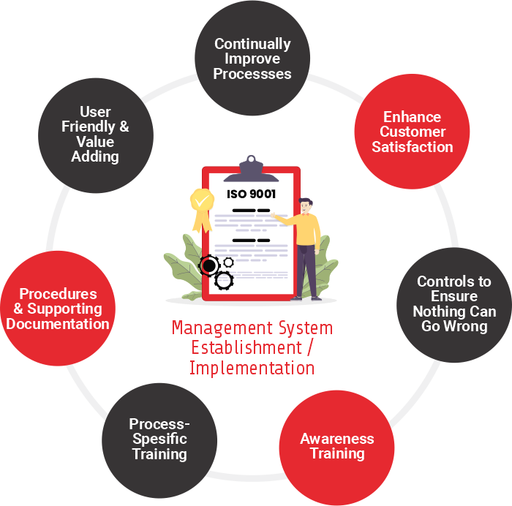

**Figure 5.** [Establishing A Management System Procedure, Implementation of Management Systems](https://9001consult.co.za/management-system-establishment/" \o "Establishing A Management System Procedure | Implementation of Management  Systems | 9001 Consult" \t "_blank)

**Contingent approach to marketing products with high level technology**

Contingency theory states that there is no set of global strategies that are optimal for all businesses or organizations, and as a result, different environmental conditions and contexts require the design of different strategies. Compared to case analysis, this theoretical framework produces results that can be generalized to a wider range of situations (Bahrami and Evans,1989).

Contingency framework has been widely accepted and used in many empirical studies in the field of strategic management and marketing strategy. This approach states that if products based on high-level technology and low-level are really different from each other, these differences are derived from industry and market characteristics. In addition, this framework suggests that in such a situation for survival and growth in the market, different marketing strategies for products with high level technology should be designed and used. Based on the contingency framework, Gardner and others tried to establish the relationship between technology factors and industry environment factors, consumer evaluations, marketing strategies and product success (Gardner et al.,2000). The first step in the contingency approach is to develop a suitable category for the products. Products with different technology are affected by environmental conditions and as a result, they should be marketed differently. Product technology is a two-dimensional concept that includes the number of changes required for the manufacturer to manufacture and sell the product and the number of changes required by the customer to buy, install and use the product. Research shows that the changes required by the consumer increase in proportion to the technological level of the product (Ellen et al.,1991, Higgins and Shanklin,1992, Schein,1985).

As mentioned earlier, Cooper and Kleinschmidt stated that high-tech products must offer unique advantages to the consumer in order to succeed in the market (Cooper and Kleinschmidt,1990).

In addition, Rossiter and Percy state that the higher the level of technology, the higher the level of consumer involvement with the product (Rossiter and Percy, 1997). This article is consistent with the previous literature which stated that the level of perceived risk increases with the level of product technology. In this context, Gardner and others state that the purchase of a high-tech product is usually done in a high-conflict situation, which usually requires searching for a wider range of information and a careful evaluation of the product case by case (Gardner et al.,2000).

**Marketing issues of products with high level technology**

Marketing management of products that have these features requires special attention to some issues. Such issues are observed in industries where there are products with high level technology. In this section, these issues are presented as a framework of emerging topics for creating high-level technology marketing paradigms. First, by discovering the internal issues and problems of the organization that are extracted from the highly technical organizational environment, and then the external issues and problems that originate from the key features of other products with high-level technology. These subjects are shown in the form of titles in table 3 (Meldrum,1995). Although these cases are not unique and separate, they provide a structure for a systematic study of the subject.

**Table 3.** Emerging topics in the marketing of products with high level technology

|  |  |
| --- | --- |
| Internal issues | Foreign issues |
| Technology deception  Life cycle of technology | Validity  Technology  Supplier  The standards  Product  Organization  Technology positioning  Infrastructures  Technology  Market |

**Internal issues**

**1- Technological deception:** One of the first issues and problems that a marketing manager faces in an environment with high-level technology is that the organization's technology can produce a product that is suitable for the target market. The vital point in this is proper management of marketing and technology interface. Unfortunately, it is very difficult to establish this relationship in general. The desire for technologists in organizations with high-level technology along with the natural tendency to continuously improve technology performance reinforces this issue. Similarly, low R&D budgets are often faced with requests for funds based on performance improvement instead of testing market potential. As can be expected, a work environment full of technical experts and technicians creates a high potential for technological deception. Deception in this form includes the promotion of technology within the organization without considering the realities of the target market and audience. Successful developments are achieved when marketing managers recognize the deception of technology and can highlight marketing concerns in such a way that decisions are consistent with real market opportunities while paying attention to technological capabilities.

**2- Technology life cycle:** In addition to developing products that have immediate sales potential, marketing managers must also have a plan for future products. In addition to the usual approaches and concepts such as market segmentation, analysis of strengths, weaknesses and opportunities, threats and portfolio modeling, the idea of the technology life cycle is also a useful aid to the decision-making process. Although this topic has been raised as a general concept for a long time, it is still often confused with the product life cycle.

However, the S-curve concept of technology proposed by Foster (Foster,1991) can bring important points for the marketing of products with high-level technology and improve internal marketing. Foster (Foster,1991) claims that this relationship is valid for all technologies and refers to many examples to show the strength of his claim. The applicability of this idea as a forecasting tool is questioned (Lee and Nakicenovic,1988). However, others have shown that this idea is strongly related to hindsight (Becker and Speltz, 1983). This relationship shows that in the early stages of technology development, relatively much effort is needed to obtain small improvements in performance. With a better understanding of technology and its wider use in products, improvement in performance can be achieved with less effort, and at this point the opposite of this case happens. Little effort and investment bring significant improvements in performance.

However, every technology has limitations. As soon as a technology faces limitations, it becomes increasingly difficult to achieve performance improvement. Here it is said that the technology has reached the maturity stage of the technological life cycle, although this is not necessarily true of the market life cycle. By adopting such an approach to the development of technologies, it becomes possible to interpret that high-level technology markets experience a short product life cycle. Other things that are taken from the technology S curve concept are related to the product development situations that the organization faces at different points of this curve. High-tech products based on emerging technologies are likely to experience limited marketing opportunities, as extensive investment in development will not result in significant performance improvements.

Therefore, marketing managers should avoid planning for major developments as a source of competitive advantage unless they have significant investment resources available to help accelerate the development process. However, even with such resources, they may face the limitation of human resources or facilities needed for this purpose. In addition, since the creation of each opportunity requires a significant investment in product development, the range of possible applications may be limited. As technology passes through different points of the curve, it is necessary for marketing managers to separately investigate any new and different technological issues that affect the pursuit of marketing goals in order to maintain the high-level technology position of the organization. One of them is to ensure the acceptance of different development scenarios by technologists. Other issues include:

* Judging the attractiveness of technology to competitors becomes relatively easy when performance improvements are achieved.
* Maintaining sufficient flexibility in technology for future product development.
* Identification of performance variables for prioritization for development.

Due to the fact that work capacity, meetings and management systems are often aimed at improving the effectiveness of technical and marketing interfaces, experience and observations show, the ability to interpret technology development in terms of marketing needs can significantly improve these interactions. Especially in a highly technical environment.

**Foreign issues**

It is very important to ensure that the way the product is marketed supports other high-tech features. The points that can be considered in this regard are:

* Create credit.
* Standards that play an important supporting role in creating credibility.
* Creating a suitable position in the market.
* Dealing with the lack of infrastructure.

**1- Credibility:** In situations where the product is perceived as a high-tech product and subsequently a solution has not yet been accepted and is associated with a high level of uncertainty, a higher degree of customer trust is needed than in other cases. be created an important component for building trust is credibility. Validity has two aspects:

* Validity of technology.
* Credit of the supplier organization.

In order to create credibility for a technology, it is necessary to create the idea in the customer's mind that the product will work properly until its performance commitment. This may be combined with the uncertainty experienced by the supplier himself. It seems that technological uncertainty is managed in the best way when the supplier organization itself clearly states its concerns in such a way that the customer's imagination is left at least as much as possible. When this content is supported by strong guarantees, product acceptance seems more likely.

In addition, if organizations can obtain third-party approval for their technology, whether by giving the product to leading consumers or even by giving points to competitors, product acceptance will advance. The credibility of the organization generally depends on its size or reputation. As Macdonald points out, many high-tech products are produced by small organizations or smaller divisions of larger organizations that often struggle with the complex procurement practices employed by larger purchasing organizations.

They become a problem. Also, the possibility that such companies have a history or a name to base their credit on is low. On the other hand, larger organizations with a long history build their business and reputation on one or a number of products and market areas, that is, offering a high-tech product in a new area can also cause problems. Many defense organizations are trying to use some of their newer technologies as a basis for products in other markets. The mechanisms of achieving organizational credit are different and depend on the nature of the market. This may require the approval of a leading consumer in a market. In another case, the key to success in excellent relations with the media may be placing a very strong CEO or creating a joint investment with a long-standing supplier. Whatever the circumstances, credit can be a potential challenge for high-tech products that need to be considered from a marketing perspective.

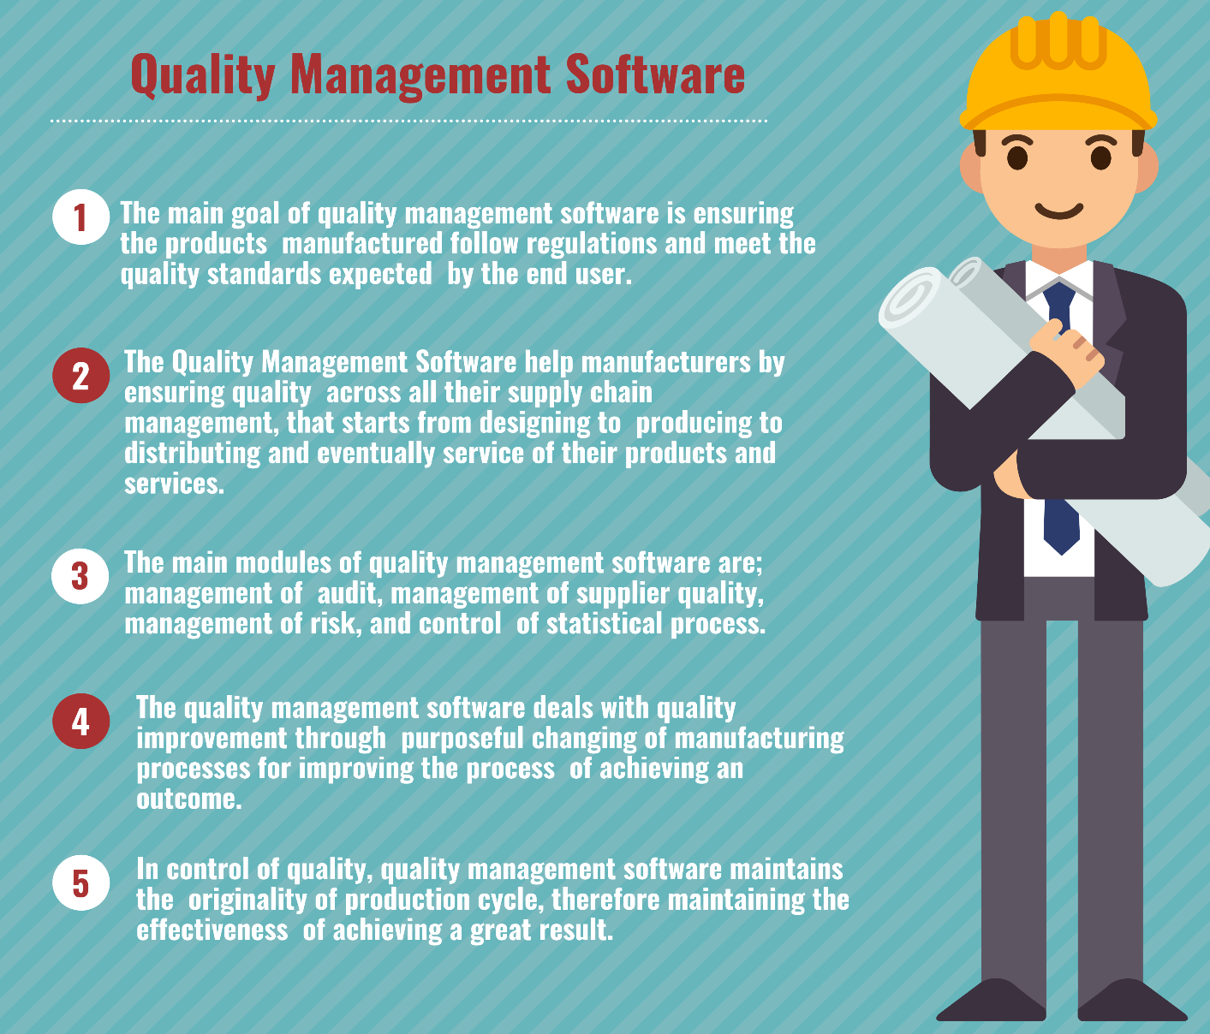

**Figure 6.** [How to Select the Best Quality Management Software in 2022](https://www.predictiveanalyticstoday.com/quality-management-software/" \o "How to Select the Best Quality Management Software in 2022 - Reviews,  Features, Pricing, Comparison - PAT RESEARCH: B2B Reviews, Buying Guides &  Best Practices" \t "_blank)

**2- Standards:** For businesses with high-level technology, product standards, if any, can help create credibility and reduce uncertainty and risk by providing a standard for judging the product. This applies especially to smaller businesses. Also, the lack of standards can affect marketing in two ways, one by providing a chance to become an actual standard and the other by threatening to be marginalized by the creation of a future standard based on an alternative interpretation of a technology. The fact that the number of published standards almost doubled between the years of the 90s (McGurty,1992), shows the important and growing influence of standards. In the marketing of high-tech products, the main problem with standards is that organizations have a tactical approach to them instead of a strategic approach. Another problem, especially for small businesses, is that large organizations or those with power in the industry can usually have a significant influence on setting standards.

**3- Technology positioning:** positioning is important for all types of products and it refers to the way customers of a market perceive an offer, especially in relation to other alternatives (Ries and Trout,1986). Also, in high technology markets, positioning propositions should be limited to a small number of aspects (Thayer,1981). Similarly, it has been discussed that increasing the chance of success of a new product requires providing a significant and unique advantage. According to what Ansoff and Stewart suggest (Ansoff and Stewart,1967), successful positions for high-tech products include:

* Technology leader or the first in the market.
* Second in the market, but following the top leader.
* The first in fulfilling a special need or leadership in a corner of the market.

The advantages that can lead to leadership in high-tech contexts are:

* Improving some quality aspects such as safety, accuracy or compatibility.
* Reducing the cost by increasing the speed, capacity or use of materials.

As a result, positioning products with high-level technology is not a simple activity according to the variables that must be considered. In general, it seems that the successful positions are those that make the purchase risk acceptable to the customer.

**4- Infrastructures:** The nature of high-level technology requires that there be external infrastructures needed to facilitate the commercialization of high-level technology products. Although infrastructure is a concern for all types of product-based marketing, it seems that this factor is especially important for high-tech products. The reason for this is that products with high-level technology usually require both market infrastructure and technology infrastructure to be successful. Technological infrastructure can include production technologies such as equipment and machinery or design capabilities that enable efficient manufacturing and production of the product. Also, these infrastructures can include other products that enhance the potential benefits of a product with high-level technology. These products reduce the risk and increase the potential of products with high level technology to become an accepted solution. Market infrastructures are those that enable efficient promotion, support, distribution and sale of a high-tech product. Undoubtedly, there are influencers on the market such as journalists, financial analysts, consultants and industry bodies, but in order for them to become effective advertising partners of the company, it is necessary to educate them about the new product. Similarly, middlemen, distributors, and advanced consumers may be familiar with existing technologies, but may not yet be able to sell or support newer product generations. The issues and problems raised are more or less common among all organizations and have been confirmed by many authors in different ways. By accepting the fact that the marketing of products with high-level technology presents a unique combination of conditions and the marketing managers of such products need frameworks, concepts and approaches that will help them in structuring information and simplifying decisions. A good understanding of the basic characteristics of the situation they are facing will be very important. There are many other issues in the field of marketing mix that it is necessary for high-level technology marketing managers to pay special attention to. For example, deciding on product range, packaging, quality, promotional and communication issues, market entry routes, customer service, price and marketing budgets cannot be kept out of sight.

**Marketing of innovations in high technology companies**

In a growing knowledge-oriented society, products and services are provided that are more focused on research and development. Markets based on technology seem necessary for economic progress. The use of new technology has led to increased profitability since the beginning of the industrial revolution. To compete in high-tech markets, manufacturers must invest in research and development and innovation. A company with high-level technology that cannot rely on internal resources for competition can use the establishment of communication and partnership strategies to expand the bases of research and development.

A network view of markets can show the value of networks in the development of technology. Investment is made on creating networks to increase competitive power and search for new knowledge. Communication between research centers and companies are an example of networks, in this way, companies can improve their innovation by using the benefit of foreign research. Increasing research and development cooperation and the circulation of information and knowledge is very important for the competition of concentrated research-oriented industries.

There is little agreement on marketing considerations for high-tech products and services. Although innovation is completely different from marketing, it is necessary to have marketing approaches in technological markets. At the same time, some of the basic principles of marketing are also applicable for innovation (John et al.,1999). The argument raised here is that the marketing of a technological product can benefit from a network perspective that covers some of the shortcomings of traditional marketing perspectives. Networks are a society of consumers or producers who cooperate with each other around a set of complementary knowledge (Farrell and Saloner,1985). Five groups participate in a network:

* Leading multinational company.
* The main suppliers.
* Main customers.
* Selected competitors.
* Non-commercial centers.

In marketing for research-oriented products and services, the relationships involved in it can be considered very important for the company. Organizations can use networks to exchange important information with their customers and develop their new products and services in close cooperation with them. A network approach can include different aspects of marketing. Market segmentation, targeting and positioning are concepts that are used in most of the academic texts of strategic marketing (Anderson and Vincze,2004, Cravens and Piercy,2003, Jain, 2000).

**1- Market segmentation:** Market segmentation is the most important factor in moving away from uniform marketing. A network approach to marketing specifies that relationships are established between buyers and sellers, and the company can gain more information about the needs of its customers through these relationships. Setting up networks provide the possibility of being able to reach all the members of that market segment with the same communication activities.

The strength of the network point of view in marketing is that the relationship established with the customers allows the flow of information between the buyer and the seller. The essential point in the market segmentation process is to communicate with customers and obtain as much information as possible about them (Novak and MacEvoy,1990).

**2- Targeting:** Targeted marketing increases the accuracy of marketing. Databases enable selective targeting of a market and allow marketers to narrow their target markets more precisely. Creating closer relationships with customers facilitates mass customization and micro marketing and offers new opportunities. Targeting also means choosing the companies you want to do business with. Creating marketing networks can help a company in its targeting efforts.

**3- Positioning:** In a network approach to high-level technology positioning, companies cannot be separated from their relationships with customers. The best position in the market is obtained through strong relationships with customers. Positioning is not what you do to the product, but what the product creates in the minds of potential customers (Trout and Ries, 1995). Different customers have different needs and interpret the benefits of an innovation in different ways. Networks that allow customers to exchange information about their future needs can greatly help in finding a favorable position in the market. A network consisting of several smaller companies with high technology can provide each of them with the possibility of benefiting from an innovative team without the need to invest in the development of the entire technology. Bridges and others (Bridges et al.,1995) state that price and technology should meet customer expectations, but should not exceed it. Of course, this does not mean that managers take the middle ground, but it means that continuous improvement should exist in such a way that product development efforts guide customer expectations. They presented a model for the market share of products with high-level technology, which is based on the relative price of the product, relative technology, history of market share of the brand name, and the effect of expectations from technology and price.

**Sales models of products with high level technology**

The models published in this field are often used to predict the sales of durable products with high level technology. From this, we can mention the following: Bass model (1969) for durable consumer products, Kalish's theory (1985) to investigate the effect of price, advertising and customer uncertainty on sales, Kalish and Leylin's model (Kalish and Lilien,1986) for the sale of durable products with high-level technology, which has considered the role of advertising and the perception of product receivers in different periods of product quality. Also, Mahajan and others (Mahajan et al.,1990) have done a comprehensive review of sales models. Norton and Bass (1987) observed that successful sales of new generation high-tech products follow a pattern spread over time. These models are summarized in table (4).

**Table 4.** Sales models of products with high level technology

|  |  |  |
| --- | --- | --- |
| Provider(s) | year of presentation | The topic under consideration |
| bass | 1969 | Selling durable consumer products |
| Kalish | 1985 | Investigating the effect of price, advertising and customer uncertainty on sales |
| Kalish and Leylin | 1986 | Selling durable products with high level technology |
| Mahajan and others | 1990 | A review of sales model’s literature |
| Norton and Bass | 1987 | Time pattern of selling products with high level technology |

**Challenges facing the strategic management of high-level technology marketing**

The main challenge of high-level technology marketing management stems from this, that in this area, it is necessary to work with the research and development department in a completely joint and coordinated manner. Table (5) mentions some cultural differences between marketing specialists and research and development specialists, which are potential sources of obstacles for the coordination of these two units (Griffin and Hauser,1996).

**Table 5.** Some cultural differences between marketing specialists and research and development specialists

|  |  |  |
| --- | --- | --- |
| dimension | Marketing specialists | Research and development specialists |
| education | Management, business | Engineering, basic sciences |
| Education | Solving the general problem | Hypothesis testing |
| Time approach | short term | long time |
| Professional orientation | Market and profit | Science and progress |
| technical language | Position and advantages of the product | Features and performance of the product |

A common problem in this field is the dominance of technology in the innovation process. As a result, the translation of high-level technology into marketable products may not be fully realized (Botindo and Frohman,1981). Therefore, we need to establish a balance between technology pressure and market tension in the field of innovation planning. This is only possible through integrated marketing and remote management of research and development, which imposes a major challenge for the former department due to the industrial structure and complexities of high-tech markets (Birkenstein and Bloch,1994, Johne and Rowntree, 1991, Livesay et al.,1989). Technological and strategic uncertainty makes the problem more complicated (Meldrum and Millman,1991). The industry does not have clear rules of the game and the possibility of exploiting economies of scale, and as a result, the barriers to entering the industry are low.

New companies and suppliers are constantly trying to take advantage of any untapped market potential. This issue has led to competitive dynamics in this field. On the one hand, high-tech markets are characterized by continuously shortening market and product life cycles. On the other hand, the increasing technological uncertainty and the importance of systems technology break the product development cycles associated with traditional technology. Ultimately, technological uncertainty creates an unstable demand pattern with customers unsure of their true preferences and the benefits they receive from products.

The problem stems from a concept described as technological turbulence. As a result, market resistance and purchase barriers are really problematic for marketing management. Short product cycles where product offerings quickly become obsolete encourage a thoughtful customer mindset, where improved generations of products are constantly expected. This behavior is compounded by expectations of price reductions in high-tech markets. Therefore, the main challenge we are facing is that the concepts of classic customer marketing cannot be applied without criticism and without question to the marketing of high-tech products.

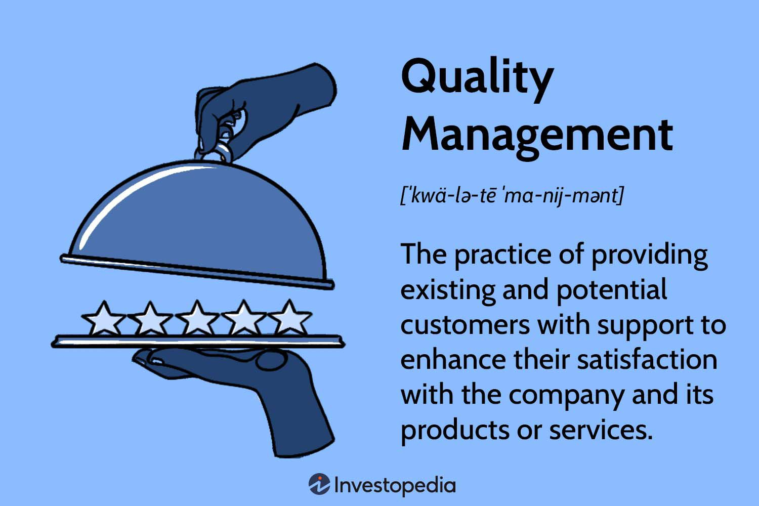

**Figure 7.** [Quality Management: Definition Plus Example](https://www.investopedia.com/terms/q/quality-management.asp" \o "Quality Management: Definition Plus Example" \t "_blank)

Especially the concepts of strategic decision-making need to be formulated based on the specific characteristics of markets with high-level technology. Fundamental technological decisions as an orientation framework for marketing products with high-level technology, complex technical dynamics and complex effects on industrial structure and development, have certain implications for the competitiveness and positioning of a high-level technology producer.

Along with technology as a fundamental success factor, a coherent and appropriate technological strategy is very vital. In this field, the basic issue is the formulation of the relationship between technological priorities and external and internal time horizons (Porter,1980). Thus, technological strategy provides a framework for high-level technology marketing. The planning process requires an accurate forecast of technological development and its effects on competitive advantage and accessible market position.

**Marketing strategy of products with high level technology**

Marketers should use push marketing strategies with emphasis on personal selling for products with high level technology, while for products with low level technology, pull marketing strategies with emphasis on advertising and sales promotion are more effective. Especially personal selling can be an effective marketing tool for products with high level technology. As Porter points out, emerging industries often lack the existing infrastructure and channels they need (Porter,1980). Another important issue is pricing decisions for high-tech products. Relying only on production costs can be risky, because the product may be priced below or above the price. Gruenwald and Vernon suggest that pricing based on consumer perception and value pricing are more appropriate options than cost-based pricing (Gruenwald and Vernon,1988).

Gardner and others (Gardner et al.,2000) also state that capital intensive pricing strategies are more suitable for high technology products. Deciding on what topics to focus on in technology is both directly and indirectly related to these three elements:

* Market selection.
* Time to enter the market.
* Participation strategies.

**Chapter II**

*Target market selection strategies in high level technology marketing*

Market segmentation and target market determination are the main elements of high-level technology strategic marketing. The special importance of this decision is due to the fact that it has an indirect effect on growth potential, expected intensity of competition, market security and return rate. However, market selection decisions are made in conditions of high uncertainty. High-end technology markets are generally young and nascent or in the early stages of growth. In these stages, the market potential can only be identified to a small extent.

It is also unclear when and under what conditions the market volume will increase significantly. Since several related markets are growing simultaneously, market boundaries are hard to discern. In such conditions, the classic tools of market restriction are not used. The above article is also associated with competitive risk. New companies are constantly entering the market especially at the beginning of entry and also in the initial stages of growth. This not only causes the transfer of market share between companies, but the diversity of strategic emphasis causes a complete restructuring on the supply side, which is called competitive spillover.

The starting point of market segmentation is the understanding that the market segments and the needs of the consumers of each market segment are more than a single provider can satisfy all of them. The first step is to divide the market according to the preferences of the consumers of each market into homogeneous sub-markets that are clearly distinguished from each other. Limitation of the market should not be limited only to consumer characteristics, but technological segmentation should also be considered.

The main goal in high-tech markets is to realize potential technological synergy. Therefore, some suggest that to create and maintain the position of the market leader, it is better to limit the range of activities to one or a small number of product lines (Covin et al.,1990, Maidique and Hayes,1984). Such positioning becomes more important for smaller manufacturers, whose strategy may be to supply a highly specialized product in a virgin corner of a particular market.

Despite the determination of which products with which technological basis should be offered to which specific group, it is not the beginning and the end of the market selection process. Spatial or geographical definition of market boundaries is equally important and maybe even more important. The challenge that arises in this field is what kind of globalization strategy organizations with high level technology should take. In this case, there are three basic choices: international strategy, multinational strategy and global strategy.

Choosing one of these strategies depends on the strategic goals and capabilities within the organization as well as on external factors. Recently, it has been shown in research that external facilitators play a very important role in the internationalization process of high-tech organizations, especially small-scale organizations (Juho and Mainela,2009). In general, for high-tech producers, if they do not operate in blocked markets, the advantages of globalization are superior to localization, especially in the capital goods market. Many large organizations have adopted a completely global marketing strategy with branches in the markets of all major countries, but even smaller companies can use the potential of global markets by franchising, joint investment or other strategic alliances.

**Strategies for determining the time to enter high-tech markets**

A vital parameter of strategic decision-making is determining the time of the organization's entry into the market. There are various choices regarding the time to enter the market. A systematic classification is based on three basic states: pioneers, primary sequences and secondary sequences (Robinson and Fornell,1985, Schnaars,1986).

These three choices can be described in terms of the stages of introduction and growth of the new market, especially with regard to the newly structured competitive environment. It is clear that none of these options have all-round benefits. The advantages of the leading strategy are more or less the same as the disadvantages of the trailing strategies and vice versa. During the stages when new organizations enter the market, the intensity of competition constantly increases and pushes many weaker companies out of the market.

At the end of this process, the market will generally become a multilateral monopoly, with a small number of large suppliers and many smaller companies that serve the virgin corners of the market. Even empirical studies do not provide clear evidence of the advantage of one of the types of market entry strategies. Robinson and Fornell showed that in both capital goods and consumer goods industries, the strategy of being a pioneer has an advantage in terms of market share, and the leading companies have more market share than the primary or secondary followers (Robinson and Fornell,1985).

In general, we can comment on the benefits of choosing the right entry strategies only in relation to the following:

* Factors related to industry context.
* Specific strengths and weaknesses of the companies in question.
* Situational factors derived from the nature of the product.

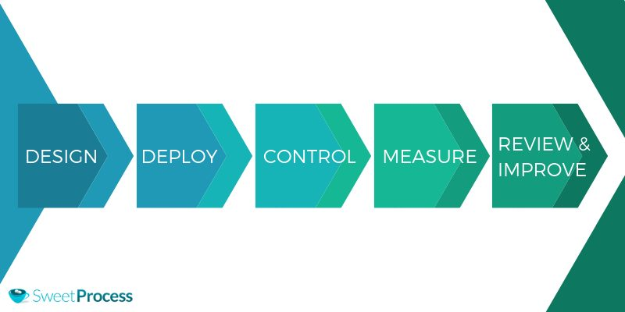

**Figure 8.** [The Ultimate Guide to Implementing a Quality Management System](https://www.sweetprocess.com/quality-management-system/" \o "The Ultimate Guide to Implementing a Quality Management System In Your  Company. - SweetProcess" \t "_blank)

**Market participation strategies in high level technology marketing**

Market selection strategies and the time to enter it are indirectly to answer the question, how should the selected markets be managed? This is where participatory strategic planning is used. There are two basic approaches to this issue: customer-oriented strategy and competitive strategy. Considering the customer-oriented strategy, a company with high-level technology must decide between the selection of differentiation and standardization strategies. Standardization means targeting the average needs of all customer groups.

In high-tech markets, this strategy rarely works. Although it may be effective only for secondary channels for whom the need to acquire and maintain long-term customers is less important than selling for short-term profits. Therefore, it is better for companies with high-level technology to use the differentiation approach, which means custom production of products for each of the specific target groups. The second key consideration related to customer orientation is that the main strategic approach is price, quantity or advantage oriented.

These two approaches strongly contradict each other. The advantage strategy is based on performance criteria both in terms of the main functions and complementary functions of the product, while the price and quantity strategy are based only on price advantages and the product has only basic functions. The price and quantity strategy has its root in the power of low price, in such a way that the company consciously sacrifices the more specific needs of the customer.

As a result, it can be said that this approach is suitable for secondary sequences and not at all suitable for precursors and primary sequences. The approach of the last two groups should be to create barriers to entry by creating a brand and loyalty to the organization, which can only be achieved by putting the customer first. One of the weaknesses of market-oriented strategies for most high-tech companies is that they do not pay enough attention to potential and actual competitive threats. Competitive strategy specifically deals with this aspect of market operations. According to Porter's opinion, cost leadership and quality leadership and focusing on specific corners of the market form the basis of competitive strategy.

Cost leadership requires reducing the unit cost to less than competitors in order to gain a competitive advantage through lower prices. This approach is consistent with the price and quantity strategy that was discussed earlier and is likely to be successful only in the final stages of the market life cycle. Considering the characteristics of high-tech markets, quality leadership seems to be a suitable strategy for them. There are three main reasons for this. First, quality leadership is very suitable for creating standards in the market in order to prevent followers from entering the market.

In addition, it seems that only adapting the product features to the special needs of the consumer guarantees quality leadership and overcomes consumer resistance to purchase in the early stages of the product life cycle. Finally, quality leadership facilitates offering higher prices than the market. The third basic strategy is to focus on the virgin corners of the market. This type of strategy has been proven to be particularly useful for market trailblazers to overcome barriers to entry.

However, this strategy is not a suitable starting point for market leaders, because in the early stages of market development, market corners are generally not recognizable. So far, competitive strategies have only been studied from a static perspective. This view is dangerous for high-tech markets surrounded by special competitive dynamics. As a result, it is very valuable to consider the dynamic aspects of competitive strategic planning.

By expanding the cost and quality leadership strategies, Gilbert and Strebel presented overtaking strategies which are based on successive exchange of quality advantages to cost and vice versa to maintain competitive advantage over time. By doing this, the classic one-dimensional strategies are united and remain dynamically. Preemption strategies are relevant to all high-tech industries, as the benefits of a dynamic adaptive approach are far-reaching. Typically, an organization that enters the market as a pioneer or a follower uses a quality-oriented competitive strategy in an effort to reach the accepted industry standard as quickly as possible.

This usually creates a serious obstacle on the way of secondary routes and also increases the level of customer acceptance. Finally, each market player seeks to overcome the other by using the appropriate combination of advantages based on cost and quality. In research, Ofek and Sarori investigated the effect of investment on marketing or on research and development in the success of new generation products with high level technology. Their analysis showed that when the market leader has more research and development capabilities, he invests more on research and development than competitors to maintain his leadership position.

On the other hand, when the leader has more reputation than the competitors, the follower's investment in research and development is more than the leader, and the leader, using the advantage of reputation, invests more in evaluation activities (Ofek and Sarvay,2003). In a study on high-tech companies, Bahrami and Evans observed that the processes of strategy formulation and its implementation are strongly intertwined and combined in a repetitive process (Bahrami and Evans, 1989).

This close relationship between planning and implementation processes is in clear contrast with the traditional strategic planning literature. Maidique and Hayes provided a wider range of guidelines for high-level technology management that differed from conventional wisdom (Maidique and Hayes,1984). Firth and Narayana profiled the new product strategies of large fortune companies (Firth and Narayana,1996). Cooper and Kleinschmidt conducted a retrospective analysis on about 200 new product projects with medium to high technology (Cooper and Kleinschmidt,1990). These researchers identified eight key factors for the success of technology-oriented projects. It is surprising that according to these findings, senior management support and competitive position have little effect on success, and as it is known, marketing activities play a major role.

* A superior product that offers unique benefits to the consumer.
* Existence of a clear definition of the project and product before the development phase.
* Technological synergy.
* The quality of implementation of pre-development activities.
* Marketing synergy.
* Quality of implementation of marketing activities.
* Attractiveness of the market

Two authors who have worked a lot in this field are William Davidow (Davidow,1988) and Regis McKenna (McKenna,1985). Davido's main role has been that he has successfully shown the need to apply marketing principles beyond a concept in the management of high-tech products. In Iran, in a study, Bandarian has investigated the steps, facilitating and key success factors in the commercialization and marketing of new technologies. The results of his research show that the key success factors proposed for technology marketing are not unique and it is possible that there are other factors in the case of some other technologies, but the adoption of these criteria, which are dependent on the successful commercialization of technology, has a positive effect on the probability It will be commercialized (Bandarian,2008).

In research, Gulabi and others discussed the conceptualization of the marketing management process in knowledge-based businesses located in Arak Science and Technology Park. In this study, the qualitative content analysis method was used to analyze the data. The findings of the research indicate that the marketing management process in the investigated businesses takes place in seven consecutive stages (Golabi, Mehrabi and Rezvani,2013).

**Briefly about nanotechnology**

Nanotechnology or nanotechnology is a field of applied knowledge that covers a wide range of researches and its main topic is the containment of matter or devices in dimensions less than one micrometer. The first spark of nanotechnology was struck by Richard Feynman in 1959, but the term nanotechnology was first proposed by Noriyo Taniguchi, a professor at Tokyo University of Science, in 1974. In fact, nanotechnology is the understanding and application of new properties of materials and systems in these dimensions that show new physical effects.

This knowledge technology is highly interdisciplinary, which can be a continuation of the current knowledge in nano dimensions or a projection of the current knowledge on a newer and more modern basis. The American National Nanotechnology Pioneering Program defines nanotechnology as follows: the development of research and technology at the atomic, molecular and macromolecular levels with an approximate length from 1 to 100 nanometers in order to provide a basic understanding of phenomena and materials at the nanoscale and with the goal is to create and use nanostructures, parts and systems that have new properties and functions due to their small or medium size. In the evolution of nanotechnology in the country, 2013 can be considered as a turning point for the start of infrastructural activities in nanotechnology research.

This year, in addition to the establishment of the country's nanotechnology association, a special headquarters for the development of nanotechnology was formed for a period of 4 years, whose duties include approving goals, strategies, macro policies and national programs for the development of nanotechnology in the country, dividing the general duties of the devices and determining the mission. Departments and their coordination in the form of a long-term national plan is an excellent monitoring of the realization of goals and plans.

The headquarters' point of view for the development of nanotechnology is to compile the country's long-term activity framework in nanotechnology, and in this regard, a ten-year strategic plan for nanotechnology was prepared and approved at the headquarters. This document was presented to the government board based on Article 43, Paragraph B of the Fourth Development Program Law, and was approved by this board in August 2014 under the title of Future Strategy Document. In this document, it is aimed to be among the top 15 countries in the world in the field of nanotechnology and to try to continuously improve this position in order to generate wealth and improve the quality of life of the people.

According to the changes and experiences gained during the implementation of the document, it was decided to prepare and approve supplementary documents at specific time intervals. This issue is important because programs should be improved in different periods based on successes and failures and past experiences. Table (6) below shows the implementation periods of the future strategy document.

**Table 6.** Implementation periods of the future strategy document

|  |  |  |  |
| --- | --- | --- | --- |
| Period | Course length (years) | Start year | End year |
| First | 3 | 2005 | 2007 |
| Second | 3 | 2008 | 2010 |
| Third | 2 | 2011 | 2012 |
| Fourth | 2 | 2013 | 2014 |

**Identify the fields of nanotechnology**

In the field of classification of nano technology in recent years, good efforts have been made by the experts of the nano headquarters, which has been published under the title of nano tree. So far, four categories of these trees have been published by this headquarters, each of which has evaluated nanotechnology based on a specific point of view and purpose. These four categories with the names of technology tree, nano nuclei tree, industry tree and nano science tree are presented on the site of the special headquarters of nanotechnology. According to the limitations and objectives of the research, in this research, the nano science tree was used. The science trees section consists of three separate trees, including the tree of basic elements, the tree of construction and modeling methods, and the tree of specification methods, each of which examines a separate field of nanoscience. One of the science trees in this section is the basic elements tree with 13 main fields, each of which includes element structure and second level elements. In the following, each of the 13 fields used in this research is mentioned.

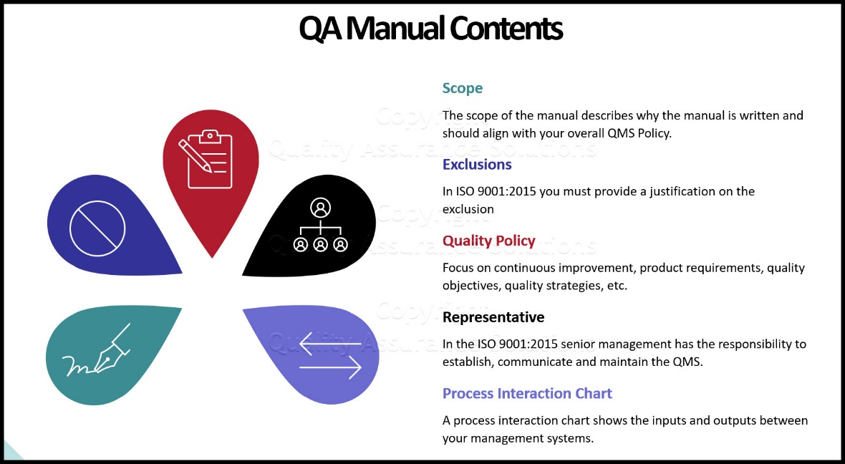

**Figure 9.** [Process approach-based model of quality management system](https://www.researchgate.net/figure/Process-approach-based-model-of-quality-management-system-in-central-banks_fig3_282733869" \o "Process approach based model of quality management system in central... |  Download Scientific Diagram" \t "_blank)

**1- Nanocrystalline materials:** Nanocrystalline materials are made of a mass of crystals that contain several hundred to several thousand atoms and are placed next to each other. The structure of nanocrystals has the lowest surface free energy due to the compression of atoms next to each other. When the crystal size in the material goes to the nanoscale, the ratio of atoms on the grain boundary increases to the total number of atoms. The behavior of the boundary atoms is completely different from the atoms inside the particle and affects the behavior of the whole material. This phenomenon in metals increases strength, hardness, electrical resistance, specific heat capacity, improves thermal expansion, magnetic properties, and decreases thermal conductivity, and in ceramics increases malleability, improves mechanical and thermal properties.

**2- Nanoparticles:** A nanoparticle is a particle whose dimensions are around 1 to 100 nanometers. Nanoparticles, in addition to metal type, insulators and semiconductors, also include composite nanoparticles such as layer 2 core structures. Nanoparticles in low sizes are considered as nanoclusters. Also, nanospheres, nanorods and nano cups are only considered forms of nanoparticles. Nanocrystals and semiconductor quantum dots are a subset of nanoparticles. Such nanoparticles are used as drug carriers and imaging agents in various electronic, electrical and biomedical fields.

**3- Nano porous materials:** Nano porous materials are porous structures whose pore size is less than 100 nm. These compounds are abundantly found in natural resources and biological systems. The size and order of the holes control the properties of nano porous materials. In recent years, efforts have been made to produce nano porous materials with specific hole sizes with high control and precision. Nano porous materials are divided into two main categories: bulk nano porous materials and nano porous membranes.

**4- Regular organic nanostructures:** Regular organic nanostructures include regular molecular arrangements that are repeatable in nanostructures.

**5- Nanofibers:** They are relatively short fibers whose two dimensions are on the nanometer scale and their aspect ratio is larger. All kinds of nanofibers can be obtained by electrospinning and electric arc methods.

**6- Nano capsules:** A nano capsule is any nanoparticle that has a shell and an empty space to place the desired material inside.

**7- Nanotubes:** Nanotubes refer to nanostructures whose diameter is up to 100 nm. Regardless of the high tensile strength, nanotubes show different electrical properties that depend on their structure. The term "nanotube" is normally used for carbon nanotubes, which have received a lot of attention from researchers in the last few years. Of course, other forms of nanotubes such as boron nitride nanotubes and organic self-assembled nanotubes have also been made.

**8- Nanowires (quantum wires):** A nanowire is a two-dimensional nanostructure, and because quantum effects are important in these dimensions, these wires are also called quantum wires. Nanowires are used to make electric circuits in small sizes.

**9- Fullerenes:** Fullerenes are often referred to spherical structures that are made of carbon, but nowadays other elements such as nitrogen are also used in their structure.

**10- Diverse mineral structures:** Mineral nanostructures are created from different metal oxides such as zinc oxide and using the solid phase and vapor thermal sublimation method under special conditions. Each of these structures shows unique properties and this phenomenon has caused extensive research in this field.

**11- Electronic and optical nano parts:** Electronic and optical nano parts are nano-sized parts that are used in electronics and optical devices.

**12- Electromechanical nano parts:** Microelectromechanical systems include micro-sized mechanical assemblies and include three-dimensional lithographed shapes with different geometries. Due to the high surface-to-volume ratio, surface effects such as electrostatics and wetting cover surface effects such as inertia. Microelectromechanical systems are made using modified silicon.

**13- Fluid nano parts:** In nanofluid nanostructures, the behavior of fluids in nano and meso sizes is studied. In this context, the systems are designed in such a way that a small amount of fluid is used. The behavior of liquids in macro sizes is different compared to micro sizes. In this process, channels whose diameter is nano and micro are used to investigate these properties, and properties such as surface tension, fluid resistance, and energy distribution are investigated.

**Chapter III**

*Different perspectives on customer relationship management*

Important general trends of economic liberalization, globalization, technological convergences and the rapid evolution of the Internet have transformed the role that organizations play in their relationships with other companies. Business experts and academics talk about alliances, networks and cooperation between organizations, but managers and researchers have largely ignored the factor that is strangely transforming industrial systems.

In a market where consumers are empowered by technology and can now engage in a dynamic dialogue with creators, one that customers control, organizations are forced to accept that the customer is becoming a partner in value creation. Customer relationship management is generally the process of designing an organization around its customers, in such a way that the customer's needs and desires are considered as the main focus in every organizational decision.

The goal of creating a customer-focused organization is to increase the mutual value of the organization and the customer in the field of customer communication. From the point of view of the organization, this value is: the improved rate of customer retention and increased revenue, while more efficiency and cost control. Banks, as monetary and financial institutions, have been placed in new refinements and bank customers have more demands than in the past. They are interested in checking the status of their accounts on time and using the instant payments system.

They travel all over the world and cross time zones and need to be available 24 hours a day, 365 days a year. They compare the various available offers with just one click of the mouse. They purchase products and services from more than one bank and do not hesitate to choose another bank due to the more attractive products and services or its conditions. Today, customers are less loyal to their bank and use the services of different banks. Customers have more knowledge about financial issues and manage them more actively and are ready to accept more risk in exchange for more returns. They also need new products that match their new lifestyles.

Customer relationship management (CRM) and knowledge management (KM) are key and strategic tools for all companies, especially in the current competitive environment. In addition, customer knowledge is a very important issue in the implementation of customer relationship management (CRM). Many studies have been conducted in the field of knowledge management component analysis, which shows the vital role of knowledge management as one of the factors that determine success in the implementation of customer relationship management.

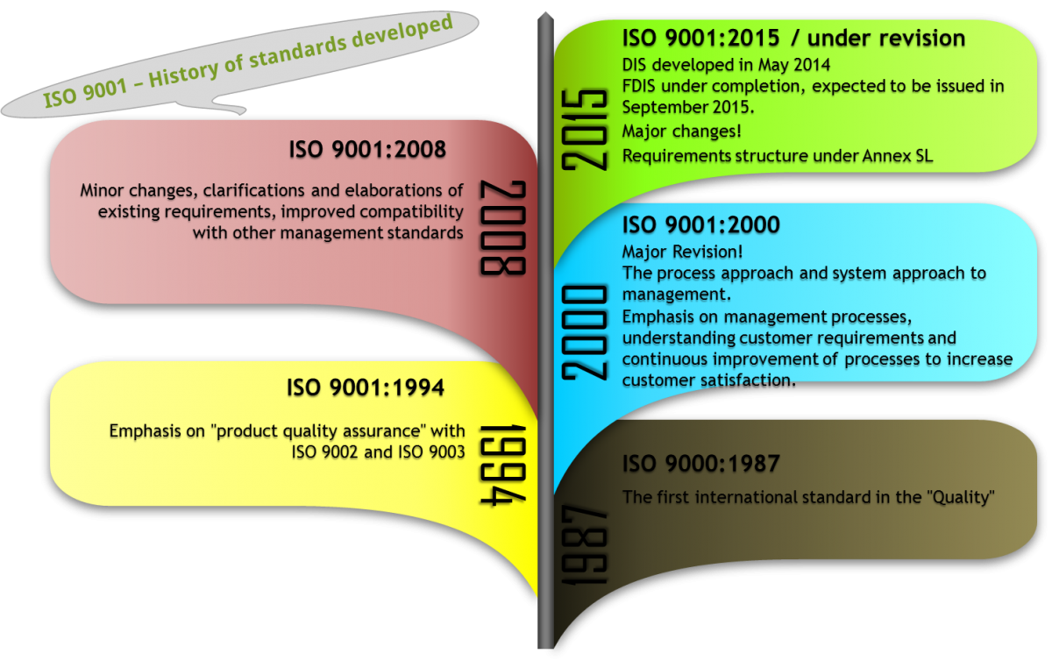

**Figure 10.** [Why is Quality so important for an organization?](https://www.cmc-global.org/content/why-quality-so-important-organization" \o "Why is Quality so important for an organization? | ICMCI" \t "_blank)

Also, these studies have shown a high rate of failure in implementing this strategy for organizations (Aurora & Antonio,2011). There are many definitions of knowledge management in various articles that consider knowledge management as a process that helps organizations in identifying, selecting, organizing, publishing and transferring important information and specializations that are part of the organizational memory and are often unstructured in organizations exist, it helps. Structuring knowledge improves effective and efficient problem solving, dynamic learning, strategic planning and effective decision making.

Knowledge management focuses on knowledge identification, description and creation and increasing its value through reuse. Customer relationship management (CRM), which is sometimes referred to as customer management, customer value management, customer-centric or customer-centric management, has for a long time been a common term to express the desire of companies to communicate continuously and constantly with has been its customers. In this regard, it is important to point out that the companies that have effectively attracted their customers and provided them with the desired services in the best way, have seen the positive effect of this at the end of their profitability. (Parlby & Taylor. 2000).

The more a company can establish a more effective relationship with its customers, the more opportunities it will have to provide more products and services to those customers. Currently, the knowledge-based economy is drawn by factors such as increasing competition, innovation in technology and the global nature of markets (Castells,1998).

In the current competitive environment, companies should pay special attention to knowledge in their business activities, which is a factor for creating a competitive advantage over other competitors in the market (Beijerse,1999; Salmador & Bueno,2007). In recent years, knowledge has been considered as an important organizational resource, and the interest of organizations in this matter is increasing day by day. In the current competitive environment, the relationship between the company and the market is very vital, and the marketing strategies of the companies have completely changed in order to create a closer relationship with the customers (Alavi & Leidner,2001; Drucker,1993).

The transition from the industrial economy and the disappearance of the geographical boundaries of business, as well as due to the increase in competition between different industries, have caused commercial and production organizations to turn to various strategies and methods to succeed in the competition, so that they can reach customers through them. maintain themselves and gain their satisfaction, because the needs of customers and their buying patterns have changed dramatically, and this has caused companies to have a great desire to meet different needs and also in order to achieve a competitive advantage. show acceptance of customer-oriented marketing strategies (Xu & Walton,2005).

Today, organizations put their customers at the center of all activities and formulate the main marketing and sales strategies based on this. Customer relationship management (CRM) is a business strategy that creates two-way value and identifies all aspects of customer profile, creates customer knowledge, shapes relationships with customers, and their perceptions and mental image. about the products and services, the organization creates (Beijerse,1999).

For this reason, it is very necessary to study how to create a relationship with the customer and also to examine the influencing factors in creating an effective relationship with the customers in order to maintain them, because the customer is the main capital of any organization (Yousfi,2014). Customer relationship management (CRM) creates integration among people, processes, and technology in order to enhance communication with the organization's customers, distribution channel members, internal customers, and suppliers. Customer relationship management is also a holistic approach and provides continuous coordination among sales, marketing, customer service and other customer-facing activities (Qara Daghi,2019). Unfortunately, many organizations do not have proper information about customer relationship management (CRM). Therefore, there is still no unified conceptual framework for companies to successfully implement this strategy. Customer relationship management alone is neither a concept nor a project, but a work strategy that aims to understand, predict, manage and personalize the needs of active and potential customers of an organization (Rigby & Schefter,2002). In this research, the researcher will show the relationship between knowledge management (KM) and the success of customer relationship management (CRM) using a structural model. As a result of the mentioned materials, this research faces several basic questions, which are:

* Is knowledge management (KM) the main and determining factor in the successful implementation of CRM?
* Does the history of activity in the field of CRM have an effect on the successful implementation of customer relationship management?
* Does the technology related to CRM have an effect on the success of customer relationship management?
* Does the organizational structure affect the success of customer relationship management?
* Does customer orientation affect the success of CRM? (Aurora & Antonio,2011).
* Today, the knowledge-based economy can be identified through factors such as increased competition, technological innovations, and global markets. Since knowledge plays a key role in creating and maintaining competitive advantages in such societies, companies and organizations should pay great attention to knowledge when starting to operate in the market.

In addition, in recent years, knowledge is considered as one of the key organizational resources and many researches have been conducted in this field. For this reason, nowadays knowledge management is considered as one of the most important research priorities in the academic and industrial environment and it is one of the topics that companies allocate a lot of resources and costs to.

Customer knowledge systems, knowledge management and customer relationship management not only improve the organization's ability to interact, attract and create personalized communication with customers, but also improve the ability of organizations to increase their knowledge in relation to customers. Knowledge management is a necessary condition for e-commerce and increasing customer focus. To continue operating in a competitive environment, organizations must have sufficient knowledge about markets, customers, products and services, methods and processes, competitors, employee skills, and how to monitor. Due to this fact, organizations can engage in integrated e-business worldwide through the Internet and internal networks in today's competitive era. Customer relationship management in today's electronic and global economy has forced organizations to rethink the way they build customer-based relationships.

**Knowledge management**

There are many praises of knowledge management in the literature. Some of these definitions are presented in the figure below.

**Table 7.** Definitions related to knowledge management (KM)

|  |  |
| --- | --- |
| Author | Definition |
| YU,2000 | Successful knowledge management includes a set of knowledge organization methods including creation, collection, compilation, personalization and distribution of knowledge. This leads to the achievement of specific company goals as well as performance goals and the implementation of extensive marketing strategies in support of those goals. |
| Parlby & taylor,2000 | Knowledge management is about supporting innovation, generating new ideas and harnessing the thinking power of an organization. Knowledge management also includes acquiring knowledge and experience that is always available and usable by anyone, anywhere and at any time. |
| Harris,1999 | Knowledge management is a business process that gives structure to management and is like the intellectual property of a company. Knowledge management is a systematic approach that leads to joint and integrated attention to create, capture, organize, access and use information assets that include tacit knowledge and knowledge about potential customers. |

Definition of knowledge management as a structured and planned approach to achieve management of initiative, creation, sharing, collection and application of knowledge to the organization as an important asset for the organization in order to improve the ability, speed and efficiency of the company in providing products or services. It is for the benefit of customers in line with their business strategy. Knowledge management takes place at three levels:

* Individual level.
* Team level.
* Organizational level.

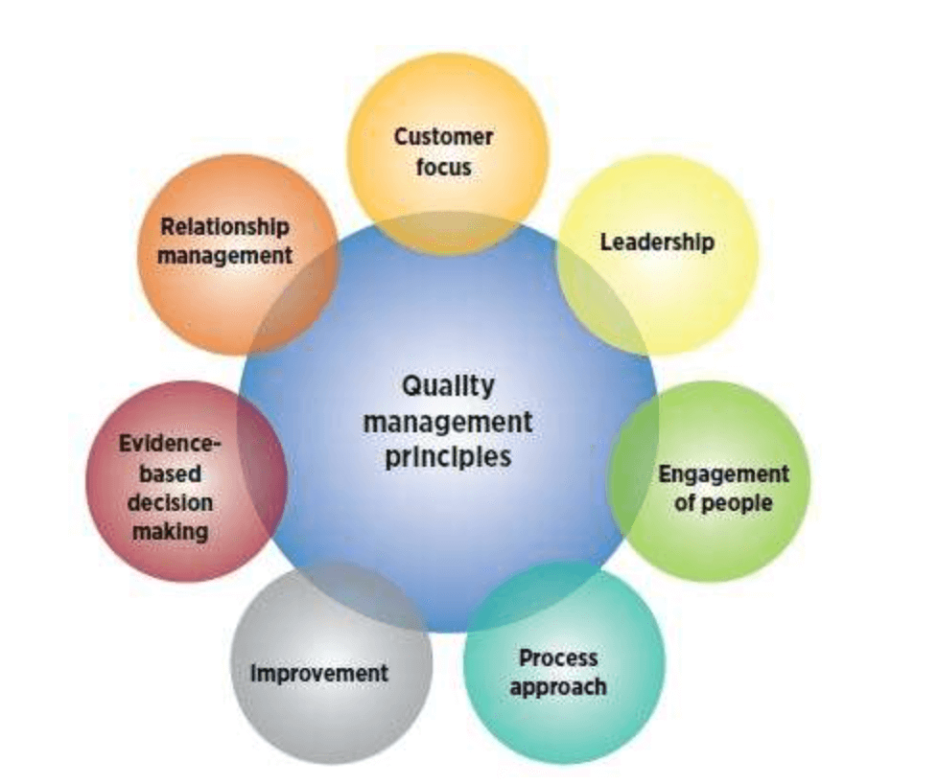

**Figure 11.** [Quality Management](https://www.qualtrics.com/uk/experience-management/customer/quality-management/" \o "Quality Management | Qualtrics" \t "_blank)

**Customer relation management**

Customer relationship management is defined by researchers as the basis of customer relationship at an organizational level, which through understanding, predicting and managing customer needs based on the knowledge obtained from the customer, leads to an increase in organizational effectiveness and efficiency and in the result is increased profitability. In fact, crm is generally the process of designing an organization around customers, in such a way that customer needs and wants are considered as the main focus in every organizational decision.

In CRM, the joy and sorrow of the organization is summed up in the customer. The purpose of creating a customer-focused organization is to increase the mutual value of the organization and the customer in the field of communication with him. This value from the point of view of the organization is: the rate of improvement of customer retention rate and increase of income, and at the same time more efficiency and cost control. With CRM, it is possible to identify the needs and desires of the customer even before they are expressed.

By using this advantage, organizations are able to increase customer loyalty, generate revenue, and reduce service and operational costs. Based on the literature review of the concept of customer relationship management, it can be said that there is still no consensus on an understandable conceptual framework for customer relationship management. In general, the concept of customer relationship management can be expressed in the form of compliments in the table below.

**Table 8.** Definitions related to customer relationship management (CRM)

|  |  |
| --- | --- |
| Author | Definition |
| Brown,C39 | Customer relationship management is neither a concept nor a project. It is a business strategy that aims to understand, anticipate and manage the needs of potential and actual customers of the organization. This strategic approach is a process of organizational change whereby a company tries to better manage its specific investments in all customer behavior. |
| Handen,2000 | Customer relationship management is the process of acquiring, maintaining and increasing profitable customers. This requires a strong focus on special services that demonstrate value to the customer and create loyalty in them. Customer relationship management includes 5 elements of strategy, segmentation, technology, process and organization. |
| Harris,1999 | Customer relationship management is a technology-driven strategy for turning data-driven decisions into business performance to respond and predict actual customer behavior. From a technological point of view, customer relationship management represents a process of measuring and allocating human resources to those activities that have the most feedback and impact on profitable customer relationships. |
| Nicolett, Andren & Gilbert 2000 | Customer relationship management is a broad business strategy aimed at optimizing, generating revenue, profitability and customer satisfaction through organizing, investing in customer orientation and promoting behaviors that lead to customer satisfaction. Also, communication processes with customers through suppliers have been designed. Investing in key customer relationship management technology creates a better understanding of the customer, increases access to the customer, more interaction and more effective customer orientation and integration of communication channels with customers. The field of customer relationship management software includes technology-oriented sales activities, providing services and support to customers, and technology-oriented marketing activities. |

**The need to identify key factors**

The key to business growth lies in its successful relationship with the customer. Before an organization implements CRM, it must be aware of the factors that influence its successful implementation so that it can consider these factors in the implementation phase. Customer relationship management is a strategic necessity for all organizations, because its effective implementation can increase customer satisfaction, loyalty, and attract them, resulting in more sales and repeat purchases (Sigala,2006).

Some organizations have difficulty in implementing CRM, because its attitude towards this category is purely technological, that is, they equate customer relationship management strategies with CRM technology, while CRM is not a technological issue, but rather a business issue. Information technology tools must be assigned, designed and coordinated with business operations and strategies (Sigala,2005).

The failure rate of CRM projects is more than 65%. It is clear that the stoppage and failure of these projects is a result of not understanding what activities are needed to implement CRM (Chen,2003). Sigala in 2005 considers the lack of a framework for the effective implementation of customer relationship management as the cause of such failures. Some other researchers have cited the lack of implementation approaches, measurement tools, the lack of integration of information technology tools with processes, people and business strategies, and the lack of business reengineering (Sigala,2005 and Sigala,2006). Customers are an organization's best asset, and an increasing number of organizations are demonstrating the importance of becoming customer-centric in today's competitive world.

Also, organizations should have knowledge of information about customers, products and services internally and externally. Therefore, the managers of the organization are drawn to find out about the important success factors of their customer relationship management (Kumwa,2001). CRM provides a 360-degree customer-centric view of all parts of the organization and includes improved and developed communication between the organization and its customers. Sales, marketing, audit, support and customer service and production or payment departments in the organization must share their information with each other. As a result, a fundamental change must be made in the field of information flow of the organization, including quantitative and qualitative data, as well as the strategy of integrating processes, technology and people, and comprehensive management. It should also be noted that CRM is not just a technology, but a tactic that can be used in practice.

Therefore, CRM requires an organizational approach and at all levels of business to be customer-centric to do business rather than a simple marketing strategy. CRM includes all functions of the organization that require direct or indirect contact with customers (Gray and Bayon,2001). In 2002, Gamson considers CRM as a necessary rule for organizations that need more development and progress, and in this regard, identifying the key dimensions of CRM is very important (Sin et al.,2005). According to the emphasis of various researchers on the need to identify the important factors of customer relationship management implementation and the research done in this field, below we briefly discuss the important and key factors proposed by various researchers in relation to this issue.

**Customer relationship management (CRM) and knowledge management (KM)**

Since in recent years, companies have realized that knowledge management plays a key role in the success of customer relationship management, for this reason, they have integrated activities related to customer relationship management and knowledge management. Identifying valuable customers is one of the complex tasks of customer knowledge management in the organization.

Technology can help in this task, but knowledge management provides the information processing power of technology for effective use. Ensuring customer satisfaction requires creating a basic understanding of the exchange of tacit knowledge and predicting and realizing the new needs of customers, which can be achieved through statistical and technological methods. Customer relationship management is: managing customer knowledge in order to create a better understanding of customers and provide appropriate services to them. Customer relationship management is related to knowledge management, and for this reason, the existence and competence of knowledge management is a key factor in the success of customer relationship systems. Despite the important role that knowledge management systems play in today's customer-oriented business environments, there is still a lack of a simple and comprehensive framework for integrating the application of traditional customer relationship management systems with the management and application of customer-oriented knowledge. It is felt (Beijerse,1999).

In addition, because knowledge management effectively manages customer relationship management, it is the most important process of customer relationship management. Therefore, companies should improve and develop capabilities related to customer knowledge management processes. Since it is difficult to imitate these capabilities, for this reason these capabilities can be considered as one of the important sources of competitive advantage (Shi & Yip,2007).

Knowledge management capabilities are the organization's abilities to capture, manage information and provide reliable and timely goods and services to customers in order to improve the response to customers and make quick organizational decisions based on real information. As a result, customer relationship management and knowledge management both have a common goal, that is, the continuous improvement of the process of providing goods and services and information to customers (Dous,2005).

In addition, the creation and transfer of knowledge is considered as one of the most important fundamental and strategic processes that determine the organization's ability to learn and innovate. For this reason and because the ability to manage knowledge causes a change in the organizational landscape, it plays a major and decisive role in the implementation of customer relationship management, and in addition, it includes a large part of organizational learning and innovation (Salmador,2007). On the other hand, empirical studies conducted in this field show the important role of knowledge management abilities in the success of customer relationship management. Therefore, it can be said that knowledge management has a key and important role in the success of customer relationship management programs and systems (Sin et al,2005). Knowledge management technology provides the processes and operating systems needed to create, share, and capture customer knowledge in a central database. Therefore, it provides a view of the customer regardless of geographical location or application area in the business.

The knowledge management system can provide the required information about potential customers as well as the customer relationship life cycle at the required time. By employing these systems, organizations can have an up-to-date set of customer knowledge and information regardless of where they operate, enabling them to develop products, distribution channels, and segmentation strategies. Market to operate more accurately and effectively. Knowledge management is one of the most important effective factors in customer relationship management and allows a better understanding of the operational environment, needs, demands and behavior of customers, and as a result, products and services are matched to customer needs. It can also lead to the identification of customer needs and create value for the customer with regard to the development of new products and services. The service reaches the customer faster, more effectively and efficiently.

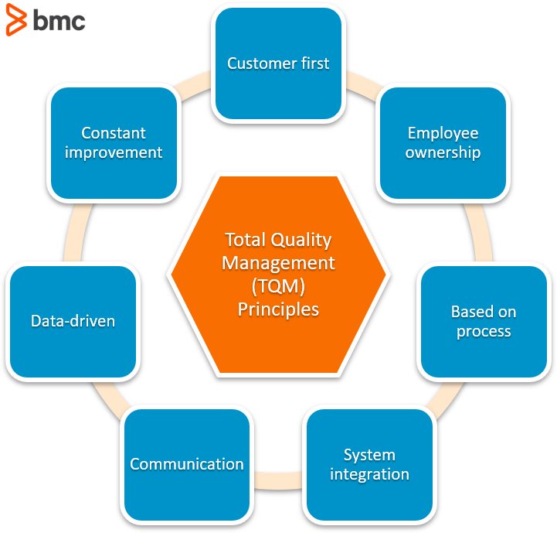

**Figure 12.** [What Is TQM? Total Quality Management Explained](https://www.bmc.com/blogs/tqm-total-quality-management/" \o "What Is TQM? Total Quality Management Explained – BMC Software | Blogs" \t "_blank)

Also, knowledge management provides customers with 24-hour access to the organization to obtain the information they need, thereby reducing the purchase time and the complexity of the customer's purchase process. Knowledge management integrates information among different groups or groups involved in customer relationship management. These heterogeneous groups may be in different business units or in different geographical locations. Knowledge management facilitates the flow of required information related to customer issues among groups, and as a result, it makes the flow of customer-related information as well as their integration faster and more effective. Knowledge management also facilitates the transparency of information needed in the integration process.

**Organizational factors and the success of customer relationship management (CRM)**

These factors are different aspects of the organization, which include human resource management, organizational structure, resource allocation, etc. The implementation of customer relationship management requires changes in the organization of the organization and its business processes. On the other hand, investigating organizational factors affecting the success of customer relationship management requires a comprehensive and complete model in this field. In fact, organizations need to redesign the organization and supply chain management for the successful implementation of customer relationship management systems and programs.

Therefore, to implement customer relationship management, factors such as strategy, organizational structure, and business processes need change and transformation. Because success in the implementation of customer relationship management requires creating the correct synergy between technological systems, processes and people of the organization (Xu & Walton,2005).

Because even with the best-defined business processes and the most advanced technologies, the relationship between people plays a key role in the implementation of any business strategy, the human factor is the most important factor among the mentioned organizational factors. This is the reason why important factors such as training employees and creating value in them and formulating and implementing appropriate reward systems are among the most important factors of involving employees in the implementation of these types of strategies.

**Technology and customer relationship management (CRM)**

Customer relationship management technological systems should be considered as a key factor and a necessary prerequisite in the implementation of these types of strategies. According to Sin and others (2005), customer relationship management software systems enable organizations to provide goods and services tailored to the needs of each customer with high quality and low cost, and for this reason, it can be said that many Customers related activities are impossible without using the right technology. As a result, companies must have the right technologies to successfully implement customer relationship management programs so that they can improve business processes involved in customer relations.

On the other hand, because customer relationship management technological systems provide a proper view of customers and manage relationships with customers in a coherent way, they have many benefits for the organization and help organizations improve the efficiency and effectiveness of the processes involved in Relatable with customers help. Despite the information mentioned above regarding the importance of the role of technology in the success of customer relationship management, it should be said that giving a key and extensive role to technology in this regard is not correct. Instead, organizations should consider technology as one of the prerequisites of a customer relationship management system. Therefore, technology can be considered as one of the necessary, but not sufficient, conditions for the success of customer or relationship management systems (Alavi & Leidver,2001).

**Customer orientation and customer relationship management (CRM)**

According to Ghaghte Tarver and others (1990), customer orientation requires gaining sufficient knowledge of customers to provide more added value to them. Also, customer orientation requires placing the customer at the center of all the organization's activities in order to create long-term relationships with customers. This is the reason why this factor is one of the fundamental components of the organizational climate required for the success of customer relationship management. An organization with a strong customer-centric perspective can better design its processes. Because this organizational culture is the main factor in improving employees' understanding of customers. Finally, it can be said that customer orientation is a basic requirement for the successful implementation of customer relationship management.

**Experience in customer relationship management (CRM) and its success**

The implementation of customer relationship management requires a fundamental change in business processes and in the organization itself, and on the other hand, organizational change management is an important factor in this field. On the other hand, organizational learning and experiences in formulating and implementing strategies can determine the effectiveness of customer relationship management systems and programs. Also, Campbell (2003) argues that the internal processes of organizational learning are essential for the successful implementation of customer relationship management. In this learning process, there are four basic factors that are related to this:

* The process of obtaining information about customers.
* Integrating the functions of marketing and information technology departments.
* Participation of senior management of the organization.
* Employee evaluation and reward systems.

Obviously, the longer the time spent training employees to successfully implement customer relationship management, the more difficult it becomes and the more time must be devoted to it. In addition, Hart et al. (2004) analyzed and empirically examined the effect of the level of experiences in customer relationship management on its effectiveness from the perspective of organizational learning and concluded that the use of experiences in the field of customer relationship management improves the organization's ability to Achieving results becomes efficient and also increases productivity and benefits from customer relationship management (Swan & Robertson,2000).

**History**

In the early 19th century, organizations focused on consumer marketing and meeting the expectations of their individual customers. After the world wars, organizations focused on industrial and production development and focused on improving their products. In the middle of the 19th century, organizations focused on improving production processes, and marketing efforts focused on strategies to attract new customers through new communication channels. In the 1980s, with the help of direct marketing, they differentiated their products from mass-produced products, and concepts such as service quality and customer satisfaction focused marketing. In the next decade, with the advent of information technology and the ability to provide personalized services, retaining and maintaining the most profitable customers became the focus of attention. In the year 2000, the means of communication changed, and this made it possible for organizations to have more information about their customers and thus meet their expectations in a customized and targeted manner (Van Eyden,2000). Today, the purpose of marketing has changed from forming a transaction through personal and long-term relationships with customers, and there is an urgent need to accept social responsibility beyond simply delivering a product or service. Today's need is to shift the mindset from selling to customers to being friendly with customers (Van Eyden,2000).

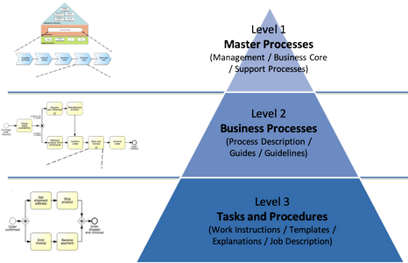

**Figure 13.** [Business process improvement](https://youconsult.ru/en/process/" \o "YOUCONSULT | Business process improvement" \t "_blank)

In general, the emergence and evolution of CRM can be summarized in the following three time periods:

**1- From industrial production to mass production (Industrial Revolution):** In 1915, Henry Ford sold 355,276 Model T cars, all of which were black. This production method made the manufactured products have a lower cost compared to their similar products, but all customers had to choose the black color of the car, which limited their choice. During the centuries before the mass production system of Ford, people did their transactions in the form of standing with personal conversation and seeing each other, and with the advent of the industrial revolution, a change in the business landscape appeared. In the mass production market environment, customization was no longer possible, and the leading companies that used mass production created a revolution in mass production techniques that led to economic benefits for the consumer. While consumers were interested in buying, companies were eager to learn how to produce and market a particular product to achieve maximum efficiency and economic efficiency.

**2- From mass production to continuous production (quality revolution):** While American companies were moving on the learning curve of mass production of their products, Japanese companies were looking for ways to continuously improve their processes that lead to production with lower costs and quality. They were looking for it to be higher. In this way, the period of continuous improvement began. Revolutionary companies that implemented comprehensive quality management in their production processes gained a competitive advantage including price and quality. With the increase of companies following them, the threshold of quality and price increased and this competitive advantage could no longer be sustained. For this reason, companies began to search for new ways to maintain their competitive advantage.

**3- From continuous improvement to customized mass production (customer revolution):** today's consumers are more demanding than ever before. They are used to low costs, high quality and variety, and if they are not satisfied, they go to competitors very easily and simply. Due to the increase in competition, the focus of companies has changed from products and processes to issues related to consumers. If the company wants to remain successful in today's customer-oriented era, it should focus its efforts from manufacturing and efficiency processes to finding ways to attract and retain customers through differentiated and differentiated capabilities. By moving from the revolution of quality to the revolution of the customer, the power of the consumer is increasing. Today, the challenge is how companies understand the needs of each of their customers and gain their satisfaction, while keeping costs low and quality high. The practical solution to these challenges is the movement of companies towards customer orientation, changing the company's processes and strategies in this direction and providing the infrastructure for the successful implementation of customer relationship management in companies. In addition to the mentioned factors, customer relationship management originates from other issues such as one-to-one marketing, marketing cost pressure, value chain management, relationship marketing and recent trends in customer behavior (Wilson et al.,2002).

In fact, crm has existed continuously since the past, but recently it has gained attention for the following reasons:

* Recently, the relationship with customers is recognized as a key point for creating a competitive advantage of an organization.
* Because many organizations obtain a large amount of data related to customers, they can implement customer management more easily and efficiently by using data warehouse, data mining and other information technology. The web has created new tools for business and marketing, so that more customers can be served at different times (Yang-an et al.,2003).

**Importance**

Until recently, most of the sales, service, support and marketing activities of organizations were done in isolation and in separate departments. Today, there is a need to integrate these departments to meet the needs of the current economic world. An economic world that emphasizes on responding quickly to the customer, sharing the knowledge created in the organization and focusing on the customer as one of the factors of the organization's ability to achieve success. In order to succeed or survive in the current growing competitive market, organizations must understand the importance of having a comprehensive view of customers and become more customer-oriented.

The necessity of e-business and cultural changes shifts various units of organizations to focus on the customer. Organizations must realize that customers are the best assets of any organization. As a result, they should understand the importance of having a customer-oriented strategy that is formed based on customer knowledge (Kumwa,2001). After Reichheld and Zasser in 1990 were able to depict the significant effect of a small increase in customer retention rate on increasing the profitability of the organization, the attention of scientific circles was drawn to the necessity of customer relationship management.

By conducting research that indicated the low costs of retaining current customers compared to the staggering costs of attracting new customers, the importance of the category of customer relationship management increased even more. According to the opinion of researchers such as White, an emerging economy is being formed in which the relationship between the buyer and the seller plays a decisive role. Attracting, keeping satisfied and maintaining customers has become the main challenge of many organizations. Therefore, an increasing number of organizations have resorted to the use of customer relationship management systems in order to efficiently and effectively manage the high volume of their interactions with customers (Karamti and Meshki,2018).

**Topics discussed crm**

These topics include:

* Customer.
* Communication.
* Management.

**1- Customer:** The customer is the only source of current profit and growth of the organization. Of course, recognizing, attracting and retaining a good customer brings great benefits to the organization. It is always difficult due to the increasing awareness of customers and as a result of changing their level of expectation as well as the existence of tight competition. With the correct and principled use of information technology, it is possible to identify and manage customers in the best possible way. Kotler defines customer satisfaction as the degree to which a company's actual performance meets customer expectations. According to Kotler, if the company's performance meets the customer's expectations, the customer will feel satisfied, otherwise, he will feel dissatisfied (Dave Andri and Al-Karfi,2014).

Blanchard and Galloway believe that customer satisfaction is the result of the customer's perception during a transaction or value relationship, so that the price is equal to the ratio of the quality of the service performed to the price and costs of the customer. The definition of customer satisfaction accepted by many experts is as follows. Customer satisfaction is a result obtained from the customer's pre-purchase comparison of the expected performance with the actual performance perceived and paid for. In 1991, Shess and his colleagues put forward the consumption value theory and divided customer value into five key dimensions, which are:

* The functional value that is related to the economic desirability and shows the benefits in the goods or services from an economic point of view and refers to the quality and functional characteristics of the product.
* Social value, which expresses the social desirability and image of having that product in the eyes of friends, colleagues and other members of the reference group from the customer's point of view.
* The emotional value that refers to the psychological and emotional consequences of the product and the product's ability to arouse emotions and create attractive situations.
* Cognitive value that refers to the new and surprising aspects of the product and its novelty and emergence.
* The value of the situation refers to a set of situations that the customer faces when making a decision.

**2- Communication:** In the past, marketing theory was based more on how sales should be done, but sales without knowing about the customer and whether he will buy again or not? It is completely useless. Today's marketers are mostly looking for regular customers. Here is the fundamental transformation in the transfer of thinking from making a deal to creating a relationship. Companies create databases for their customers, and databases that contain information about demographic status, lifestyle, and different levels of customer sensitivity to various marketing stimuli and past transactions. In this way, they deal with what they offer to make their customers happy. Customers who always remain loyal to the company (Cutler,1984).

**3- Management:** Customer relationship management is not an activity that is used only in the marketing department, but includes continuous changes in steps, work processes and organizational culture. Today's companies are thinking of changing their way of thinking. They abandon the way of managing a set of semi-independent departments, each of which has its own logic, and turn to the management of basic processes that affect customer service and satisfaction. Companies entrust the management of each process to people with multiple work backgrounds. Instead of working in marketing departments, marketing personnel work more and more in multi-functional teams. This is a positive development that increases the insight of marketers towards economic activity and provides them with more and bigger opportunities to add to the insight of employees of other departments. Collected customer information is transformed into organizational knowledge, which is used in order to gain superiority over competitors in order to achieve market positions.

**Types of CRM**

In general, customer relationship management technologies are divided into 3 categories:

1- Operational customer relationship management.

2- Analytical customer relationship management.

3- Collaborative customer relationship management.

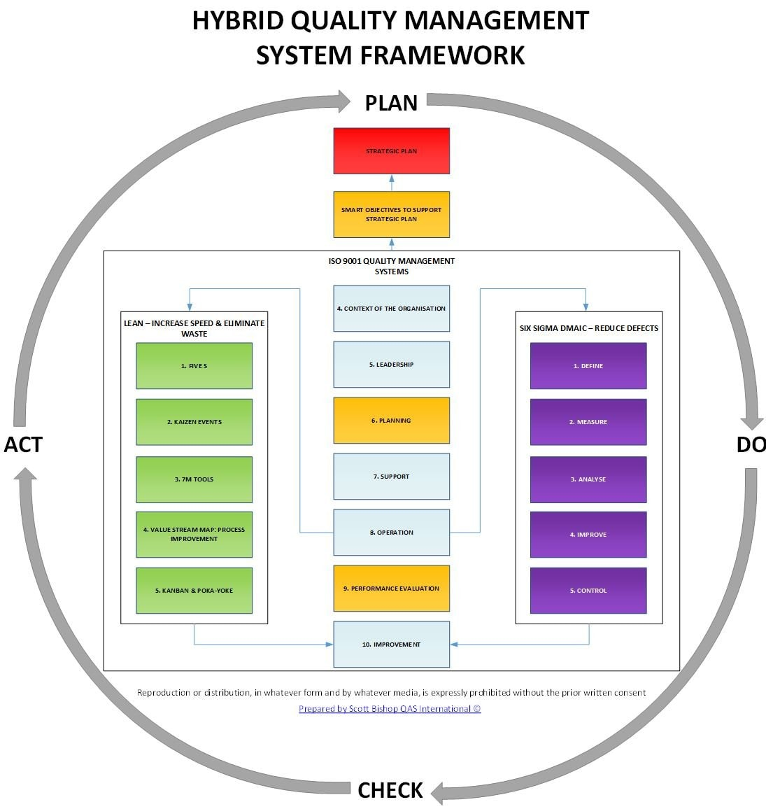

**Figure 14.** [Which should you use - ISO 9001, Six Sigma or Lean?](https://streamline.business/which-should-you-use-iso-9001-six-sigma-or-lean/" \o "Which should you use - ISO 9001, Six Sigma or Lean? - Streamline ISO  Consultants" \t "_blank)

**1- Operational customer relationship management:** By establishing cooperation between several communication channels, it provides diagnostic and efficient marketing, sales and service activities. By implementing this technology, cost savings are achieved through integration between processes and customer communications. Operational customer relationship management refers to customer-oriented applications of customer relationship management, such as automatic sales, automatic marketing of the institution, and customer service. This category of software emphasizes the horizontal implementation of integration processes such as the customer contact point process, communication paths and the integration of the organization's back offices (Elahi,2014). Operational customer relationship management provides marketing, sales and service activities in a personal and efficient manner by establishing cooperation between several communication channels. By implementing this technology, cost savings are achieved through integration between processes and customer communications. With the spread of communication technology, operational customer relationship management has been divided into two types, electronic and two-way, and another component of operational customer relationship management, namely the institution's integration system, works in the field of integrating the organization's back-end and front-end processes.

Electronic customer relationship management applications give organizations the ability to take care of their customers through the web and communicate with them centrally. Electronic customer relationship management has created a new paradigm in customer relationship management, and because of this, software vendors who do not optimize their applications for the web are the ones who will soon be out of business. Another type of operational customer relationship management, i.e., two-way customer relationship management, provides software that enables two-way and continuous interactions between customers and institutions anywhere. It is viewed as a tool that makes customer relationship management more powerful by utilizing advanced wireless communication tools. Another component of operational customer relationship management, namely the institution's integration system, as it was said, is responsible for the integration of the organization's back-end and front-end processes. According to the studies of Meta Consultants Group, the main reason for the failure of customer relationship management projects is its inability to integrate with the old legacy systems.

The institution's integration system works as a middle tool between the customer relationship management system and previous systems. These tools provide a variety of messaging and data mapping services that allow systems to communicate with other separate systems regardless of their formats. Operational customer relationship management deals with applications of customer relationship management that are face-to-face with the customer and cause the integration of the sales force and support. In this technology, a business process is actually supported by the queue of the organization that is responsible for contacting the customer (Greenberg,2004).

**Operational customer relationship management is divided into three branches:**

**A) Sales Force Automation (SFA):** It is designed to improve field sales productivity and automates many basic sales and sales management processes, including customer account management, contact management, price management, forecasting and management. Sales (Haji Zamanali,2013)

Some of the features of SFA are:

* Product Configuration: Combination of alternative product specifications and pricing.
* Sales analysis: analysis of sales data.
* Opportunity Management: Management of potential opportunities for new customers.
* Forecasting: Helping with goals, objectives and future sales forecasts.
* Communication management: communication through e-mail and fax.
* Activity management: providing a calendar and schedule for each sales person.
* Marketing Encyclopedia: Providing timely information on products, prices, promotions.
* Contact management: maintaining customer information and contact history for existing customers (Brown,2000).

**B) Customer support and services:** Fusht support and services is responsible for supporting some of the services needed by customers, such as controlling returned products, providing information needed by customers, and integrating computers and telephones. The most advanced form of contact centers is called the customer interaction center, where various communication channels such as the Internet, telephone, remote control, and face-to-face communication are used (Elahi and Heydari,2014). This field includes methods of packaging, distribution and description of the product, delivery of the invoice, installation, repair or redesign of a product. What causes the competitive differentiation of an organization, both in the production sector and in the service sector, is the support and services that are provided to the customer along with the product (Brown,2000). Services to customers include management of response time, management of field services, provision and follow-up and automatic routing, obtaining customer feedback information for field service management, allocation and scheduling and distribution of the right people with services and at the right time, recording materials and costs and Time related to service requests, customer history, searching for proven solutions, making corrections and following up on problem reports, providing new and updated versions. Today, customer relationship management includes all customer-facing applications including the following:

* Marketing and sales management.
* Sales force automation.
* Activity and contact management.

**C) Institutional Marketing Automation:** This section deals with the operational and analytical aspects of retrieval management and its purpose is to plan and manage multi-channel and comprehensive advertising campaigns and information related to the business environment such as competitors, industry and macro environmental variables. provides (Elahi and Heydari,2014).

This system, like the sales force in the field of sales, has a similar strengthening and mechanized effect on marketing. The Internet revolution has provided new methods for programs and has necessitated the mechanization of marketing programs on the websites of online centers. The goal of customer relationship management is to evolve from the mass marketing model, which is compatible with the product-oriented marketing structure, to customized marketing for each customer. In order to manage the relationship with each customer individually, it is necessary to target the organization's marketing tasks, follow-up, acquisition and analysis of data related to each customer's activities for each specific part of the customer in an interactive manner. Also, the acquired knowledge should be used to develop new products and services and design communication programs that will attract and retain customers (Brown,2000).

**2- Analytical customer relationship management:** Analytical CRM, which is also referred to as the CRM of the executive or strategic part of the organization, includes the identification of customer behavior in the headquarters department and its analysis using data mining. This category includes applications that analyze customer data generated as a result of implementing operational CRM. In order to create a complete profile of customers or a single image of a customer, all data must be stored in a database. This database is called a data warehouse, where current information and customer records are entered. These data can be collected from internal sources of the organization, customers and other sources. A data warehouse can store a huge amount of data and enable the organization to identify customer behavior in the long term. By analyzing these data, information is provided to the organization by which they can create value for customers. Below are some types of data analysis.

**A) Real-time analysis process (OLAP):** online analytical processing is a well-known tool in the field of decision support. In general, OLAP takes a set of data characteristics based on certain dimensions such as time and location from the database and provides them. For example, an organization may want information about the revenue from the sale of a certain product in a certain region. By using the down-exploration function, a user can get detailed information by city sales and then by re-exploring, he can get the sales by region and continue in the same way until he gets the information he wants.

**B) Data mining:** Data mining is the examination and analysis of a huge amount of data in order to obtain meaningful models and rules. The purpose of business data is to improve marketing, sales and after-sales service activities through better understanding of customers. The efficiency of data mining can be divided into two categories: direct and indirect. Direct data mining deals with analysis and grouping based on the desired field, for example, income. Indirect data mining finds examples or similarities between records in a database without considering a specific field.

**C) Data mining capabilities:** Data mining capabilities that are used in various commercial, economic and industrial fields include: grouping, estimation, prediction, grouping based on dependencies, categorization, profiling. The first three are examples of direct data mining that retrieves a value for a specific variable. The purpose of grouping based on dependencies and categories is to obtain the structure of the data regardless of a specific variable. Profiling can be attributed to direct or indirect data mining.

**3- Collaborative customer relationship management:** Collaborative customer relationship management leads to work and constructive balances with customers throughout all communication channels. In fact, by taking advantage of internet cooperation and collaboration, customer service costs can be reduced. In this customer relationship management technology, multi-channel interaction with individual customers becomes possible by integrating contact centers. Also, while interacting with the customer at the exchange level, the organization acquires an integrated attitude towards the customer (Seyd Javadin and Yousefi,2015).

It is a group of CRM functions that facilitate the exchange between customers and organizations. One-way communication should give way to two-way communication, in a way that involves the customer with issues related to his future purchase. In other words, combined CRM includes functions of CRM that provide an exchange point between the customer and the supplier. For example, technologies such as telecommunications are used to facilitate time-consuming, sensitive and personal exchanges with customers (Gibb et al.,2005).

**Different approaches and perspectives on CRM**

By categorizing different definitions of customer relationship management, five main views or approaches in the field of customer relationship management are stated:

**1- Customer relationship management as a process:** a process is a set of activities that will lead to a desired result. Business process refers to a group of activities that transform the organization's inputs into desired outputs. Srivasta et al in 1999 defined CRM as a quantitative process. Some have defined customer relationship management as a high-level process that includes all the activities that the company uses to create permanent, profitable and mutually beneficial relationships with customers.

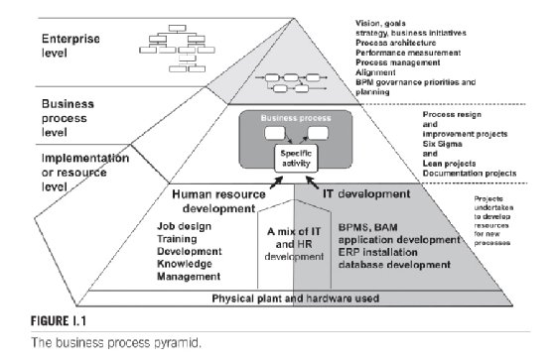

**Figure 15.** [What is Business Process Management?](https://www.techtarget.com/searchcio/definition/business-process-management" \o "What is Business Process Management? An In-Depth BPM Guide" \t "_blank)

At the same time, some others have narrowed it down and considered customer relationship management as a process for managing interactions with customers in order to create and maintain long-term profitable relationships (Rogers,1996). The former defines CRM as a quantitative process and the latter focuses on managing customer interactions. Swift considers customer relationship management to be a continuous learning process in which information about each customer is transformed into creating a relationship with them. This process, which is shown in the figure, begins with the collection of knowledge related to customers and ends with interaction with them. Kai Tom also considers customer relationship management as a process that revolves around converting information and knowledge from customers into interaction and then communicating with them. This process includes the insight obtained from the customer, the value obtained by the customer, marketing planning, interaction with the customer, and the analysis and refinement of information (Kai Tom,2002). In the process perspective, the relationship between buyer and seller develops based on the customer life cycle. Academic research favors a process perspective.

**2- Customer relationship management as a strategy:** Strategy is a big plan that specifies the use of resources to create a favorable situation. The strategic view of customer relationship management emphasizes the fact that the benefits determined to create and maintain relationships are allocated based on the customer's lifetime value. This view states that not all customers are equally valuable, and therefore profitability can be prioritized, when possible, resources are invested in relationships with customers that provide the desired level of return. The main point of this point of view is that companies should continuously evaluate and prioritize customers in order to create long-term and profitable relationships based on the expected value of their lifetime. The focus of this view of CRM is not on how to develop and maintain relationships, but rather on how to have the right relationship that can have a positive effect on the profitability of the organization. Therefore, in this view of CRM, customer relations are considered as a portfolio of required assets and funds, which need to be effectively managed in order to obtain the maximum profit of the organization. Gartner also considers customer relationship management as a kind of strategy that maximizes profitability, income and customer satisfaction in the following ways.

* Organization around customer departments.
* Conducting behaviors that satisfy customers.
* Implementation of customer-oriented processes.

Proponents of this point of view believe that in order to achieve the long-term value of customer relationship management, institutions should realize that this strategy encompasses the entire organization and should be dealt with at a macro level.

**3- Customer relationship management as a philosophy:** this view shows that there is a strong relationship between customer loyalty and company profitability.

The philosophical point of view of customer relationship management emphasizes that a loyal customer base is obtained when interactions are consistently considered. Customer relationship management as a philosophy is unavoidably related to the concept of marketing and emphasizes that companies should be organized around customers and their changing needs and be responsive to them (Kahli and Chavorsky,1990). Philosophical view shows that in order to sustain the relationship, selling companies must be able to consistently provide what customers value, and this is a force in which companies that have a customer-oriented culture will be more successful (Rigby et al.,2002). In addition to this, this point of view effectively establishes a relationship between the concept of marketing and relational marketing and focuses on the importance of creating value for the customer and points out that by recognizing the evolving needs of the customer, the daily activities of companies should be motivated to create long-term profitable relationships. become (Wilson et al.,2002).

**4- Customer relationship management as a capability:** resources include production factors such as capital equipment, employee skills, and monopoly rights, and capabilities refer to the capacity of a group of resources to perform some tasks and activities, while the source resources They are the main competitive advantage. Generally, unlike resources, capabilities are basic and complex knowledge and cannot be easily bought and acquired. This view emphasizes that a certain combination of resources is necessary for effective management and customer relations. This capability includes everything that enables the company's daily activities. Successful implementation requires that companies are at least able to:

* Gain intelligence about their potential and actual customers.
* Use this intelligence to shape the next interactions with customers.

The view of CRM as a capability emphasizes the fact that companies should develop and combine their resources to modify their behavior towards special customers or a group of permanent customers. The crm perspective is not interpreted as capability in the sense of supporting activities, but emphasizes the combination of resources required to effectively manage customer relationships. In addition, this view shows that effective CRM identifies the organization's potential in creating competitive advantage, that is, resources that are difficult to imitate.

**5- Customer relationship management as a technology:** Although the emergence of customer relationship management technology has led customer relationship management to be the subject of marketing and academic research, but now there are few marketers who consider customer relationship management only as a tool. that enables companies to create a relationship with the customer. In fact, one of the common views in the literature is that customer relationship management is something more than a technology and that the lack of a correct understanding of its main nature is partly the reason for the failure of many measures in the field of customer relationship management (Chen and Pivovich,2003). Emphasizing the vital role of technology in CRM is very important, and among other things related to it is the integration of front-end and back-end departments of the organization to provide efficient and effective management of interactions at different customer contact points. In addition, CRM tools enable the organization to create a database and data mining and interactive technologies to collect and store data, create knowledge from it and disseminate the results of this knowledge in the organization.

**Objectives of customer relationship management**

**A) From Barnett's point of view:** Barnett states in 2001 that CRM objectives can be generally divided into three groups: cost savings, revenue increase, and strategic effects. He admits that the following goals seem reasonable for an organization that implements CRM:

* Increase in sales revenue.
* Improve success rate.
* Increase in profit.
* Increasing customer satisfaction.
* Reducing marketing administrative costs and general sales costs.

**B) From Null's point of view:** Null states that identifying and presenting things that create value for customers is the key to customer relationship management. This point of view refers to the point that since customers have different attitudes towards value There are many ways to satisfy each of them. Therefore, the goals of customer relationship management are:

* Identifying the specific values of each segment of customers.
* Understanding the relative importance of those needs for each department.
* Determining whether presenting such values in a positive way will be effective or not?
* Communicating and delivering value tailored to each customer in a way they want to receive information.

**Measure results and prove return on investment**

**A) According to Swift:** Swift stated in 2001 that the purpose of customer relationship management is to increase business opportunities in the following way:

* Improving the communication process with real customers.
* Providing the right products to every customer.
* Providing the right products through the right channels to every customer.
* Providing the right products at the right time to every customer.

**B) From the point of view of Galbraith and Rogers:** these two researchers state that the main purpose of customer relationship management is customization, creating personalized communication and providing after-sales support services. They believe that many factors affect the customer's purchase decision. Customers buy products and services that meet or exceed their expectations and receive the dedicated attention of employees.

**C) From Kalakuta and Robinson's point of view:** According to the opinions of these researchers, customer relationship management is considered a kind of integrated framework and business strategy. They have identified three objectives for the organizational framework of customer relationship management, which are:

* Using communication with existing customers to increase income.
* Using integrated information for superior service.
* Introduction of frequent consistent processes and methods (insurance).

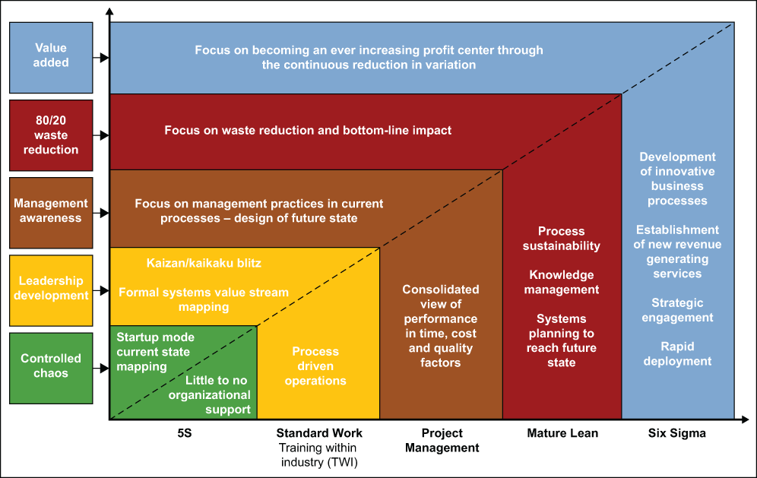

**Figure 16.** [Assess the Maturity of an Organization to Realize Process Improvement Success](https://www.isixsigma.com/deployment-health/assess-the-maturity-of-an-organization-to-realize-process-improvement-success/" \o "Assess the Maturity of an Organization to Realize Process Improvement  Success" \t "_blank)

In order to achieve the goals of customer relationship management, there are a series of concepts that include:

* The processes that are related to the customer and the organization are: marketing, sales and service. In addition to these processes and depending on the business area, there are other processes that are directly effective and should be addressed.
* Human factors have a key role in customer relationship management strategy, both in terms of employees within the organization and in terms of existing customers.
* Technology is a facilitator of strategy implementation. Therefore, it is important to know which of the technologies are more important and how they help to implement the strategy.
* Customer relationship management business strategy includes marketing, sales, customer service, human resources, and the use of the Internet to maximize profitability and interaction between customers.

**The concept of processes, human resources and technology in order to implement the customer relationship management strategy**

**1- Processes:** Customer relationship management is an internal organizational strategy to create satisfaction and long-term relationships with customers. Also, one of the important and determining factors is the analysis of the processes that are in any way related to customer interaction. Therefore, the most important processes related to interaction with customers are marketing, sales and service.

**2- Marketing:** There is a new perspective on the marketing mix including product, processes, efficiency and performance and people, which gives personality to traditional marketing and improves it by focusing on communication with customers. Although the marketing process is at its center, its orientation is based on the needs of customers. Customer relationship management, understanding and recognizing customer needs, recognizing customer behavior and buying habits are all processes within the marketing process, but they should be considered as more than one piece of the marketing machine and a source of information that should be shared throughout the organization.

**3- Sales:** In the sales process, communication between customers and the sales force is very essential in the framework of customer relationship management. Sales force and customers have long-term face-to-face communication and interaction. Although customer relationship management is always a natural aspect of the sales process, the customer relationship management strategy has a more significant impact on it. Collecting and tracking sales data is helpful in developing a marketing plan.

**4- Services:** within the environment of customer relationship management strategy, relationship with customers is a basic concept. Services are related to all concepts and issues related to the customer. The service stage provides the organization with a definition of customers who have interacted over the phone or in person with employees of the organization. In other words, customer care creates a great relationship, about how they behave, how they solve their problems. Studies conducted at Harvard University show that the overall quality of services provided by the organization is directly related to the level of customer satisfaction, and this emphasizes the importance of personal communication between customers, the organization, and its employees. It is quite clear that the marketing, sales and service process has evolved over time and must be in line with the new needs and demands of the markets. In the customer relationship management strategy, the evolution of these processes is directly related to the overall goals of the organization: to create satisfaction and long-term relationships with customers.

**5- Human factors:** The key factor in customer relationship management strategy is how to communicate with customers. This approach is based on the fact that at least two parties are involved in this relationship: the supplier and the buyer.

**Customer related concepts**

In order to have sustainable relationships with customers, organizations must be aware of three key concepts. First, they must know how customers define value, and then they must create value according to the needs of customers, and finally, they must strive for customer retention and loyalty.

**1- Value:** Customers identify value in different ways: what customers want from goods and services, low price and correlation between price and quality.

**2- Satisfaction:** satisfaction is created by fully responding to customers. When long-term relationships are established, customer satisfaction turns into loyalty.

**3- Customer loyalty:** Customer loyalty is one of the key points in today's marketing. It is quite obvious that profitable customers are those who have lasting relationships with the organization. Loyalty is closely related to performance and efficiency, having the right products and services, the right price at the right time and place.

**Organizational concepts**

There are different concepts related to organizational behavior, which include:

**1- Change in the culture of the organization's employees:** changing from a product-oriented approach to a customer-oriented approach requires changing attitudes in the organization. The most important reasons for poor service quality are: lack of quick access to staff, inattentiveness of staff, highest level of customer abandonment with service-related problems.

**2- Management changes:** It is very necessary to pay attention to the fact that customer-oriented strategy has strong effects on employees and management.

**3- Communication:** When implementing any strategy plan, communication with desired goals is very important.

**4- Feedback:** Employees have direct contact with customers on a daily basis. As a result, the existence of feedback programs in connection with the implementation of customer relationship management strategy is mandatory.

**5- Effective leadership:** Customer relationship management includes the introduction of process changes and new information technology. Therefore, effective leadership of this information is very important. Also, effective information management plays a key and decisive role in customer relationship management.

**Technology**

In many commercial communications, especially those involving customers and buyers, technology often has a new paradigm in the way of doing business. On the other hand, technology provides solutions for organizations' challenges. Technological advantages in global networks lead to the development and convergence of interactions and are useful for the growth of e-business and customer relationship management. It is important to note that in order to implement the customer relationship management strategy within organizations, organizations should not start from zero. In general, companies today have information about customers, but this information exists in separate systems. One of the biggest challenges facing today's organizations is the need for integrated information in order to access customer information.

**1- Information systems:** One of the biggest problems with customer relationship management is that it is often thought of as software, not a strategy. In order to provide solutions, organizations introduced and created organizational systems. In customer relationship strategy, integrated systems are a key factor. Because through them you can access information about customers, information that can be used in marketing, sales and service departments.

**2- Automation of the sales force:** one of the most important problems of customer relationship management software, especially in the sales area, is that most software does not pay attention to the fact that companies did not start from zero. They have specific products and markets and develop specific cultures and operations. The only solution for this case and creating a competitive advantage for the organization is to evaluate each element correctly and look at the organization from a comprehensive point of view, coordinated with people, processes and technology.

**3- Data warehouse and data mining:** In general, the purpose of data warehouse is to create and establish a repository and warehouse of data created by the organization's systems, to keep them available and easy to read for people in the system. Once the data is transferred to the data warehouse, it is collected and integrated into a consistent and stable structure. In general, the data warehouse has different databases as the source and access gateway for the end user.

**4- The impact and penetration of the Internet:** from the perspective of customer relationship management, the Internet means interacting with customers, those who create advantages for the organization. Also, the Internet increases the value of communication with customers at certain levels such as easy access, convenience and lower price.

**5- Call centers:** one of the elements and components that have evolved dramatically in competitive conditions is customer service. Many organizations have developed responses to customer-related issues such as complaints, questions, and product warranties. Modern and state-of-the-art call centers include a mixture of traditional technology and new Internet developments.

In other words, they promoted the interaction and communication of new media in order to communicate between customers and organizations. In fact, the phenomenon of the Internet has changed the design of traditional customer service and many organizations have it as an important medium to communicate with customers. One of the key and important aspects is that organizations often ignore the main purpose of contact centers and they tend to forget the essential factor of availability of customer information.

**6- Coordination in the implementation of customer relationship management:** one of the consequences of distress and confusion in the concept of customer relationship management is the inefficiency in its implementation and implementation, which leads to problems and even failure in organizations that perform this method. Leads. Most organizations understand the concept of customer relationship management as a technological solution to problems in their personal realm.

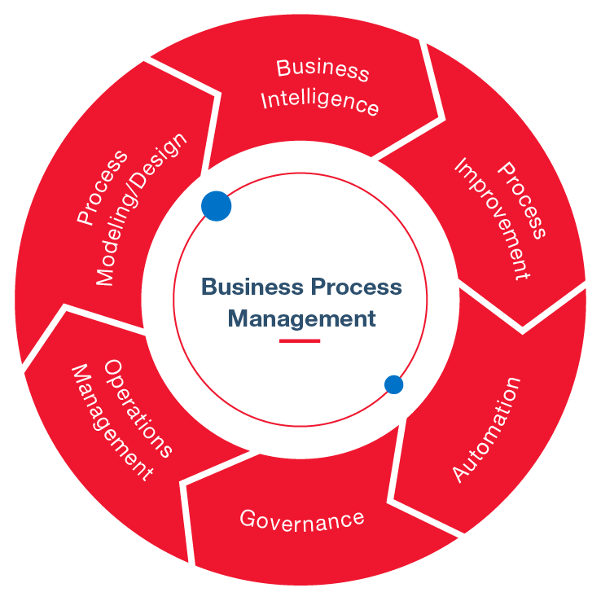

**Figure 17.** [Business Process Management BPM](https://econsgroup.com/business-process-management/" \o "Business Process Management BPM - ECONS" \t "_blank)

**Advantages of customer relationship management (CRM)**

Customer retention is very important in small companies due to their limited resources. In addition, an unsatisfied customer causes damage to the organization's market. Because they harm the competition and convince other customers to avoid doing business with the organization. Therefore, it is not surprising that customer relationship management is an important topic in the business world. Chen and Chen have also divided the benefits of customer relationship management into two tangible and intangible parts, as shown in Table (9).

**Table 9.** Benefits of customer relationship management (Chen and Chen, 2004)

|  |  |
| --- | --- |
| Tangible benefits | Intangible benefits |
| Increasing income and profitability  Increasing the speed of work  Reducing internal costs  Increasing employee productivity  Reducing marketing costs  Increasing customer retention  Maintaining investment costs in marketing with the highest return on investment | Increasing customer satisfaction  Increase in positive terms  Improving customer service  Simplifying and making the sales process more effective  Closer communication with managers  More depth in customer segmentation  Increasing knowledge of customer needs and desires |

In general, Andre has listed the advantages of customer relationship management business as follows, which can be considered as a more general framework:

* Collecting and integrating information about the customer.
* Development and maintenance of the company's customer base.
* Developing close relationships with customers.
* Providing sustainable competitive advantage.
* Supporting effective sales activities through better sales process management.
* Increased profitability due to more sales.
* Receiving stable and efficient services for the customer regardless of the channel.

Also, if we want to count the benefits of customer relationship management based on each of the units related to customer relationship management, we will reach the following classification.

**Table 10.** Benefits of customer relationship management based on related units (Andre, 2003)

|  |  |
| --- | --- |
| Advantages of marketing and sales | Advantages of customer service |
| Ability to manage opportunities  Find information about accounts  Track and find information about contacts  Access to sales history, knowledge base  Access to competitive information  Support the official sales method  Availability of information to help sales systems  Ability to track, coordinate and report activities | Paying attention to the customer's needs in a timely manner  Reducing problem solving time  Reducing rework in solving similar problems  Assurance of responsibility for requesting services |

**Implementation stages of customer relationship management project**

(Chaffey, Beldi and K. Dessi, 2010) have divided the implementation of the project into three stages:

**1- Planning:**

* Defining the boundaries and scope of the customer relationship management project.
* Creating communication programs.
* Proper definition of the organization's project.
* Software infrastructure design.
* Project planning.
* Selection of people in different fields.
* Selection of executive agents.
* Ensuring the right resources.
* Definition of goals.
* Launching the customer relationship management project website on the company's internet.

**2- Foundation:**

* Gathering the expectations of end users.
* Technical design of work.
* Customer orientation and improvement of customer relationship management software.
* Control the results of the work package.
* Ensuring the quality of the work package.
* Testing in a reduced scale of functional tools.
* Establishing the project and controlling it.
* Communication with top management and local manager.
* Tool compatibility.

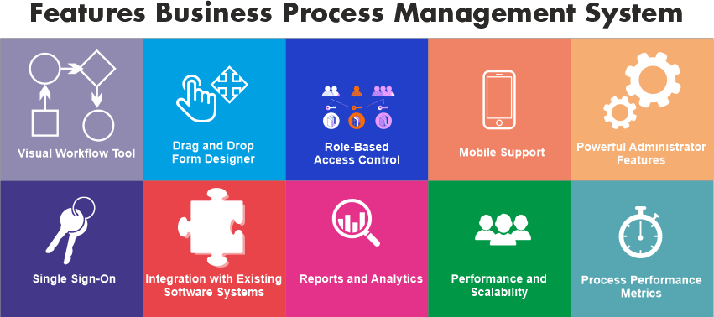

**Figure 18.** [BPM Full Form: Business Process Management](https://www.javatpoint.com/bpm-full-form" \o "BPM Full Form: Business Process Management - javaTpoint" \t "_blank)

**3- Execution:**

* Improving the technical features of customer relationship management software.
* Evaluation of end users.
* Valuing usefulness and usability.
* Transferring communication to brokers.
* Marketing the final project in the local area with top managers and end users.
* Establishing and distributing successful communications through the Internet and mail.

**Obstacles and failure factors in the implementation of customer relationship management strategy**

* Organizational changes.
* Company policies.
* A level understanding of the concept of customer relationship management.
* Poor executive skills.

This evidence shows the importance of defining customer relationship management as a business strategy and therefore as a starting point for organizations with senior management (Torkzadeh & et al,2005). Although customer relationship management is a relatively new concept, there are few experimental companies pursuing proper understanding and implementation.

As a result, there is an imperative need to know more about the objectives, to evaluate the experiences gained by other companies, to find and discover the skills both inside and outside the organization in order to successfully implement customer relationship management. There are also other factors for the failure to implement the customer relationship management strategy:

* The understanding of the board of directors and managers is that customer relationship management is not just a strategy that requires changes in aspects and concepts of different organizations, and its implementation is not instantaneous.
* It is assumed that today's customers are known and that they do not use all available sources to gather information about customers.
* There is also ineffective communication between departments.
* The lack and absence of standards does not allow the creation and gradual evolution of a strong strategy (J. Laplaca, 2004, 14).

Traditional marketing focused on winning customers, but today, customer relationship management focuses on keeping winning customers. The new paradigm of customer relationship management reflects changes in traditional marketing and is described as customer management. Customer relationship management grows in business processes such as relationship marketing and the increasing emphasis on keeping loyal customers through effective customer relationship management. Relationship marketing emphasizes that customer retention has a significant impact on the company's profitability. Because maintaining relationships with existing customers is much more efficient than creating new types of customers.

In some organizations, CRM is a simple technological solution to developing separate databases and sales force automation tools that link marketing and sales functions to improve targeting efforts. The rest of the organizations focus on customer relationship management as the specialized design of tools for one-to-one communication with customers, which is responsible for sales and service, contact center and marketing department. Therefore, it is clear that the concept of customer relationship management has technological components and factors.

Although the technological components are there, it is important that the organization has a systematic view. They need to understand the practical and theoretical concepts of customer relationship management before embarking on its projects. Customer relationship management systems should potentially address key components of the strategy process (Rygielski & et al,2002(.

**Chapter IV**

*Analysis of the mixed effect of social marketing*

Today, organizations live in a different world than in the past years. The increasing competition that exists among different organizations within the borders as well as at the international level has prompted organizations to maintain their position in this field by using different methods and using different tools. to move forward (Abdolahi, 2011). Social marketing is the application of business marketing techniques to analyze, design, implement and evaluate programs designed to influence the behavior of target audiences in order to improve their personal and social well-being. This philosophy wants to create a balance between satisfying the interests of customers, long-term interests of society, satisfying the goals of the organization and economic enterprises (Andreesen,1994). The perspective of social marketing is based on the basis that each organization first determines the needs, wants and interests of its consumer markets and then provides them more efficiently and effectively compared to competitors, in such a way that the survival and improvement of the welfare of the customer and society provide both (Cutler,1984). The current research seeks to analyze the effect of mixed social marketing on the effectiveness of urban advertising and ultimately help the Isfahan municipality for citizenship education and increase the effectiveness of urban advertising in the field of citizenship behavior.

**Definition of the subject (definition of the problem, purpose of implementation and application of research results)**

In this part, the definition of the subject has been discussed, which includes the statement of the problem, the purpose of the implementation and the application of the research results. With the introduction of the concept of sustainable development into the business and political environment, the unstable nature of the existing patterns of development and consumption was revealed. Social marketing is the field and territory of a new science that tries to realize social goals and objectives by using commercial marketing techniques. In other words, the philosophy of social marketing is different from other marketing philosophies in that it emphasizes the interests of the future and the society and their well-being, and it does not only seek to deal with commercial purposes, but seeks to involve cultural and value issues in a way It is real in marketing issues. A review of past researches shows that although the most application of social marketing is seen in the health sector, it also has potential in sectors such as resource protection, energy and natural environment, culture and influencing actions and behavior in society. Also, since the tool used in marketing is the marketing mix, and companies and institutions achieve their goals by controlling the components of this mix, and considering the new and different philosophy of social marketing, the components of this mix for social marketing It is defined differently. Therefore, there is a need for research in the field of recognizing and measuring the extent of the influence of these components on the behavior of customers, and considering the research gap in the mentioned fields, it is necessary to carry out research in these fields.

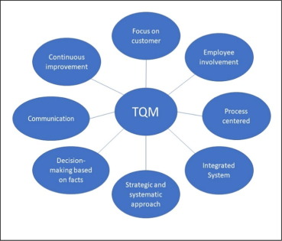

**Figure 19.** [The Total Quality Management (TQM) journey of Malaysian building contractors - ScienceDirect](https://www.sciencedirect.com/science/article/pii/S209044791930156X" \o "The Total Quality Management (TQM) journey of Malaysian building  contractors - ScienceDirect" \t "_blank)

**1- The purpose of the implementation and the necessity and importance of the research:** Andreessen (1994) defines social marketing as follows: social marketing is the application of commercial marketing techniques in order to analyze, design, implement and evaluate programs determined to influence the audience's behavior. The goal is to improve their personal and social well-being.

This philosophy wants to create a balance between satisfying the interests of customers, the long-term interests of the society, and satisfying the goals of the organization and economic enterprises. The perspective of social marketing is based on the basis that each organization first determines the needs, wants and interests of its consumer markets and then provides them more efficiently and effectively compared to competitors, in such a way that the survival and improvement of the welfare of the customer and society provide both (Cutler,1984). To collect information and organize the subject literature and theoretical foundations from the library method and review the texts and electronic resources to prepare the questionnaires used from the interview method and library study and to collect the data needed to test the research hypotheses from the questionnaire.

This research is in terms of research strategy in the category of applied research, in terms of research purpose it is descriptive type, in terms of correlation research type, in terms of research environment it is field type, in terms of research method it is survey type and in terms of time horizon, it is cross-sectional. A questionnaire was used to collect information. spss and smart PLS software were used to analyze the data. Social marketing is the field and territory of a new science that tries to realize social goals and objectives by using commercial marketing techniques. In other words, the philosophy of social marketing is different from other marketing philosophies in that it emphasizes the interests of the future and the society and their well-being, and it does not only seek to deal with commercial purposes, but seeks to involve cultural and value issues in a way It is real in marketing issues.

A review of past research shows that although the most application of social marketing is seen in the health sector, it also has potential in sectors such as protecting resources, energy and the natural environment, creating culture and influencing actions and behavior in society. The tool used in marketing is the marketing mix or 4P, which is defined in a different way due to the different philosophy of social marketing. Today, the importance of advertising in advancing the goals of organizations active in the commercial and social fields is accepted. Advertising is a tool for organizations to communicate with the audience through which they introduce their products and activities. This matter is of particular importance in improving the position of the organization in the competitive environment. However, the use of such a tool requires the allocation of significant financial and human resources. The importance of evaluating the effectiveness of advertising for organizations is the need to know whether advertising can achieve the goals it is designed to achieve. And did the allocated costs have a good return for the organization?

Also, advertising for many years has been considered as one of the important tools of commercial and non-commercial organizations to introduce activities and attract the attention of target audiences and groups. People are exposed to countless advertisements every day, and organizations pay for these advertisements through their financial and human resources. What questions such a volume of investment is the degree of success of these advertisements and investments in achieving the goal, and in other words, the degree of their effectiveness. Can advertising achieve what it was designed to achieve? One of the methods used by Isfahan Municipality to spread the correct culture of citizenship in recent years has been designing and presenting street advertising banners with various social issues.

The purpose of this research is to analyze the effect of mixed social marketing on the effectiveness of urban advertising in Isfahan municipality. The second chapter examines issues related to this issue. In other words, this chapter is devoted to a review of the literature and the background of the research, in which the researchers conducted in connection with the issue of social marketing and the effectiveness of advertisements and the results of these researches are presented, and based on these results, the investigated factors and research variables are extracted. becomes in the beginning, the concept of social marketing and the activities related to social marketing and then the mixed components of social marketing are mentioned in the discussion of advertising and effectiveness. In the following, he examined the effect of the components of this mixture on the effectiveness of urban advertisements of Isfahan municipality in the direction of promoting citizenship culture, and finally, this chapter ends with the presentation of models for evaluating the effectiveness of advertisements and finally the research model.

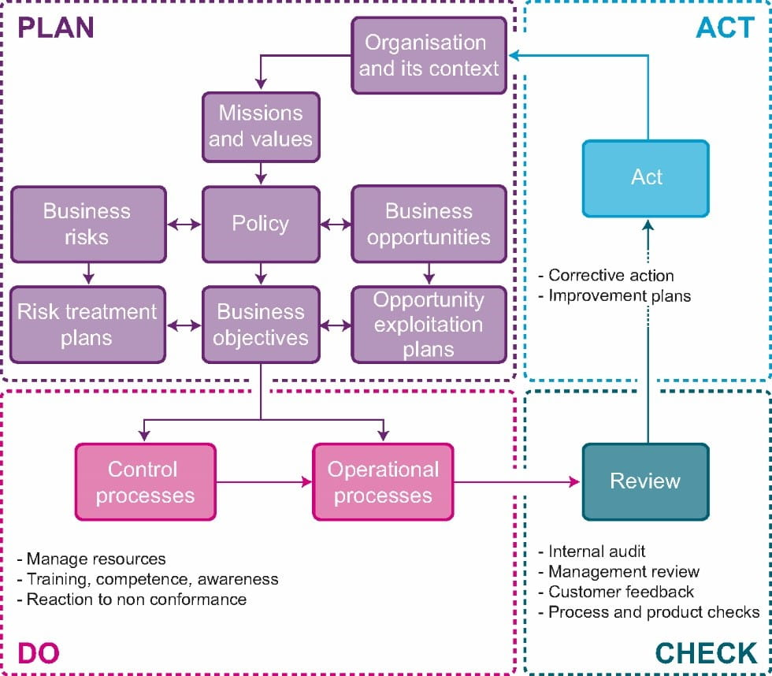

**Figure 20.** [Quality Management Systems and ISO 9001 2015 Certification](https://www.bmtrada.com/resources/quality-management-systems-and-iso-9001-2015-certification" \o "Quality Management Systems and ISO 9001 2015 Certification | BM TRADA" \t "_blank)

**Social marketing**

Social marketing has long been used by government and non-profit organizations as a tool to influence and influence the behavior of the public, but the beginning of social marketing is attributed to the studies of Kotler and Levy (1969) and Kotler and Zaltman (1971). (Lennon, Rentfer and Ellery,2010).

The idea of using the principles and techniques of commercial marketing in the field of social and behavioral sciences dates back to more than three decades ago. In the more than 30 years since Cutler and Levy (1969) introduced this way of thinking, many of the basic ideas of marketing have been adopted in the health and social sector (Hastings and Saren,2003). In the opinion presented by Weib, this issue can be seen: the sale of brotherhood is done in the same way that is used to sell soap (Domegan,2008). In this way, the application of the principles and methods of commercial marketing in the field of social issues was accepted. In the 1970s, social marketing was considered as selling ideas (Domegan,2008).

In fact, social marketing uses the principles and techniques of commercial marketing to solve social problems. Social marketing has expanded over the years and in recent years has become one of the increasingly important aspects of marketing, and researchers such as Andreessen predict that this trend will continue (Cutler, Roberto and Lee,2002), so that This marketing approach has been widely accepted by government and non-government agencies, and they use it to solve social problems and dilemmas, including improving health, preventing violations and encroachment on the rights of others, protecting the environment, and encouraging social participation. Andreessen,2003; Lai, Nepal and Cheng,2009).

Today, government organizations, especially the United States federal government, continuously use social marketing (Lennon, Rentfer and Ellery,2010).

**1- The concept of social marketing:** theoretically, there is no general definition for social marketing (McDermott, Steed and Hastings,2005). Several definitions of social marketing have been provided by different experts.

According to the definition of Lazar and Kelly (1973), social marketing deals with the application of marketing knowledge, concepts and techniques to promote social goals at the level of economic goals, as well as with the analysis of social consequences of policies, decisions and marketing activities (Hastings and Saren,2003).

Andreessen (2011) defines social marketing as: the application of commercial marketing technology to analyze, plan, implement and evaluate programs designed to influence and influence the administrative behavior of target audiences in order to improve their personal and social well-being (both,2008).

According to Cutler's view, social marketing uses the principles and techniques of marketing to influence a target group to accept, reject or leave a behavior for the benefit of individuals, groups or the whole society (Cutler, Roberto and Lee,2002). also believes that the main characteristic of social marketing is its fraternity model of business concepts, including consumer orientation, mutual exchange of benefits, the need to focus on changing behavior and handling and solving issues related to the environment as well as people (Hastings,2003). The Academy of Educational Development in Washington, DC offers a new perspective on social marketing, defining it as a method that makes a behavior interesting, easy, and public.

The interesting concept refers to whether the proposed behavior has meaningful benefits from the point of view of the target audience group. The concept of ease refers to whether the target audience has the knowledge, skills and other resources to successfully manifest the desired behavior. And finally, generality or universality refers to the social effects affecting the audience from family, ethnic groups, colleagues or neighbors (Smith,2007). According to the several definitions that have been mentioned, it can be seen that in general, social marketing is: the application of commercial marketing principles to solve social problems.

**The importance of social marketing**

Social marketing is a systematic way to support behavior change related to health, human services, environmental and social issues and problems, which is based on the principles and processes of business marketing. The six concepts of the social marketing approach are: focusing on behavior change as the main body, intervention or influence originating from the audience, segmenting or grouping the audience group into smaller groups, homogeneous groups, using exchange theory to create balance. and the balance between the costs and benefits that an audience faces in relation to a particular behavior. Considering competing behaviors may be more attractive to the target audience than the target behavior and using the traditional four strategy of business marketing namely product, price, place, and promotional activities (Andreesen,1995).

The fact that many social problems have behavioral roots has been accepted by everyone (Domegan,2008). Social marketing uses a set of tools with the ultimate goal of changing the behavior of target audiences (Lai et al.,2009). When the need to change behavior is felt among a group of people, in fact, harmful behaviors such as smoking, drinking alcohol, harming the environment, ignoring rules and regulations should be guided by using efficient and effective programs. stop driving, or through incentive programs and appropriate messages, encourage people to develop desirable social behaviors, including compliance with health-related programs, use of seat belts while driving, or environmental protection in the form of compliance with regulations and laws Citizen encouraged. Social marketing can systematically help relevant department officials in this issue by using commercial marketing techniques (Novak et al.,2015). In fact, social marketing tries to solve social problems by changing the beliefs that have penetrated and established in people's minds, as well as behaviors related to these beliefs that have harmful effects on consumer health (Walsh et al.,2010).

Laws and regulations and educational programs are also among the methods of behavior control, but social marketing is different from education that tries to change people's views by providing information. Education can be considered an effective tool to encourage a desired behavior only when people are motivated by their personal interest to engage in the desired behavior and informing them about the available options is sufficient to encourage voluntary acceptance of the behavior. On the other hand, these laws and regulations force people to behave in a socially desirable manner (Rothschild,1999).

This approach is used when stopping undesirable behavior is beneficial for the target audience group, and using rewards to change it is not socially desirable. In addition, the laws and legal restrictions require continuous monitoring and the use of coercion, which increases the implementation costs and, in some cases, may cause disagreements among program designers (Lai et al., 2009). When the question of engaging in social marketing is raised, agencies use a type of exchange to provide a social product, the tangible and intangible benefits of engaging in this relationship clearly go back to the target audience group (Lai et al.,2009).

And the advantage that agencies get in this relationship is actually the support they receive from the audience (Rothschild,2004). Therefore, when there is no personal interest to engage in a specific behavior among the audience, and also when laws and regulations are inappropriate for forced behavior change, social marketing can provide designers with appropriate solutions (Lai et al.,2009). According to the above, it can be understood why today both commercial organizations and non-profit organizations have turned to using social marketing programs, especially in areas where the intervention of educational programs and laws and regulations are not successful (Dumegan,2008). In fact, social marketers can use rules and regulations to change and modify behavior in a way that commercial marketers cannot (Cutler, Roberto and Lee,2002).

**Social marketing objectives**

The ultimate goal of social marketing is to improve individual and social well-being, not systemic profitability, and this is what distinguishes social marketing from other dimensions of recovery (McFadyen et al.,2002). Emphasis on society and people is another point that social marketing cares about.

Social marketing does not only influence the behavior of individuals, but this influence also includes professions, organizations and policy makers. In other words, in addition to the downward flow, social marketing can also work upward and seek to change professional behavior. For example, encouraging policy makers to adopt laws and regulations related to consumption is included in this field (Digaspati,2014). In general, social marketing seeks to achieve one of the following four goals in the audience: acceptance of new behavior, rejection of potential behavior, modification of current behavior or abandonment of old behavior (Cutler et al.,2002). Behavior change is voluntary and helps to understand what the target audience knows, believes or does using a client-centered approach (Cutler et al.,2002).

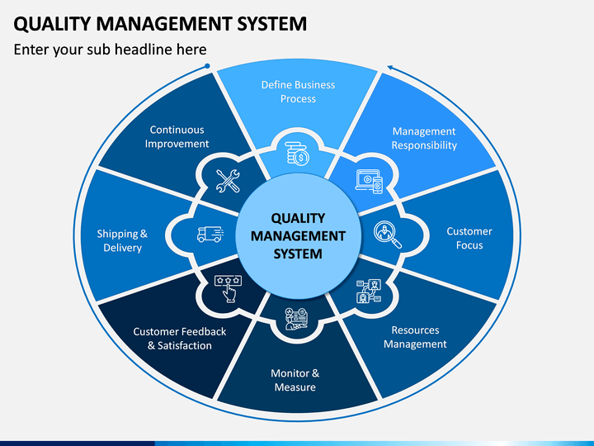

**Figure 21.** [Quality Management System](https://www.sketchbubble.com/en/presentation-quality-management-system.html" \o "Quality Management System PowerPoint Template - PPT Slides" \t "_blank)

**Characteristics of social marketing**

In 1994, Andreessen provided an acceptable definition that stated that the ultimate goal of social marketing is to influence voluntary behaviors (Andreessen,1994). He defined social marketing as the application of commercial marketing techniques, which aims to analyze, design, implement and evaluate the determined programs and voluntarily influence the behavior of the target audience and lead to the improvement of personal well-being and community well-being. be made the four features discussed in this definition are:

* Focus on voluntary behavior change which states that social marketing is not forced or legal.
* Social marketing tries to change by applying the principles of causal exchange. Social marketing outlines that if change occurs, there will be clear benefits for the customer (Haustin and Sennheiser,1987).
* It uses marketing techniques such as consumer-based market research, segmentation, targeting and marketing mix.
* The ultimate goal of social marketing is to improve individual and community well-being, not the profitability of the organization, and this is what distinguishes social marketing from other aspects of marketing.

**The social marketing approach brings with it certain concepts that are necessary to achieve social change. These concepts include: (Petty and Petty, 2008)**

**A) Customer Orientation:** Social marketing is similar to business marketing in emphasizing understanding, responding and communicating with the customer. In relation to social issues, communication moves from focusing on the message to considering the customer's common point and includes every factor that the customer may encounter in the process of change.

**B) Emphasis on retention:** Social marketing seeks to go beyond attitude change to encouraging new behavior and ensures that new behavior is maintained until it becomes consistent and consistent.

**C) Flexibility:** social marketing can be used for different groups of stakeholders including media, target audience and legislators. It can also be used for the target audience in different stages of awareness and accountability in relation to issues and behaviors. In other words, for the group that has not yet paid attention to the issue, the emphasis will be on awareness, while for the group that has committed to the behavior, the emphasis is on maintaining that behavior.

**D) Participation opportunities:** Facing social issues such as encouraging consumption reduction can provide new opportunities for participation among community members, associations and companies. For example, a social marketing intervention to reduce energy consumption can involve the energy supply system, employees, individuals and public departments.

**Social marketing theories and models**

Social marketing is a powerful theory based on socio-psychological theories, and as previously mentioned, its basic basis is exchanging theory (Petty and Petty,2003), but it is actually an interesting and complementary combination of different theories. Although exchange theory is related to economic and marketing patterns, it is a tool related to economic and marketing patterns that is widely used in social marketing. The most famous theory used in social marketing is the transtheoretical model of health behavior change (Andreesen,1995), which is known as stages of change. Prochaska and DiClemente initially developed this model from psychotherapy and behavior change theories and developed it with the steps that people took to achieve a behavior change and it with the steps that people went through to achieve a desirable behavior. combined (Krosirovsky,2013).

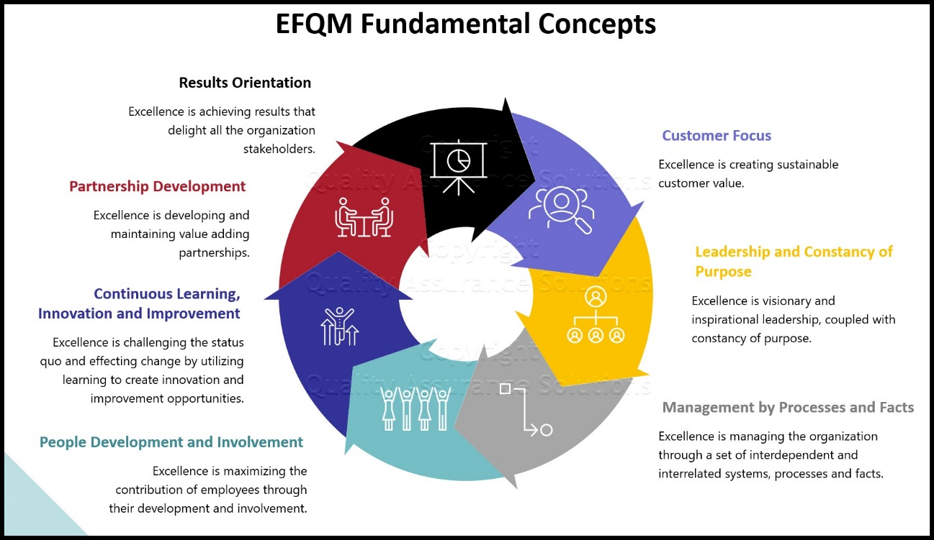

**Figure 22.** [EFQM Business Excellence Model](https://www.quality-assurance-solutions.com/EFQM.html" \o "EFQM Business Excellence Model" \t "_blank)

In this model, five stages are considered for behavior change, which are: pre-contemplation, reflection, preparation, action and maintenance. According to this model, people are in one of 5 stages of change. Each intervention should be tailored to the specific characteristics of the target audience in each of these stages. This model is very important from the point of view of social marketing. Because it states that in most situations people are not ready to act.

Therefore, it is very important to focus on the previous stage and accompany the target audience before they engage in the new behavior (Lefebvre,2001). Another famous theory in social marketing is social cognition theory, which was proposed by Albert Bandura. This theory implies the role of abilities acquired by people in influencing behavior. He uses the metaphor of the human brain as a computer. Researchers now focus on how computers process inputs and produce outputs, rather than on external stimuli that affect information processing.

This theory describes the function of psychology based on three elements, which are: internal personal factors, behavioral patterns and natural events. They also emphasize personal, social and cultural indicators (Bandura,2001). Another theory in this field is the unbalanced cognition model. In this behavior change model, it is expressed as follows: a person's attitude will change when his behavior changes.

This theory is used to show the benefits of applying regulations to promote desirable behaviors (Mohammadi et al.,2014). Among other existing models, we can mention the health communication model. When more realistic results are considered, a combination of useful social learning or marketing strategies with communication strategies through mass media can perform better (Mohammadi et al.,2014). Another model is the theory of planned behavior model, which was used in the study of Mirandazgara (2010) to analyze the impact of social marketing on changing behavior and attitude towards the consumption of scarce resources.

The independent variables in this model are: social marketing mix including product, price, place and promotion and people's perception is also dependent on the perceived behavioral control that this behavioral control is related to, on people's perception of how hard it is to perform a new behavior.

According to this theory, human behavior is guided by 3 types of considerations:

* Beliefs about possible consequences of behavior (behavioral beliefs).
* Beliefs about the normative beliefs of others (normative beliefs).
* Beliefs about the existence of factors that may facilitate or hinder the performance of behavior (control beliefs).

Behavioral beliefs create a positive or negative attitude towards behavior. Normative beliefs are the result of perceived social pressure or subjective norm. Control beliefs cause perceived behavioral control. As a general rule, the more favorable the attitude and the stronger the perceived mental norm and control, the more the individual will intend to perform the desired behavior.

**Social marketing criteria**

One of the problems that hinders the evaluation of the effectiveness of social marketing is the lack of a general agreement on the concept of social marketing. General definitions are not sufficient to distinguish an intervention as a social marketing intervention. Therefore, we must know what essential elements must be present in an intervention so that it can be considered as a social marketing intervention. In 2002, Andreessen identified the defining criteria of social marketing. He stated that if an intervention has six criteria, it is considered as social marketing (Andreesen,2002).

**A) Behavior change:** The intervention seeks to change undesirable behaviors and provides specific criteria to measure behavior.

**B) Consumer research:** intervention is formed based on the identification of consumer experiences, values and needs.

**C) Segmentation and targeting:** the intervention seek to divide the market into homogeneous segments and set targets in those segments.

**D) social marketing mix:** In addition to the 4p mix of product, price, place and promotion, social marketing also considers policy change and people and states that an intervention that only uses promotion is called social advertising. It is classified, not social marketing.

**E) Trade-off:** considering the factors that lead to more participation of people against the benefits that are given to them.

**F) Competition:** considering competitive behaviors and using strategies that seek to reduce this competition.

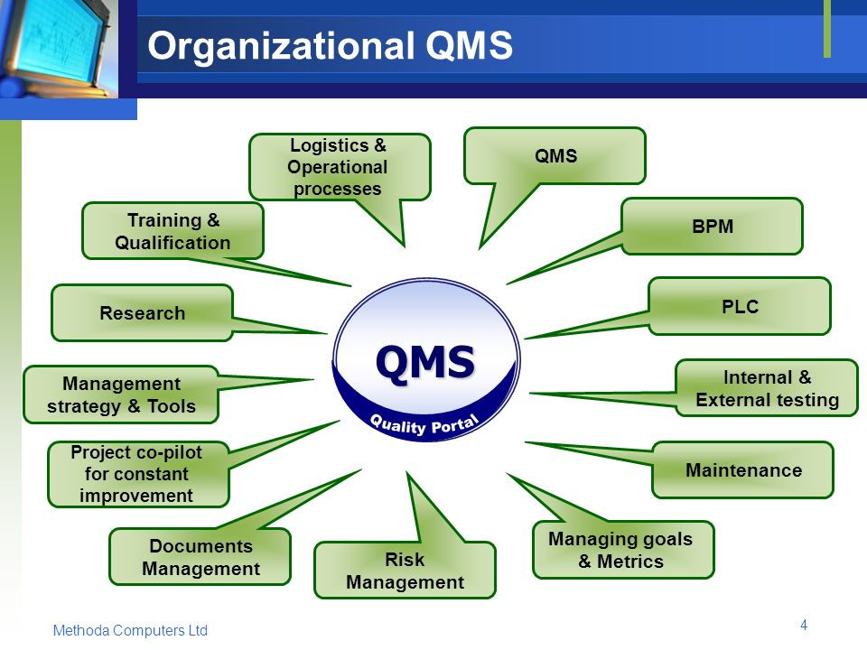

**Figure 23.** [Method QMS Quality Management System](https://slideplayer.com/slide/7003566/" \o "MethodQMS Quality Management System. - ppt download" \t "_blank)

**Social marketing mix**

Social marketing emphasizes the use of business marketing concepts and their application for social purposes and voluntary behavior change of individuals on a non-profit basis. The acceptance of these behaviors is based on the concept of exchange. Exchange theory assumes that human beings are need-oriented and have a natural desire to progress (Hastings & Saren,2003). The economic and psychological basis of this theory supports the concept of social marketing and helps it achieve its goal. Social marketing, like business marketing, benefits from the philosophy of customer orientation. According to this philosophy, business marketers try to identify their current needs, wants and behaviors through continuous research (Andreesen, 1994; Leffer and Flora,1998). By identifying the needs of the target group, the marketing mix will be more likely to be effective.

The process of segmenting the target audience is the main key to intervention design. The next step after segmenting the audience and identifying their behaviors is intervention design and finally the marketing mix which forms the core of social marketing. In 1964, Neil Boroden presented the use of four factors to achieve the desired marketing goals on the target audience. These factors are: product, price, location and promotion. Here the question arises as to how concepts such as product, price, place and promotion are defined in the social environment.

In the discussion of social marketing, the product refers to the new behavior and the benefits that this behavior brings to the target group. The price represents the cost that the consumer bears in exchange for the new behavior, and it mostly shows the dissatisfaction that people express when adapting to the new behavior. Place also refers to the place and market where the exchange takes place. In order for the new behavior to be formed, environmental factors greatly facilitate this adaptation. And finally, promotion refers to the efforts made to communicate with the target group regarding the benefits of the product. It is important to mention here that advertising can be a large part of promotion strategies, but not all.

Usually, the application of marketing mixes in social marketing is much more complicated than business marketing. The main issue is the invisibility of the product that is presented to the audience. Other authors also considered the presence of other factors in the mix of social marketing, among which government, politics and participation can be mentioned (Weinrich,1999). Considering the things mentioned above, it can be said that social marketing, taking into account a wide range of social issues, needs a suitable mix that is compatible with its respective field. Such a consistent and appropriate mix can include the following adjustments to the commercial marketing mix:

**1- Offer rather than product:** The product mix is the basis on which other elements of the marketing mix are determined (Cutler et al.,2002). The product in social marketing is considered as desirable behavior and benefits related to this behavior that social marketers try to offer to the target audience (Cutler et al.,2002; Weinrich,1999). It can also include products and services that facilitate adaptation to new behavior (Lefebvre and Flora,1988).

In the theory of social marketing, the product includes three levels: the main product, the real product and the additional product. The core product refers to the benefits that the audience will receive from the new behavior. The actual product is the specific behavior that is promoted and encouraged. The additional product refers to the additional products and services that are provided in the next steps. Each of the product levels has its own strategies and fills a specific place in the mind of the audience (Cutler et al.,2002). In general, it can be said that marketing interventions seek to encourage a desirable behavior and, in fact, a specific goal.

**2- Cost of participation instead of price:** In most social marketing interventions, the cost of changing behavior is not financial. The cost may come in the form of people's time, physical barriers, etc. The price in social marketing refers to the cost that the audience bears in adapting to the new behavior. In exchange theory, price is expressed in the form of time, effort and energy that the audience spends in exchange for the new behavior and its benefits. Some of these costs have a psychological aspect or the lack of satisfaction that may result for the audience when leaving the previous behavior. The goal of social marketing is to create the perception and awareness that the benefits are equal to or greater than the costs incurred (Cutler et al., 2002; Weinrich, 1999). In addition, the price can be divided into monetary and non-monetary costs. Non-monetary costs are more relevant to social marketing and can include emotional (Weinreich,1999), structural, geographic and physical costs (Lefebvre and Flora,1988).

**3- Accessibility rather than location:** Social marketing is not always based on a physical product, although it may include it. Therefore, the term "location" or "distribution" cannot be suitable for it. Social marketing is more related to service marketing, the main key of which is accessibility. From another point of view, the element of place refers to the place or service where the group will act in the desired behavior and can include receiving the relevant services (Cutler et al., 2002).

**4- Social communication instead of promotion:** Promotion is also a part of the social marketing mix, which is usually confused with social marketing. Social marketing relies less on promotion and advertising-based efforts than business marketing. In social marketing, the characteristics of the target group determine the type of communication channel and appropriate promotion. If in some cases the availability of media or personal communication can be more effective than extensive advertising efforts (Andreesen,1995). Social marketing includes a continuous process that begins with trying to change behavior and ends with achieving social change and maintaining that behavior. Social marketing shares with business marketing communication and interaction, while business marketers communicate with customers to encourage continued consumption and purchase of their products. Social marketers also communicate with target audiences to encourage adoption, adoption, and maintenance of a specific social behavior.

In addition to the conventional 4p in marketing, two elements of partnership and politics also play an important role in marketing efforts. Sometimes, some organizations do not have enough financial and human resources to pursue social marketing efforts. In this situation, partnering with other like-minded organizations can double the success of social marketing efforts (Weinrich,1999). It should also be said that changing the behavior of people can be effective in a certain time and place, but when the behavior change goes beyond a social marketing program or resources are not available to maintain that behavior, it is costly in terms of cost. It is beneficial to adopt a policy that forces behavior change (Weinrich,1999).

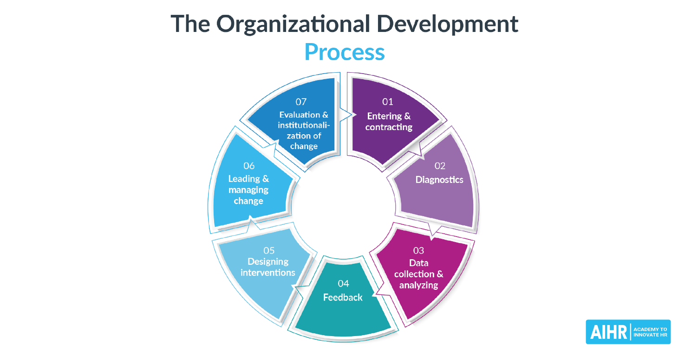

**Figure 24.** [What is Organizational Development?](https://www.aihr.com/blog/organizational-development/" \o "What is Organizational Development? A Complete Guide - AIHR" \t "_blank)

**Advertising**

**1- The concept of advertising:** There are several definitions for advertising.

Advertising means conveying a message, introducing something to others, or pretending something is good or bad, and includes visual and audio messages that are used to promote an opinion or a product from a source through advertising channels to specific groups or to the whole society is destroyed and money is paid for it (Rosta, Venus and Ebrahimi,2013).

Advertising is: a method of marketing that provides information about the product, service and business itself (Park,2008). Commercial advertising is a form of impersonal communication that takes place in exchange for payment of money by a specific sponsor using mass media to persuade or influence the audience (Wells et al.,2013). Advertisements are social communications that are designed and used in order to inform and increase awareness and, in most cases, to convince the recipient of the advertisement message to accept a certain point of view or behavioral tendency (Wire,2002). Based on the above definitions, the concept of advertising can be expressed as a method of social communication through which a message is conveyed to the audience, and its purpose is to change the audience's point of view and influence his behavior.

**2- The purpose of advertising:** advertising is considered one of the important means of communicating with customers (Bendixen,1993). Organizations usually design advertisements to achieve specific goals. In fact, advertisers expect specific results based on the goals they set (Ramalingam et al.,2006). According to different points of view, different opinions have been presented regarding the purpose of advertising design.

Park (2008) stated that the main purpose of advertising is to create an image of the product and encourage consumers to buy.

Wire (2002) believes that the purpose for which advertising is designed is to create and increase awareness in the audience and to convince him to accept the point of view and behavior presented in the advertising message.

Bendixen (1993) also believes that the topics that an advertisement is designed to achieve are:

* Creating awareness about a new product or brand.
* Communicate about product or brand features and benefits.
* Creating a favorable perception and impression towards the product or brand.
* Creating a preference or advantage for a product or brand.
* Convincing customers to buy a product or brand.

The point that is taken from different opinions in this field is that advertisements aim to create psychological effects on the audience and to influence his view on a certain issue and also to create a positive view in the mind of the audience towards that issue and finally It is designed to create a desire to accept and act on the advertisement.

**3- Importance of advertising:** In society or advanced communication technology, advertising has become one of the main tools used by industries to communicate with consumers (T Sai,2006). Different companies around the world allocate a significant part of their financial resources to the use of advertising agencies every year.

**4- The concept of advertising effectiveness:** In the literature related to advertising, various explanations have been provided for the concept of advertising effectiveness. Also, several concepts have been introduced as factors and components of advertising effectiveness. In the following, this point of view and the factors raised as components of advertising effectiveness will be examined. According to the opinion of a group of experts, the effectiveness of advertising generally includes two parts. One is a communication effect and the other is a sales effect. The communication effect is evaluated through the recognition of the ad and the attitude towards the ad. Sales effectiveness is evaluated through behavioral goals.

**5- The importance of evaluating the effectiveness of advertisements:** Undoubtedly, today's competitive world has turned advertisements into one of the key tools for managers and organizations to achieve their goals and communicate with their customers and target groups. Organizations try to introduce their products and services to their contacts and customers through advertising and by using advertising messages to make them aware of these products and services and their advantages over other products and services and their advantages over other products and services. increase services and thereby improve their position among competitors. In this regard, a huge amount of money is invested in advertising every year. In America alone, companies invest over a hundred billion dollars in advertising every year. To determine the importance of the return of this amount of investment, advertising should be evaluated in terms of how much it can contribute to organizational performance (McAllister et al.,2007).

Achieving such an understanding is possible by realizing the effectiveness of advertising in attracting the attention of the audience and engaging the viewer (De Res,2008). Currently, the relationship between management activities and advertising is increasingly important among organizations. This issue emphasizes the importance of studies regarding the determination of factors that can strengthen or limit the effectiveness of advertisements.

As mentioned, organizations allocate a considerable part of their financial resources to media advertising. Despite the high costs that these activities entail for organizations, the importance of achieving the expected results and the need to evaluate the effectiveness of advertising for managers and advertising designers, however, there are still limited evaluations in this field, whether these costs in terms of sales and the benefit have been fruitful or not? It is worth mentioning that the limited studies that have been conducted in this regard have generally evaluated and measured the general and general effects of advertising on sales and market share (Tellis et al.,2005).

This is despite the fact that, in addition to commercial activities, advertising is also considered as one of the key tools to influence the audience and convince them to accept certain behavioral trends in the field of social marketing. In this research, the mixed effect of social marketing on advertising effectiveness is measured.

**6- Factors affecting the effectiveness of advertising:** Considering the mentioned materials regarding the importance of measuring the effectiveness of advertising for organizations and advertising agencies, we can understand the role of effective advertising design in achieving the goals of this organization. Therefore, knowing the factors that can affect the effectiveness of an advertisement in a positive or negative way is of great importance.

As mentioned, advertising is a type of social communication, in order to predict the effect of this type of communication, the factors that attract the attention of the recipient of the advertisement to various aspects of the advertisement message, understanding its content and the behavior that changes the application of the advertisement message in the format, attracts, to be investigated (Weir,2002). Many studies have been done on the factors affecting the effectiveness of advertisements.

Each of the studies has focused on certain factors according to the different aspects of the advertisement and the audience of the advertisement or the purpose of the advertisement design. In this section, the most important factors that can influence the effectiveness of advertising are discussed. There are several factors that affect the effectiveness of advertising, such as media, time, market life stage, advertisement life stage, as well as creative signs of advertising such as content and implementation elements (Tellis et al.,2005). Also, the use of popular cartoon characters (Rangbrian,2018), size, color (Park,2008; Moriati, Mitchell and Wells,2009; Cheng and Cao, 2011), complexity or simplicity of advertising (Morrison and Dineff,1972; De Res,2008), the use of humor (Makerjee and Huber,2004), the use of famous stars (Rosta, Venus, Ebrahimi, 2013) and consumer characteristics (Martin, Paimi and Agee,2002, Park,2008) are among these variables. Repetition of advertising is also a factor that helps to remind the audience of its content (Rosta, Venus, Ebrahimi,2013). One of the important factors in evaluating the effectiveness of advertising is the attitude towards the advertisement.

Attitude towards advertisement is: general interest or disinterest towards an advertising stimulus when faced with a specific issue (Moven and Minor,2008). Mental imagery (Ben and Allen,1992), clarity of content and emotions called through the advertisement are among the variables influencing the attitude towards the advertisement. Some of these factors can lead to powerful effects, while others may have weak effects or no effect at all. Knowing the effect of each of these factors helps to make management decisions (Tellis et al.,2005).

Managers who are more careful about advertising will try to measure the extent to which a particular advertising campaign achieves its communication objectives. They will also attempt to measure the extent to which a particular advertising campaign achieves communication goals (Bendixen,1993). Among the necessary and needed information for managers is the awareness of which type of advertising works best, through which media, in which way, at which point in time, with what level of repetition, and for how long. Managers should also be aware of why a particular ad works well based on its creative features and what aspects of these features should be changed to increase its effectiveness (Tellis et al.,2005).

The effectiveness of advertising depends on several factors and the effectiveness of each of these factors is different depending on the situation. In general, the effectiveness factors of an advertisement can be classified into three categories. factors related to advertising, factors related to the audience and factors related to the environment (Park,2008).

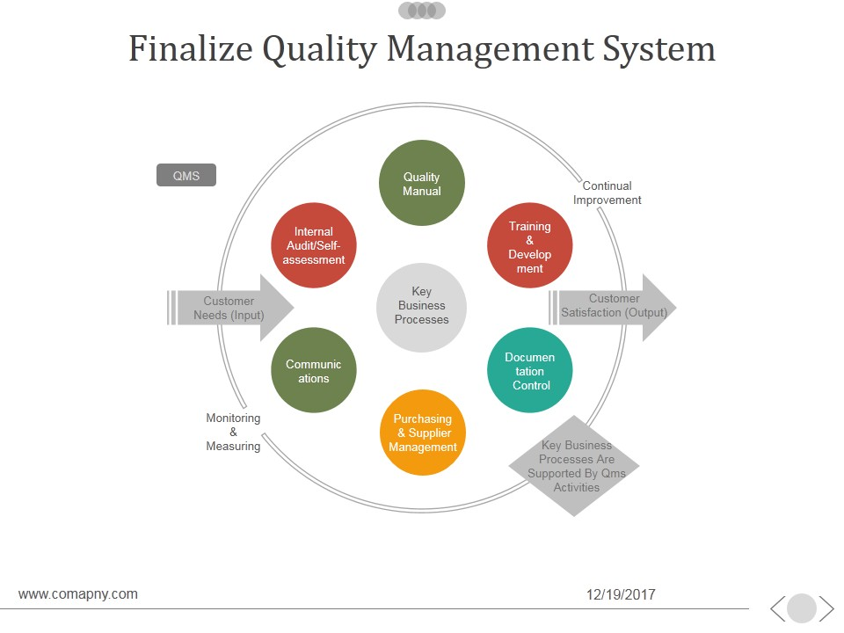

**Figure 25.** [Finalize Quality Management System](https://www.slidegeeks.com/business/product/finalize-quality-management-system-ppt-powerpoint-presentation-guide" \o "Finalize Quality Management System Ppt PowerPoint Presentation Guide -  PowerPoint Templates" \t "_blank)

**Advertising effectiveness models**

**1- Hierarchy of effects model:** Hierarchy of effects model or hierarchical consequences of effectiveness was proposed in the early 1960s by Lavage and Steiner. This model assumes that consumers who purchase a product move through a sequential hierarchy from awareness to product purchase (Bendixen,1993). In other words, this model starts with the awareness of the advertisement and then proceeds through knowledge to create a connection and desire, preference, belief and purchase intention and finally ends with the purchase of the product. The designers of the model believe that this model integrates the cognitive, emotional and behavioral stages of information processing (Kim, Huang and Fesenmeyer,2005).

Accordingly, in this model, three separate stages are identified regarding the response to advertisements (Bendixen,1993).

Most people who have the opportunity to see or hear an ad reach the first stage, however, fewer reach the second stage and even fewer reach the third stage (Bendixen,1993). Therefore, in order for advertisements to work effectively, it must have the ability to guide the viewer from the first stage to the last stage. The research conducted in recent years has questioned the hierarchy of effects model from the point that direct links from the attitudinal dimensions of lower levels to the purchase behavior may provide a better description of their relationship (Kim, Hwang and Felsenmeer,2005).

**2- AIDA model:** studies in the field of evaluating the relationship between advertising and sales include a range of simple linear models to multivariable models and dynamic and static equations. In the meantime, linear models that link related structures to product purchase are the most common approach to describe the relationship between attitudinal dimensions of advertisements and actual purchase behavior (Kim, Hwang and Fens Meyer;2005). The AIDA framework, which is a stage model that enables the classification of behavioral stages related to purchasing by expressing the different stages of the evolution of this behavior (Petit et al.,2011).

The AIDA model was first invented and designed by Almo Lewis in 1898. This model, which depicts the process of sales success based on advertisements, is the result of various studies that were conducted in the life insurance industry in America and made it possible to model the purchasing action from the consumer's point of view in four stages (Petit and colleagues,2011).

This model was based on the belief that sales activities are successful if they can go through four stages, that is, they must attract the audience's attention, create interest in them, and create a desire and a persuasive state in the audience, and finally to accelerate the action (Kim, Hwang,2005). In fact, advertising provides a tool through which organizations can guide their audience from one buying stage to the next (Petit et al., 2011). These steps are:

**A) Attention (A):** attention and awareness of the existence of the product or service.

**B) Interest (I):** interest in receiving information about the features and benefits of the product or service.

**C) Desire (D):** desire towards the product or service.

**D) Action (A):** It means buying a product or using a service.

These steps at any time express the point of view and mental state in relation to the message of the advertisement. In other words, at a certain time, the audience's behavior can appear under the influence of a certain stage of the model (Petit et al.,2011). The figure below depicts these steps in the form of AIDA model.

AIDA model is one of the most used models in the field of advertising. Although the main idea of designing the model was to express the stages of development of the audience's or viewer's point of view of the advertisement during the process of buying products or services, this model also has the ability to measure the effectiveness of advertisements presented in non-commercial areas.

As mentioned before, the subject of advertising in the field of social marketing is social behavior and the purpose of these advertisements is to make the audience aware of undesirable behaviors, their consequences, change the attitude of the audience and finally accept a new attitude in line with the desired behavior. The AIDA model in this section can also evaluate the extent to which these advertisements achieve the established goals. The steps of the model in this case are:

**A) Attention (A):** The audience's awareness of the subject of the advertisement and attention to the message presented in the advertisement.

**B) Interest (I):** interest in receiving more information about the positive and negative consequences of the behaviors presented in the advertisement.

**C) Willingness (D):** being convinced of a new behavioral attitude in the advertising message and accepting this attitude.

**D) Action (A):** fully accepting the new point of view and changing the behavior towards the recommended behavior in the advertising message.

Therefore, according to the social marketing advertising model, it is effective only if it leads the audience from the first stage to the last stage. Based on this, when advertising or attracting the audience's attention and informing him about the subject of the advertisement can lead him to the last stage, i.e., the actual change of behavior, the purpose of the advertisement has been achieved and the advertisement has the desired effectiveness.

**Krugman's Hierarchy Model:** This model was presented by Kugman in 1965, and based on it, effective advertising goes through a triple hierarchy based on position in three different paths, which led to the formation of three sub-models. These models, which are proposed as a result of the difference in the stages of formation of the mental and behavioral position of a person in the face of advertising, are: the learner hierarchy, the documentary unbalanced hierarchy, and the low mental involvement hierarchy.

**A) Hierarchy of the learner:** based on this model, the consumer buys a product or service when he has acquired enough information about that product or service, or in other words, his learning about it has been completed. It is generally used for products and services that the consumer carefully decides about. Buying a house and car and using insurance as well as making decisions about education are among these products and services.

**B) Unbalanced and documentary hierarchy:** The documentary theory is based on the belief that people try to attribute their behavior to reasons. These causes can be internal or external to the person or subject in question. Accordingly, if it is someone else's reference, do you know if the endorser is endorsing the product because they are interested in it, or because they are being paid to do so?

**C) Hierarchy of low mental involvement:** This model is used for products that the consumer does not spend a high mental effort to make a decision. In other words, in these cases, the product group has a low price and is cheap. Therefore, the consumer prefers to try a brand and make a decision after using it, instead of examining the possible purchase options and choosing among the proposed brands. Satisfaction in a trial purchase leads to brand recall and, as a result, repeated purchases. Otherwise, the purchase will not be repeated. Repeat purchase of a brand leads to the creation of interest towards that brand (Park,2008). The behavioral path of the individual and the hierarchy of this model are as follows:

**DAGMAR model:** Another model that has been proposed to evaluate the effectiveness of advertising is the advertising process model called DAGMAR, which was invented by Kelly in 1961. This model uses ad goals to evaluate the ad. According to this model, commercial advertising should be able to move a potential customer through four stages of perception. In other words, it should lead a person from ignorance to awareness and then to perception, belief and finally purchase (Kim, Huang and Felsenmeer, 2005).

**Lavage and Steiner's psychological model:** this model was presented in 1961 by Lavage and Steiner based on the idea that people take steps as a result of exposure to advertisements, which are different depending on the distance between each step and the next step. be in the case of some products, these steps go faster.

These products have more economic or psychological obligation for the consumer. Other products may be considered less seriously and purchased with a lower level of informed decision making. In this case, since brand loyalty has been established, the threat from brands is significantly reduced.

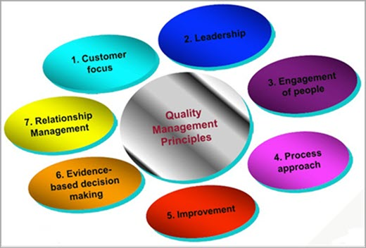

**Figure 26.** [What is Software Quality Assurance (SQA)](https://www.google.com/url?sa=i&url=https%3A%2F%2Fwww.softwaretestinghelp.com%2Fsoftware-quality-assurance%2F&psig=AOvVaw0W0tKxm-UpjhzdEmXaH5MO&ust=1680258737525000&source=images&cd=vfe&ved=2ahUKEwiG5dvauYP-AhUDRuUKHUQJAKwQjhx6BAgAEAs" \o "What is Software Quality Assurance (SQA): A Guide for Beginners" \t "_blank)

**Information Interpretation Probability Model (ELM):** The information probability model (Interpretive Probability Model) is one of the most comprehensive persuasive hierarchical models (Marshall,2006). In fact, this model is used to understand the process of persuasion, in such a way that it describes the decision-making path towards changing belief, attitude and behavior. In this model, the persuasion process starts when the consumer receives a message.

After receiving the message, the consumer starts processing the information. According to factors such as the content of the message, the nature of the consumer and the state of the consumer, the person processes the communication established with a higher or lower level of mental involvement. In this model, depending on the level of mental involvement, the change of belief and attitude may take place in two separate ways. When information processing occurs with high mental involvement, it is said that the person has chosen the central path to persuasion, and on the other hand, when the person is in a condition of low mental involvement, it is said that he has taken the next persuasive path. Is. When belief and attitude change occur through the central pathway, the effects of the higher engagement hierarchy come into play. In this way, the consumer pays more attention to the received message and focuses on the communication and compares it with his attitude position.

If this consumer has the ability to process information, it is possible to create a number of cognitive responses regarding the said communication. Cognitive responses are favorable or unfavorable thoughts that are formed as a result of a relationship in the consumer's mind. Based on the intensity of the cognitive responses, the belief will change and then the attitude will change and finally the behavior will change. When the change of belief and attitude takes place from the central path, it creates relatively stable effects that are predictors of behavior. In this case, the audience uses central clues to evaluate the message.

Central clues are supporting ideas and data that are directly related to the quality of the topics covered in the message. On the other hand, the number of cognitive responses is at the lowest level in the side path to encourage. In this case, the audience evaluates the message using side clues such as the attractiveness and expertise of the source, the number of arguments presented, and the positive and negative stimuli underlying the message (Moven and Minor,2016).

**Non-hierarchical models:** In non-hierarchical models, a specific process sequence is not assumed. In this classification, a person-based approach to advertising is considered, based on which advertising is a part of the brand as a whole. In this model, the opinions of the audience in relation to the product form a set of awareness, test, verbal communication, promotion and advertisement, which works interactively and simultaneously (Park,2008).

Etisami (2013) in his research entitled "Analysis of the impact of social marketing on the preservation and maintenance of urban green spaces" investigated the mixed effect of social marketing on the preservation of green spaces. The results show the effectiveness of the mixed components of social marketing in people's participation in the protection of urban green space.

Shahbazlou (2013) investigated the basic concepts of social marketing in research titled "Investigating the place of advertising in social marketing with the approach of promoting books and reading books". Also, with the approach of book promotion and book reading marketing program, it also separates the basic foundations of these foundations by examining the place of promotion and advertising in the mix of marketing and perceptions and beliefs, and in general, promotion as an alternative to the whole concept of social marketing.

Majdzadeh et al. (2013) in research entitled "Using the social marketing model to reduce the dangerous driving behaviors of taxi drivers in Tehran" investigated the effect of an intervention based on the dangerous driving behaviors of taxi drivers in Tehran. The results indicate a significant decrease in the observed cases of two behaviors in the intervention group compared to the control group and a significant increase in the chance of avoiding these two behaviors by the intervention group after the implementation of the program, indicating the effectiveness of the designed intervention. Also, in this study, they showed that determining the specific target group, designing the intervention model according to the needs and desires of the audience and paying attention to the effective factors of the behavioral market are the basis of the social marketing model. Observance of these principles in the design of behavioral interventions can lead to the reduction of dangerous driving behaviors.

Khajeh (2010) in his research entitled "Investigation of the role of social marketing in modifying the electricity consumption pattern of household customers and its effect on managers' attitude towards the organizational transformation of the Isfahan Regional Electricity Company" measured the effect of social marketing tools on the modification of the electricity consumption pattern. The results showed that social marketing has a significant effect on the reform of the electricity consumption pattern of household customers in the city of Isfahan at a significant level of 05. Also, the significant effect of social marketing on the organizational transformation of the electricity company was confirmed.

Ebrahimian Jolodar (2011) has evaluated the effectiveness of TV commercials on saving electricity in Isfahan city. In this research, he sought to use the AIDA model as one of the models of the hierarchy of effects to measure and evaluate the effectiveness of television advertisements on the topic of saving electricity consumption and the success rate of these advertisements among the citizens of Isfahan. For this purpose, 255 residents of Isfahan city have been selected as a sample and the effect of television advertisements on attracting attention, creating interest, creating desire and finally changing their behavior has been investigated. The results of this research have shown that these advertisements have been effective in terms of attracting attention, creating interest and desire, as well as changing the behavior of the audience. In other words, this research has emphasized the effectiveness of these advertisements based on the AIDA model. Also, the findings of this study have determined that as the end stages of the model are approached, the impact of each stage on the audience increases.

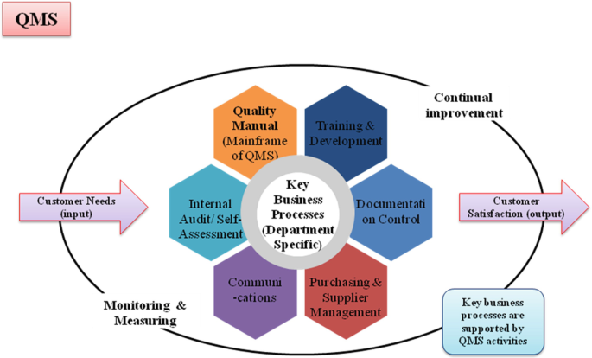

**Figure 27.** [ISO 13485: Medical Devices – Quality Management Systems, Requirements for Regulatory Purposes](https://link.springer.com/chapter/10.1007/978-3-030-91855-2_2" \o "ISO 13485: Medical Devices – Quality Management Systems, Requirements for  Regulatory Purposes | SpringerLink" \t "_blank)

In their research, Ebrahimi et al. (2009) investigated the effect of advertising in attracting tourists in Isfahan city. For this purpose, the type of advertising tools used to attract tourists as well as the effectiveness of these media have been evaluated. The selected sample includes 124 international tourists from European countries, Australia, Oceania and the Middle East, and by distributing questionnaires among this group of tourists, their purpose of traveling to Isfahan and the effectiveness of advertisements to introduce tourist attractions the city of Isfahan has been evaluated from their point of view. The results of the research show that only five advertising tools, television, guide book, newspaper, brochure is in the third place.

By evaluating the effectiveness of these tools, it was found that none of them have the desired effectiveness, but according to the results of the research, the researchers suggest that if the quality of the information provided on the website of the Organization of Cultural Heritage, Handicrafts and Tourism is improved, this tool can be more effective. to be favored in the field of advertising slogans, researchers suggest that considering that the main purpose of tourists traveling to Isfahan is to spend a vacation and visit the historical monuments of Isfahan, the topic of tourism advertising slogans in Isfahan city should be based on advertising and a historical place rich in resources.

Samsam Shariat, Ateshpour and Kamkar (2006) in a study entitled "Comparison of effective factors in the effectiveness of commercial advertising from the perspective of the public and advertising experts" to determine and compare the effective factors in the effectiveness of commercial advertising from the perspective of the people of Isfahan city and also from the experts' point of view. They have paid attention to advertising. The results of this research show that from the people's point of view, television channels and the structure of cartoon animation, attractive packaging, colors related to the product and innovation, attention to the feeling of security and associated signs, information about quality, background and price, dialects and Common reforms, diversity in the content of messages in the TV media, broadcasting between 18:00 and 23:00 and before the start of the programs are the factors affecting the effectiveness. In comparing the effective factors from the point of view of people and advertising experts, the experts found the use of billboards and related colors, cartoon animation, information about awards and certificates, and broadcasting in the form of subtitles to be more effective in advertising from the point of view of the people in this field and in front of the people. , the use of images of women and children, attention to security, informing about the price, benefits and background, dialects and common corrections, proverbs and advertising slogans are considered more effective in these cases from the experts' point of view.

Houshmandi (2004) has also presented research titled "Investigation of the relationship between consumer involvement and the effectiveness of television advertisements". This research has been compiled in two qualitative and quantitative parts through interviews with senior and middle managers of companies active in the detergent and sanitary products industry.

Quantitatively, using a sample of 215 women living in Tehran, the relationship between three independent variables of a person's involvement in buying a product, the quality of information provided in an advertisement, and side signs and symptoms of an advertisement with four dependent variables of brand recall. Product category recall, purchase intention and individual's attitude towards an ad have been investigated. The results of this research show that only the quality of information presentation in advertisements has a positive relationship with one of the variables of advertisement effectiveness, that is, a person's attitude towards the advertisement. It was also found that buyers of consumer products in Iran, regardless of the type of learning they have, do not pay much attention to the many television advertisements of those products, and before being influenced by the arguments presented in the advertisements, they are influenced by side attractions. Advertising, like music, is in the public space of the show. Finally, the attractiveness and persuasiveness of an ad does not necessarily lead to a purchase decision regarding the products that the ad advertises.

Siavashi (2012) investigated the use of humor in Iranian television advertisements and its effect on the effectiveness of these advertisements. In this research, in the first part, the current state of television advertisements in Iran and the place of humor in these advertisements have been examined, and in the second part, the effect of the type of advertising product on its effectiveness has been measured by dividing the advertising products based on the FCB network. By determining the type of mechanism used in the advertisement, the researcher measures the effect that each mechanism has on the effectiveness of the advertisement.

These mechanisms are: emotional mechanism, cognitive mechanism and interpersonal mechanism. According to the results of this research, 14% of the total advertisements broadcasted in Iran have used humor. These results show that there is a relationship between the type of advertised product and the type of mechanism used in advertising with its effectiveness. The effectiveness of advertising in the case of products in which the consumer's emotions are the basis for making decisions when purchasing them is the performance of the product. Also, advertisements that use emotional mechanisms are more effective than advertisements that use emotional mechanisms.

Tapp et al. (2013) in research experimented with social marketing in order to reduce the aggression of drivers in young men from deprived areas. The results indicate the improvement of driving skills in people who completed the test and a significant change and improvement in people's behavior while driving.

Wilhelm et al. (2013) in their research entitled "Using social marketing to promote systematic land use planning in Africa", investigated the role of social marketing in improving systematic land use planning. The analyzes show the usefulness of the social marketing approach for environmental protection.

In their research, Chadhari, Al-Elsen and Persjes (2011) have investigated the effect of increasing the number of images in advertisements on the cognitive and emotional responses of the viewers of the advertisement. These researchers state that the use of images in advertisements attracts attention, creates emotional responses and creates an opinion about the product's features. In this study, two experiments have been conducted, during these experiments, the effect of increasing the number of images in advertisements that have a mixed background and also have a single background. The emotional responses and cognitive responses of viewers have been measured. In the first test, 150 students were selected as a sample, and for 30 seconds in the advertising bias with three features

* A positive factor, a negative factor.
* Three positive factors, one negative factor
* One positive factor and three negative factors were placed.

Then they were asked to answer the questionnaire. The factors that were measured through the questionnaire are: positive feeling, negative feeling and attitude towards advertisement. Based on the results of the analysis of the advertisement questionnaire, types A, B and C were ranked in terms of creating positive, negative feelings and attitudes towards the advertisement. The second experiment was conducted with a sample of 158 students and was similar to the first experiment. The difference between these two experiments was the two sub-sets of images, which means that four separate images were considered for each type of advertisement and the three factors measured were rated. Finally, this research determined that if an advertisement with a mixed context is used, more positive elements and less negative elements should be used to create an emotional response.

In terms of cognitive responses, ads that use both images and phrases to describe the features presented in the ad are not more effective than ads that only have images. Also, when the existing images have created an attitude in people's minds, adding images will not affect their attitude. In ads with a single context, increasing the number of images does not change the emotional response of people. Also, increasing the number of images does not affect the audience's cognitive responses.

Ahmad and Mahmood (2011) in a study explained the relationship between creativity used in advertising and the effectiveness of advertising in Pakistan. In this study, the potential effectiveness of successful television advertisements in Pakistani media has been evaluated. In order to ensure the real situation of the successful lifespan of advertisements, two groups of advertisements were presented in the form of creative advertisements and control group advertisements in a television program to two separate groups of subjects. These ads were played once in one stage and three times in another stage.

After observing the subjects, based on recollection and rereading, they have expressed their answers and reactions regarding the brand and their attitude towards the advertisement and finally their intention to buy. Based on these results, it has been determined that in the condition of viewing the advertisement once, no difference was observed between the creative advertisements and the advertisements of the control group in terms of readability and recall, attitude towards the advertisement and purchase intention.

Nesbit et al. (2009) in a study entitled the effects of age, need for recognition and stimulus intensity on the effectiveness of advertisements investigated how personal characteristics such as age, need for recognition and stimulus intensity in interaction with each other affect the effectiveness of advertisements. they let. They used a mixed research design in this research. The results of this research showed that younger people remember emotional messages, especially negative messages, better than adults. Adults prefer rational and positive messages to emotional messages. Also, the results showed that age affects advertising reactions in comparison with stimulus intensity, not in comparison with the need for recognition. Finally, it showed that both age and the intensity of the stimulus affect the attitude towards the advertisement.

Takahashi (2008) has analyzed the theories and practical methods of social marketing in the field of environmental protection in his research entitled "Social Marketing for the Environment". The results state that social marketing is a cost-effective approach for long-term behavioral changes on a large scale and in appropriate conditions.

Cole (2007) in his research entitled "Group social marketing intervention for the environment: recycling and increasing the purchase of green products" introduces marketing as a tool to increase awareness and change behavior in relation to recycling and the use of green products. The results of the research show the effectiveness and efficiency of social marketing in creating an attitude towards its practical tools to change behavior.

**References**

Alavi, M., & Leidner, D. E. (2001). Review: KM and KM systems: Conceptual foundations and research issues. MIS Quarterly, 25(1), 107–136.

Allen R. Kathleen, (2003), Bringing New Technology to Market, Prentice Hall, New Jersy.

Alshavi.S,Missi.F,Irani.Z,(2011),organizational, technical and data quality factors in CRM adoption-SMEs perspective.

Andrew O. Martyniuk, Ravi K. Jain, Meredith N. Haft, (2002), Market opportunity analyses and technology transfer, International Journal of Technology Transfer and Commercialisation, Vol. 1, No.4 pp. 385-404.

Aurora Garrido-Moreno,Antonio Padilla-Melendez.Analizing the impact of knowledge management on CRM success:The mediating effects of organizational factors.

Aurora, G.M, Antonio,P.M.(2011).Analyzing the impact of knowledge management on CRM success.the mediating effects of organizational factors.

Bandarian, Reza, (2018), Marketing and Commercialization of New Technologies: Stages, Facilitating and Key Success Factors, Rosh Tekhnih, No. 91, pages 39 to 45.

Beijerse,R .P .(1999) .Questions in KM:Defining and conceptualizing a phenomenon. Journal of knowledge Management,3(2),94-109.

Bentum, R. V., & Stone, M. (2005). Customer relationship management and the impact of corporate culture—A European study. Journal of Database Marketing & Customer Strategy Management, 13(1), 28–54.

Briwn, StandIy , Custom reIation management a strategic imperaction in the word if e – business.

Bueren, A., Schierholz, R., Kolbe, L. M., & Brenner, W. (2005). Improving performance of customer-processes with KM. Business Process Management Journal,11(5), 573–588.

Chen, J., & Ching, R. (2004). An empirical study of the relationship of IT intensity and organizational absorptive capacity on CRM performance. Journal of Global Information Management, 12(1), 1–17.

Colgate, M. R., & Danaher, P. J. (2000). Implementing a customer relationship strategy:The asymmetric impact of poor versus excellent execution. Journal of the Academy of Marketing Science, 28(3), 375–387.

Croteau, A., & Li, P. (2003). Critical success factors of CRM technological initiatives. Canadian Journal of Administrative Sciences, 20(1), 21–34.

Danaei Fard, Hassan, Elwani, Mehdi, Azar, Adel, (2008), Quantitative Research Methodology in Management: A Comprehensive Approach, Second Edition, Tehran, Safar Publishing.

Dous, M., Kolbe, L., Salomann, H., & Brenner, W. (2005). KM capabilities in CRM: Making knowledge for, from and about customers work. In Proceedings of the eleventh Americas conference on information systems Omaha, NE, USA, (pp. 167–178).

Frank Meister, bill chambers, Joe fenner , Doculabs, may 31 ,2001 – 1.

Frank Siderio, financial services industry strategist, PeopleSoft, Inc, CRM for Insurance Mardh 07,2003.

Gardhan, Alireza, (2004), Guide to research methods using questionnaires, second edition, Tehran, Jihad University Publishing Organization, Tehran branch.

Greenberg, p (2002). CRM at the speed of light: capturing & keeping customer in intrnet read time. Mc Grawhill . Osbone media.

Gulabi, Amirmohammed, Mehrabi, Roza, Rizvani, Mehran, (2013), Conceptualization of marketing management process in knowledge-based businesses based in Arak Science and Technology Park, Modern Economy and Trade Quarterly, numbers 21 and 22. Page 77 to 98.

Hafez Nia, Mohammad Reza, (2008), an introduction to the research method in humanities, organization for the study and editing of university humanities books, Tehran.

Hansotia, B. (2002). Gearing up for CRM: Antecedents to successful implementation. Journal of Database Management, 10(2), 121–132.

Jan U.Becker ,Goetz Greve ,Sonke Albers.The impact of technological and organizational of CRM on customer acquisition,maintenance,and retention.

Khaki, Gholamreza, (2012), research method with an approach to thesis writing, Tehran, Reklam Publications.

Lehman & Winer (2001), A framework for cuotoRM calafornia management review. Vol 43, no. 4, pp.89-105.

Li, P. (2001). The critical success factors of customer relationship management (CRM) technological initiatives. Doctoral Thesis. Concordia University.

Momeni, Mansour, Ghayoumi, Ali, (2007), statistical data analysis using spss, second edition, Tehran, New Book Publications.

Momeni, Mansour, Ghayoumi, Ali, (2009), statistical analysis using SPSS, Kitab Nou Publishing House, third edition, Tehran.

Munnukha, juha, dynamics of price sensitivity aming mobile service customs. www. Emerald insight. Com, 2004.

Ngai, V. W. T. (2005). Customer relationship management research (1992–2002): Anacademic literature review and classification. Marketing Intelligence and Planning,23(6), 582–605.

Philip koiIer & Gary Armstrong Marketing An introduction, USA, prentice Hav , inc , 1987.

Piccoli, G., O’Connor, P., Capaccioli, C., & Alvarez, R. (2003). Customer relationship management: A driver for change in the structure of the US lodging industry. Cornell Hotel and Restaurant Administration Quarterly, 44(4), 61–73.

Rafiq, Mohammadk. Ahmed, perviz, using the 7PS as generic Marketing Mix & expIoratory survey.

Reppel, Alexande, The privacy marketing review, The marketing mix: 4p, 7 p or what? 2003.

Rigby, D., Reichheld, F., & Schefter, P. (2002). Avoid the four perils of CRM. Harvard. Business Review, 80(2), 101–109.

Roh, T. H., Ahn, C. K., & Han, I. (2005). The priority factor model for customer relationship management system success. Expert Systems with Applications, 28, 641–654.

Romano, N., & Fjermestad, J. (2003). Electronic commerce customer relationship management: A research agenda. Information Technology and Management, 4,233–258.

Salmador, M. P., & Bueno, E. (2007). Knowledege creation in strategy-making: Implications for theory and practice. European Journal of Innovation Management,10(3), 1060–1460.

Salmador, M. P., & Bueno, E. (2007). Knowledge creation in strategy-making: Implications for theory and practice. European Journal of Innovation Management, 10(3), 1060–1460.

Sekaran, Uma, (2008), research methods in management, first edition, Tehran, Public Management Education Center Publications.

Sin, L. Y. M., Tse, A. C. B., & Yim, F. H. K. (2005). CRM conceptualization and scale development. European Journal of Marketing, 39(11/12), 1264–1290.

Sin, L. Y. M., Tse, A. C. B., & Yim, F. H. K. (2005). CRM conceptualization and scale development. European Journal of Marketing, 39(11/12), 1264–1290.

Stefanou, C. J., Sarmaniotis, C., & Stafyla, A. (2003). CRM and customer-centric KM: Empirical research. Business Process Management Journal, 9(5), 617634.

Swan, J., Newell, S., & Robertson, M. (2000). KM—When will people management enter the debate? In 34th Hawai’i international conference on system sciences (p. 70). Maui: IEEE Computer Society Press.

Tarter Jeffrey, service Marketing, the reIation ship factor, Published by the associaon of support proffessioals, 2002.

Thompson, (2002). What is CRM? the CRM primer, what you need to know to get started. publhshed by CRMguru. Com

Tung,wei – M.capella, Louis – K . Tof, peter- service pricing: a multi-step synthetic www. google. com 2002 approach.

Wiersema, f, (2003), Winning in smart markets, slon management. Rewview , summer , 2003 37. Wolfgang HardIe, Homburg, University of Berlin, May, 20.

Wu, W. (2002). Customer relationship management. Technology, market orientation and organizational performance. Doctoral Thesis. Concordia University.

Xu, M., & Walton, J. (2005). Gaining customer knowledge through analytical CRM.Industrial Management + Data Systems, 105(7), 955–972.

Zablah, A. R., Bellenger, D. N., & Johnston, W. J. (2004). An evaluation of divergent perspectives on customer relationship management: Towards a common understanding of an emerging phenomenon. Industrial Marketing Management, 33,475–489.